

**E-FASHION**

|  |
| --- |
| Trần Quang Huy  Hồ Ngọc An  Nguyễn Minh Trung  Phạm Thị Thu Hiền |

|  |
| --- |
| Supervised by **Thân Văn Sử** |

|  |  |
| --- | --- |
| No. SE04.C – 003 |  |

|  |  |
| --- | --- |
| **Logo_FPT_University_doc** | **MINISTRY OF EDUCATION AND TRAINING** |

|  |
| --- |
| **FPT UNIVERSITY** |
| Capstone Project Document |
| E-Fashion |
|  |
| |  |  | | --- | --- | | **Group 3** | | | **Group Members** | Tran Quang Huy – Team leader –60245  Ho Ngoc An – Team member – 60095  Nguyen Minh Trung – Team member – 60307  Pham Thi Thu Hien – Team member – 60168 | | **Supervisor** | Mr. Than Van Su | | **Ext Supervisor** |  | | **Capstone Project code** | EFAS | |
|  |

Ho Chi Minh City, 12/2012

***This page is intentionally left blank***

***PREFACE***

Have you ever shopping for clothes online?

Is it difficult for finding clothes in online shopping?

Almost website ecommerce in Vietnam have various kinds of products, not just clothes and their search process is use for all products. That will make customer hard to find their desired product especially in fashion field where have a lot of colorful and manufactures involve.

Besides that, all most clothes website in Vietnam based on PHP open source and has similar function, hard to modify and not have backend support clearly.

That’s why we want to work on this project; to build a website for a shopping store supports them with 2 parts. The front end for customer view and finding their desired product, making order, etc. The back end for staff manages and control activities of their store.

This document contains information and explanation that is well edited about what we’re working on with our hope that if we’re not working on this project anymore, someone will continue the work and give the contribution to preserve things that deserve our respect.

***This page is intentionally left blank***

***ACKNOWLEDGEMENTS***

A project is not a work that one person alone can finish, even a team. We got a lot of help from others people. With all our respect, we would love to thank each person that helps us on this project.

First of all, we thank FPT University for giving us a chance to work on this project, a chance to improve ourselves, a chance to grow up all these years.

Secondly, we’re really thankful to Mr. Thân Văn Sử (our supervisor) for yelling at us, for being angry with us so that we can find out our mistakes, for guiding us, clearing our mind when we stuck.

We also want to give our respect and grateful for all teachers who teaching us, make us stronger with valuable lessons.

We cannot forget about all the authors of the articles that we read on the internet. Thanks for your kindness of sharing knowledge with us.

Most important of all, with all our respect we greatly thank and acknowledge our family.

And finally, we will thank for anyone in the future that has interest in this project and want to give a hand improving it.

***This page is intentionally left blank***

**Record of Changes**

|  |  |  |  |  |
| --- | --- | --- | --- | --- |
| **Date** | **Changed Item** | **Description** | **By** | **Version** |
| Sep-16-2012 | All | Create document | HienPTTT | 0.1 |
| Sep-16-2012 | Introduction | Add Introduction | AnHN | 0.1 |
| Sep-24-2012 | Project Management Plan | Create Project Management Plan (.mpp) | HuyTQ,  TrungNM,  AnHN | 0.1 |
| Oct-10-2012 | Software Requirement Specifications | Add Software Requirement Specifications | Team | 0.1 |
| Sep-20-2012 | Software Design Description | Add Software Design Description | Team | 0.1 |
| Nov-15-2012 | Software Test Document | Add Software Test Document | Team | 0.1 |
| Dec-05-2012 | Software User’s Manual | Add Software User’s Manual | Team | 0.1 |
| Dec-08-2012 | All | Finalize to version 1.0 | HuyTQ,  AnHN | 1.0 |

***This page is intentionally left blank***

Table of Contents

[A. Introduction 1](#_Toc342833534)

[1. Project Information 1](#_Toc342833535)

[2. Purpose 1](#_Toc342833536)

[3. The People 1](#_Toc342833537)

[4. Background 1](#_Toc342833538)

[5. Review of Existing Systems 1](#_Toc342833539)

[5.1 123.vn 2](#_Toc342833540)

[5.2 Enbac.com 2](#_Toc342833541)

[5.3 5giay.vn 3](#_Toc342833542)

[6. Our Proposal 3](#_Toc342833543)

[7. Products 4](#_Toc342833544)

[B. Software Project Management Plan 4](#_Toc342833545)

[1. Problem Definition 4](#_Toc342833546)

[1.1 Name of this Capstone Project 4](#_Toc342833547)

[1.2 Problem Abstract 4](#_Toc342833548)

[1.3 Project Overview 5](#_Toc342833549)

[2 Project organization 6](#_Toc342833550)

[2.1 Software Process Model 6](#_Toc342833551)

[2.2 Roles and Responsibilities 7](#_Toc342833552)

[2.3 Tools and Techniques 7](#_Toc342833553)

[3 Project management Plan 8](#_Toc342833554)

[3.1 Tasks 8](#_Toc342833555)

[3.2 Task Sheet: Assignment and Timetable 10](#_Toc342833556)

[3.3 All Meeting Minutes 10](#_Toc342833557)

[4 Coding Convention 10](#_Toc342833558)

[4.1 Simple – Precise 10](#_Toc342833559)

[4.2 Violations of Standard Rules 10](#_Toc342833560)

[4.3 Naming Convention 10](#_Toc342833561)

[C. Software Requirements Specification 11](#_Toc342833562)

[1 User Requirement Specification 11](#_Toc342833563)

[1.1 Boss Requirement 11](#_Toc342833564)

[1.2 Admin Requirement 11](#_Toc342833565)

[1.3 Staff Requirement 12](#_Toc342833566)

[1.4 Deliverer Requirement 12](#_Toc342833567)

[1.6 Customer Requirement 12](#_Toc342833568)

[1.7 Communication Requirement 12](#_Toc342833569)

[2 System Requirement Specification 13](#_Toc342833570)

[2.1 External Interface Requirements 13](#_Toc342833571)

[2.2 System Overview Use Case 14](#_Toc342833572)

[2.3 List of use case 15](#_Toc342833573)

[3. Software System Attribute 62](#_Toc342833574)

[3.1 Reliability 62](#_Toc342833575)

[3.2 Availability 63](#_Toc342833576)

[3.3 Security 63](#_Toc342833577)

[3.4 Maintainability 63](#_Toc342833578)

[3.5 Portability 63](#_Toc342833579)

[3.6 Performance 63](#_Toc342833580)

[4. ERD diagram 64](#_Toc342833581)

[D. Software Design Description 64](#_Toc342833582)

[1. Design Overview 64](#_Toc342833583)

[2. System Architectural Design 65](#_Toc342833584)

[2.1 Choice of System Architecture 66](#_Toc342833585)

[2.2 Discussion of Alternative Designs 66](#_Toc342833586)

[2.3 Description of System Interface 67](#_Toc342833587)

[3. Component Diagram 67](#_Toc342833588)

[3.1 Presentation Layer’s Components 68](#_Toc342833589)

[3.2 Business Logic Layer’s Components 68](#_Toc342833590)

[3.3 Data Access Layer’s Components 69](#_Toc342833591)

[3.4 Common Component 69](#_Toc342833592)

[4. Detailed Description of Components 70](#_Toc342833593)

[4.1 JSP Components (Presentation Layer’s Components) (Optional) 70](#_Toc342833594)

[4.2 Servlet Components (Business Layer’s Components) 70](#_Toc342833595)

[4.3 Data Transfer Object (Business Layer’s Components) 73](#_Toc342833596)

[4.4 Data Access Object 87](#_Toc342833597)

[4.5 Business Logic Object (Optional) 96](#_Toc342833598)

[4.6 Sequence Diagram 97](#_Toc342833599)

[5. Database Design 106](#_Toc342833600)

[5.1 Database Diagram 106](#_Toc342833601)

[5.2 Tables 106](#_Toc342833602)

[5.3 Table Detail 107](#_Toc342833603)

[6. Page Flow diagram 112](#_Toc342833604)

[6.1 Customer/Guest page flow 112](#_Toc342833605)

[6.2 Staff page flow 113](#_Toc342833606)

[6.3 Access right 114](#_Toc342833607)

[E. Software Test Document 114](#_Toc342833608)

[1 Introduction 114](#_Toc342833609)

[1.1 System Overview 114](#_Toc342833610)

[1.2 Test Approach 114](#_Toc342833611)

[2. Test Plan 115](#_Toc342833612)

[2.1 Feature to be tested 115](#_Toc342833613)

[2.2 Feature not to be tested 117](#_Toc342833614)

[2.3 Testing Tools and Environment 117](#_Toc342833615)

[3. Test Case 119](#_Toc342833616)

[3.1 Customer/Guest Test Case 119](#_Toc342833617)

[3.2 Boss Test Case 127](#_Toc342833618)

[3.3 Deliverer Test Case 136](#_Toc342833619)

[3.4 Staff Test Case 138](#_Toc342833620)

[3.5 Admin Test Case 138](#_Toc342833621)

[4. Check lists 147](#_Toc342833622)

[4.1 Checklist of Aesthetic Conditions 147](#_Toc342833623)

[4.2 Checklist of Authorization 147](#_Toc342833624)

[4.3 Checklist of Validation 147](#_Toc342833625)

[4.4 Checklist of Data Field Validation 148](#_Toc342833626)

[4.5 Submission CheckList 149](#_Toc342833627)

[5. Appendix A: Test Logs 150](#_Toc342833628)

[Test Results 150](#_Toc342833629)

[F. Software User Manual 151](#_Toc342833630)

[1 Installation Guide 151](#_Toc342833631)

[1.1 Setting up the environment at server side 151](#_Toc342833632)

[1.2 Deployment at server side 151](#_Toc342833633)

[1.3 Setting up the environment at client side 159](#_Toc342833634)

[2 User’s Guide 159](#_Toc342833635)

[2.1 Boss’s Guide 159](#_Toc342833636)

[2.2 Staff’s Guide 160](#_Toc342833649)

[2.3 Admin’s Guide 163](#_Toc342833650)

[2.4 Deliverer’s Guide 166](#_Toc342833747)

[2.5 Guest’s Guide 168](#_Toc342833748)

[2.6 Customer’s Guide 174](#_Toc342833810)

[G. Appendix 179](#_Toc342833877)

[1. Definitions, Acronyms and Abbreviations 179](#_Toc342833878)

[2. References 179](#_Toc342833879)

**List of Tables**

[Table A-1 Supervisor 1](#_Toc342833880)

[Table A-2 Team members 1](#_Toc342833881)

[Table B-3 Roles and Responsibilities 7](#_Toc342833882)

[Table B-4 Task Project Management Plan 10](#_Toc342833883)

[Table B-5 Capitalization rule 11](#_Toc342833884)

[Table D-6 Database Table List 107](#_Toc342833885)

[Table D-7 Categories 107](#_Toc342833886)

[Table D-8 CollectionProducts 107](#_Toc342833887)

[Table D-9 Collections 107](#_Toc342833888)

[Table D-10 Comments 107](#_Toc342833889)

[Table D-11 FeedbackResponse 108](#_Toc342833890)

[Table D-12 Feedbacks 108](#_Toc342833891)

[Table D-13 ImageSeries 108](#_Toc342833892)

[Table D-14 Manufacture 108](#_Toc342833893)

[Table D-15 MessageInboxUser 108](#_Toc342833894)

[Table D-16 MessageOutboxUser 109](#_Toc342833895)

[Table D-17 Messages 109](#_Toc342833896)

[Table D-18 OrderDetails 109](#_Toc342833897)

[Table D-19 Orders 109](#_Toc342833898)

[Table D-20 OrderStatus 109](#_Toc342833899)

[Table D-21 OrderStatusHistories 110](#_Toc342833900)

[Table D-22 ProductHistories 110](#_Toc342833901)

[Table D-23 ProductPromotion 110](#_Toc342833902)

[Table D-24 Products 111](#_Toc342833903)

[Table D-25 Promotions 111](#_Toc342833904)

[Table D-26 Roles 111](#_Toc342833905)

[Table D-27 Users 111](#_Toc342833906)

[Table E-28 Checklist of Aesthtic Conditions 147](#_Toc342833907)

[Table E-29 Checklist of Authorization 147](#_Toc342833908)

[Table E-30 Checklist of Validation 148](#_Toc342833909)

[Table E-31 Checklist of Data Field Validation 149](#_Toc342833910)

[Table E-32 Submission Checklist 150](#_Toc342833911)

[Table E-33 Test result 151](#_Toc342833912)

[Table D-34 Definitions, Acronyms and Abbreviations 179](#_Toc342833913)

**List of Figures**

[Figure A-1 123.vn site 2](#_Toc342833914)

[Figure A-2 enbac.com 2](#_Toc342833915)

[Figure A-3 enbac.com product 3](#_Toc342833916)

[Figure A-4 5giay.vn 3](#_Toc342833917)

[Figure B-5 Agile Development Model 6](#_Toc342833918)

[Figure C-6 System Overview UseCase 14](#_Toc342833919)

[Figure C-7 Boss Overview UseCase 15](#_Toc342833920)

[Figure C-8 Boss Add Admin UseCase 15](#_Toc342833921)

[Figure C-9 Boss Add Admin Screen 17](#_Toc342833922)

[Figure C-10 Boss View Feedback UseCase 18](#_Toc342833923)

[Figure C-11 Boss View Feedback Screen 19](#_Toc342833924)

[Figure C-12 Boss View Report UseCase 21](#_Toc342833925)

[Figure C-13 Staff Overview UseCase 23](#_Toc342833926)

[Figure C-14 Staff Login UseCase 23](#_Toc342833927)

[Figure C-15 Staff Login Screen 23](#_Toc342833928)

[Figure C-16 View Notification UseCase 24](#_Toc342833929)

[Figure C-17 View Notification Screen 25](#_Toc342833930)

[Figure C-18 Admin Overview UseCase 28](#_Toc342833931)

[Figure C-19 Admin Manage Product UseCase 29](#_Toc342833932)

[Figure C-20 Admin Manage Order UseCase 29](#_Toc342833933)

[Figure C-21 Admin Manage Feedback UseCase 30](#_Toc342833934)

[Figure C-22 Admin Manage Promotion UseCase 30](#_Toc342833935)

[Figure C-23 Admin Manage Comment 30](#_Toc342833936)

[Figure C-24 Admin Manage Account UseCase 31](#_Toc342833937)

[Figure C-25 Admin Add Product UseCase 31](#_Toc342833938)

[Figure C-26 Admin Add Product UseCase 33](#_Toc342833939)

[Figure C-27 Admin Assign Order UseCase 36](#_Toc342833940)

[Figure C-28 Admin Assign Order Screen 38](#_Toc342833941)

[Figure C-29 Admin Add New Promotion 40](#_Toc342833942)

[Figure C-30 Admin Add New Promotion Screen 41](#_Toc342833943)

[Figure C-31 Deliverer Overview UseCase 43](#_Toc342833944)

[Figure C-32 Customer/Guest Overview UseCase 44](#_Toc342833945)

[Figure C-33 Customer Login UseCase 44](#_Toc342833946)

[Figure C-34 Customer Login Screen 45](#_Toc342833947)

[Figure C-35 Customer/Guest View Product Detail UseCase 46](#_Toc342833948)

[Figure C-36 Customer/Guest View Product Detail Screen 48](#_Toc342833949)

[Figure C-37 Customer Add Product to Collection UseCase 49](#_Toc342833950)

[Figure C- 38 Customer Add Product to Collection Screen 51](#_Toc342833951)

[Figure C-39 Customer View Collection UseCase 53](#_Toc342833952)

[Figure C-40 Customer View Collection Screen 55](#_Toc342833953)

[Figure C-41 Customer/Staff Get New Password UseCase 55](#_Toc342833954)

[Figure C-42 Customer/Staff Get New Password Screen 57](#_Toc342833955)

[Figure C-43 Customer View Histories Order UseCase 58](#_Toc342833956)

[Figure C-44 View Histories Order Screen 60](#_Toc342833957)

[Figure C-45 Customer Search by Color UseCase 61](#_Toc342833958)

[Figure C-46 Customer Search by Color Screen 61](#_Toc342833959)

[Figure C-47 Customer/Guest Search by Price Range UseCase 62](#_Toc342833960)

[Figure C-48 Customer/Guest Search by Price Range Screen 62](#_Toc342833961)

[Figure C-49 ERD Diagram 64](#_Toc342833962)

[Figure D-50 3 Tiers Physical Architecture 65](#_Toc342833963)

[Figure D-51 3 Layers Logical Architecture at Application Server 66](#_Toc342833964)

[Figure D-52 Component Diagram 67](#_Toc342833965)

[Figure D-53 Presentation Layer's Components 68](#_Toc342833966)

[Figure D-54 Business Layer's Components 68](#_Toc342833967)

[Figure D-55 Data Access Layer's Components 69](#_Toc342833968)

[Figure D-56 Common Components 69](#_Toc342833969)

[Figure D-57 Servlet Components 71](#_Toc342833970)

[Figure D-58 Data Transfer Object Class 73](#_Toc342833971)

[Figure D-59 CategoryDTO 74](#_Toc342833972)

[Figure D-60 Class Diagram 88](#_Toc342833973)

[Figure D-61 Customer Search Product Sequence 97](#_Toc342833974)

[Figure D-62 Customer Add to collection 98](#_Toc342833975)

[Figure D-63 Admin Add Product Sequence 99](#_Toc342833976)

[Figure D-64 Admin View Order Sequence 101](#_Toc342833977)

[Figure D-65 Admin Assign Order Sequence 102](#_Toc342833978)

[Figure D-66 Admin Change Order Status Sequence 103](#_Toc342833979)

[Figure D-67 Boss Add Admin Sequence 104](#_Toc342833980)

[Figure D-68 Boss View Report 105](#_Toc342833981)

[Figure D-69 Database Diagram 106](#_Toc342833982)

[Figure D-70 Customer/Guest Page Flow 112](#_Toc342833983)

[Figure D-71 Staff Page Flow 113](#_Toc342833984)

[Figure F-72 Prepare Deployment Package 152](#_Toc342833985)

[Figure F-73 Deploy Database (1) 152](#_Toc342833986)

[Figure F-74 Deploy Database (2) 153](#_Toc342833987)

[Figure F-75 Deploy Database (3) 154](#_Toc342833988)

[Figure F-76 Deploy Database (4) 154](#_Toc342833989)

[Figure F-77 Deploy Database (5) 155](#_Toc342833990)

[Figure F-78 Deploy Database (6) 156](#_Toc342833991)

[Figure F-79 Deploy Database (7) 156](#_Toc342833992)

[Figure F-80 Deploy Web Application (1) 157](#_Toc342833993)

[Figure F-81 Deloy Web Application (2) 158](#_Toc342833994)

[Figure F-82 Run Tomcat 158](#_Toc342833995)

[Figure F-83 Configure Web 158](#_Toc342833996)

[Figure F-84 Configure Ini 159](#_Toc342833997)

[Figure F-85 View Report Guide (1) 159](#_Toc342833998)

[Figure F-86 View Report Guide (2) 160](#_Toc342833999)

[Figure F-87 View Inbox Message Guide 160](#_Toc342834000)

[Figure F-88 View Outbox Message Guide 161](#_Toc342834001)

[Figure F-89 Reply Message Guide 161](#_Toc342834002)

[Figure F-90 Delete Message Guide (1) 162](#_Toc342834003)

[Figure F-91 Delete Message Guide (2) 162](#_Toc342834004)

[Figure F-92 Delete Message Guide (3) 163](#_Toc342834005)

[Figure F-93 Add Product Guide (1) 163](#_Toc342834006)

[Figure F-94 Add Product Guide (2) 164](#_Toc342834007)

[Figure F-95 Assign Order Guide 164](#_Toc342834008)

[Figure F-96 Export PDF Guide 165](#_Toc342834009)

[Figure F-97 Reply Feedback Guide 165](#_Toc342834010)

[Figure F-98 Add Promotion Guide (1) 166](#_Toc342834011)

[Figure F-99 Add Promotion Guide (2) 166](#_Toc342834012)

[Figure F-100 View Order Detail Guide (1) 167](#_Toc342834013)

[Figure F-101 View Order Detail Guide (2) 167](#_Toc342834014)

[Figure F-102 Search Order Delivery Guide 167](#_Toc342834015)

[Figure F-103 View Order Detail PDF Guide 168](#_Toc342834016)

[Figure F-104 Change Order Delivery Guide (1) 168](#_Toc342834017)

[Figure F-105 Change Order Delivery Guide (2) 168](#_Toc342834018)

[Figure F-106 Register Guide 169](#_Toc342834019)

[Figure F-107 View Product Detail Guide (1) 170](#_Toc342834020)

[Figure F-108 View Product Detail Guide (2) 171](#_Toc342834021)

[Figure F-109 View Product Detail Guide (3) 171](#_Toc342834022)

[Figure F110 View Comment Guide 172](#_Toc342834023)

[Figure F-111 View Current Order Guide (1) 172](#_Toc342834024)

[Figure F-112 View Current Order Guide (2) 173](#_Toc342834025)

[Figure F-113 View Feedback Guide 173](#_Toc342834026)

[Figure F-114 Search by Category Guide 174](#_Toc342834027)

[Figure F-115 Search by Color Guide 174](#_Toc342834028)

[Figure F-116 Comment Product Guide 175](#_Toc342834029)

[Figure F-117 Comment Product Guide 175](#_Toc342834030)

[Figure F-118 Submit Order Guide 176](#_Toc342834031)

[Figure F-119 Update User Detail Guide 177](#_Toc342834032)

[Figure F-120 View Collection Guide 177](#_Toc342834033)

[Figure F-121 Remove Item from Collection Guide 178](#_Toc342834034)

[Figure F-122 View Histories Order Guide 178](#_Toc342834035)

***This page is intentionally left blank***

# A. Introduction

## Project Information

* Project name: **E-Fashion**
* Project code: **EFAS**
* Product type: **Website**
* Timeline: **From 10 Sep 2012 To 20 Dec 2012**

## Purpose

This project is developed and registered as the capstone project for group number 3. The purpose is fulfilling the requirement from FPT University training program.

## The People

**Supervisor:**

|  |  |  |  |
| --- | --- | --- | --- |
| **Full name** | **Phone** | **E-Mail** | **Title** |
| Thân Văn Sử | 01654883725 | sutv@fpt.edu.vn | Teacher |

Table A-1 Supervisor

**Team members:**

|  |  |  |  |  |  |
| --- | --- | --- | --- | --- | --- |
| **No** | **Full name** | **Student code** | **Phone** | **E-Mail** | **Role in Group** |
| 1 | Trần Quang Huy | 60245 | 0983602918 | huytq60245@fpt.edu.vn | Leader |
| 2 | Hồ Ngọc An | 60095 | 0973400751 | anhn60095@fpt.edu.vn | Member |
| 3 | Nguyễn Minh Trung | 60307 | 01685481335 | trungnm60307@fpt.edu.vn | Member |
| 4 | Phạm Thị Thu Hiền | 60168 | 0938654669 | hienptt60168@fpt.edu.vn | Member |

Table A-2 Team members

## Background

Vietnam is a developing country and technology. So today many businesses based on internet, using IT technology, many shop and company using website as a store to show and marketing their products, this trend is highly popular in Vietnam.

Clothes are a very interested field with a lot of attractive, colorful things to make us notice. Beside that finding fashion website store is hard and finding desired clothes are even harder with normal search.

E-Fashion is new place for people to surf and diving for their desired clothes. It is also a connected part of local store for the management activities.

## Review of Existing Systems

Currently, in Viet Nam, there is some website having similar purpose with us. They are 123.vn, 5giay.vn…

### 123.vn

123.vn is a famous website developed by VNG Corporation. This is a big ecommerce site and has a lot of service and this site inspirit our website a lot. Beside that we decided to put in the comment & rating feature for the product that they do not have and also the history price view. The search function takes long time and have limit of option for user finding their product.

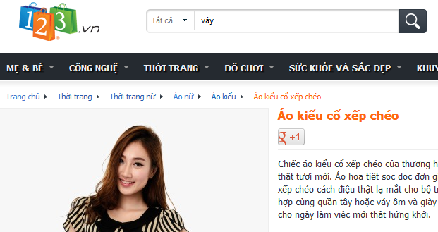

Figure A-1 123.vn site

### Enbac.com

This is like compound page with a lot of variety product that make use confuse. The grid display of product is not user friendly

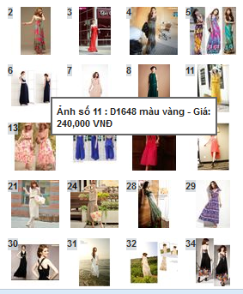

Figure A-2 enbac.com

The content of product is also like thread in forum.

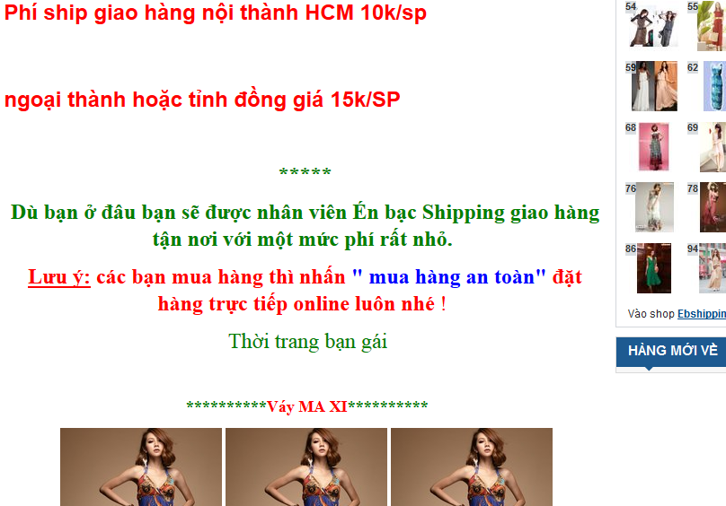

Figure A-3 enbac.com product

They also have limitation of option for user searching their product, the price will also can’t view the history.

### 5giay.vn

This is a forum based website and working like a bridge of sellers and buyers. But it still a great site for finding clothes and of course make a customer feel uncomfortable for searching what they want. They can’t search for detail of type, category or price directly but tag or text.

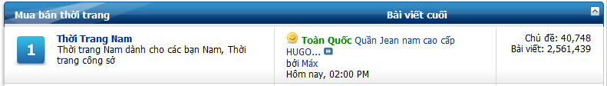

Figure A-4 5giay.vn

## Our Proposal

Our website focus to all kinds of customers, ordering process is very simple so everyone can used without learning, products will be showed in cleaver view, search support, reliable delivery system.

Functions our website will provide to people:

* Front-End
* Searching for desired products (more specific and ease)
* Comments, Rating, Feedback features support
* View History Orders
* Export PDF view Offline
* View history price
* Support Collection Feature (Wish List)
* Back-End
* Products Management
* Users Management
* Internal Message Support
* Promotion Management
* Orders Management
* Export Order to PDF
* Internal Mail Box Communication
* Feedback Managemen

## Products

Main products of our website is focus on fashion products, combine with delivery system, delivery status will be updated on time so customer can access and know how their product going. Our website help customer shopping way more easily and quick, make/view your own collection of chosen products, so can buy it later.

# B. Software Project Management Plan

## Problem Definition

### Name of this Capstone Project

E-Fashion (EFAS)

### Problem Abstract

The authors of the project found that IT technology is more and more important in social and Internet help people more connecting and communicating to each other. As a Managers of Store which sold many things they need web-based system for supporting Sales, Internal communicating, managing with take a lot of efforts in tradition way.

The aim of the project team is to create a new system that let customer reduce effort of coming to store to view products, promotions and make orders in traditional way. This system also helps Managers manage their store through Internet easily, visually.

### Project Overview

#### The Current System

* Customer can’t know the status of their orders after they made it.
* Doesn’t help customer storing their favorite products for later buy.
* Doesn’t store history of changes price to help customer tracking changes of price to make order when they feel the price is good in time.
* Doesn’t store history of changes order status for support managers tracking and managing orders.

#### The Proposed System

The aim of this system is to build a website with the following main features:

* Display all kinds of products in modern layout
* Searching desirable products
* Comments, view rating, feedback
* View your orders status
* View product price history
* Manage customer orders.
* Manage Users
* Manage Products
* Make a favored collection of products
* Internal message box for staff work

#### Boundaries of the System

The system under development of this Capstone Project will include:

* Based on web application
* Logistics details not involve in this version
* Product quantity management not involve in this version

#### Development Environment

Below is the list of hardware and software requirements needed for development environments:

##### **Hardware requirements:**

* Personal computers for developing with the minimum configuration: CPU Core 2 Duo 2.0GHz, 2GB of RAM, 120GB of hard disk, and internet.

##### **Software requirements:**

* Operating system: Windows 7
  + Microsoft Windows 7: operating system and platform for development
  + Microsoft SQL Server 2008: used to create and manage the database for
  + system
  + Tomcat 7: web server
  + StarUML and Microsoft Visio 2010: used to create models and diagrams
  + Microsoft Project 2010: used to manage process and work schedules.
  + Skype: used for communication and meeting
  + DBMS: Microsoft SQL Server 2008
* Source Control: Tortoise Subversion (SVN) and Assembla code server

## Project organization

### Software Process Model

The process model used for developing this project is agile development modal.

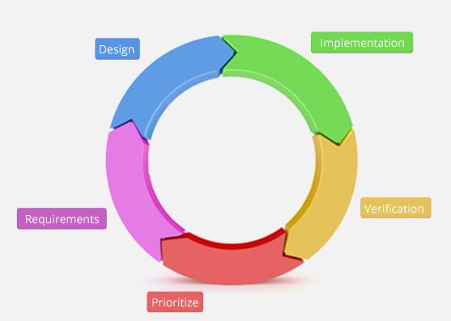

Figure B-5 Agile Development Model

All of the phases in implemented model are included in the scope of this project and are the responsibilities of the team.

**Requirement:** During this phase research is being conducted which includes brainstorming about the software, what it is going to be and what purpose it is going to fulfill.

**Design:** This step involves formulating the basic design of the software on paper.

After the basic design gets approved, then a more elaborated technical design can be planned. Here the functions of each of the part are decided and the engineering units are placed for example modules, etc.

**Implementation:** In this phase the source code of the programs is written.

**Verification:** At this phase, the whole design and its construction is put under a test to check its functionality.

**Prioritize:** This phase will be the experience the release and review selects next tasks for the next iteration.

* **Benefits:** The most important benefit from agile methodology is an ongoing focus on customer business goals. It allows eliminating the guess-work as well, and to control development cost, experience fewer bugs and have greater confidence when adding new features.

### Roles and Responsibilities

|  |  |  |  |
| --- | --- | --- | --- |
| No | Full name | Role in Group | Responsibilities |
| 1 | Than Van Su | Supervisor | * Give advice on technical problems and solutions * Specify user requirement * Control the development process * Review and approve project Elements |
| 2 | Tran Quang Huy | Team Leader | * Managing process * Designing database * Clarifying requirements * Prepare documents * GUI Design * Create test plan * Coding * Testing |
| 3 | Ho Ngoc An | Team member | * Designing database * Prepare documents * GUI Design * Clarifying requirements * Support technique * Coding * Creating test cases * Testing |
| 4 | Nguyen Minh Trung | Team member | * Coding * Clarifying requirements * GUI Design * Creating test plan and test cases * Testing |
| 5 | Pham Thi Thu Hien | Team member | * Coding * Clarifying requirements * GUI Design * Creating test plan and test cases * Testing |

Table B-3 Roles and Responsibilities

### Tools and Techniques

* Front-end technologies: html, CSS, JavaScript, jQuery, AJAX
* Tools: NetBean, Microsoft SQL Server 2008, JUnit, Visio, MS Project Management, Notepad++
* Architecture and design patterns: 3 Layeres Logical and 3 Tiers Physical

## Project management Plan

### Tasks

|  |  |  |  |  |  |  |  |
| --- | --- | --- | --- | --- | --- | --- | --- |
|  | Description | Output | Deliverables | Resources Needed | | Dependencies and Constraints | Risks |
| Develop Task List | Develop tasks, milestone, and assign task for team members | Task list | Deliver task list, project plan document before Sep 19th, 2012 | 4 people for 3 days | None | | None |
| Create software project plan | Create software project plan | Software Project Management Plan (SPM) document | Deliver SPM before Sep 22nd, 2012 | 4 people for 5 days | None | | None |
| Create Software Requirements Specification | Create software requirement specification | Software Requirement Specification (SRS) document | Delivery before Sep 28th, 2012 | 4 people for 7 days | None | | Changing requirement and scope of this project |
| Design Database | Create conceptual, logical, physical database design | Database design and Database script | Deliver with SRS before Sep 30th, 2012 | 4 people for 2 days | Depends on the completion in SRS | | SRS may not be detailed enough to make database design |
| Software Design Description | Design the system in an OOP manner | Architecture design, detailed design, diagrams and design specification | SDD before Oct 8th, 2012 | 4 people for 6 days | Depends on the completion of SRS | | Misunderstanding SRS and not review carefully will make risk occur |
| Coding | Implement the system to reflect SDD | Source code of the project , unit test report | Executable programs and source code before Nov 18th, 2012 | 4 people for 29 days | Depends on the completion of SRS, SDD, Database design | | Unit test may not be performed thoroughly causing spending many efforts in system test phase.  The team members don’t have a common place, so it is hard to perform collaboration and CM  Team members may not easily get used to new technologies  Team members are not expert in developing layout and css. This can cause more time for improve layout. |
| System Test | Perform system test for the system | System test report | Software test documentation before Nov 29th, 2012 | 4 people for 9 days | Coding is finished | | Lack of professional testers in team.  Developers are also responsible for system testing, this may lead to compromise. |
| Deployment | Deploy the system to Internet or LAN connection, create user manual | Running website with domain and hosting, user manual | Delivery user manual before Dec 6th, 2012 | 4 people for 6 days | Coding and system test are finished, initial data is inputted | | Composing document can cause by integrate from many team members’ document.  Training staff may take more time. |

Table B-4 Task Project Management Plan

### Task Sheet: Assignment and Timetable

Refer to EFAS.mpp file

### All Meeting Minutes

--------------------------------------------------------------------

## Coding Convention

### Simple – Precise

* **Keep your code simple and comprehensible.**
* **Be precise and consistence**
* **Don’t optimize too soon**

### Violations of Standard Rules

No standard is perfect and no standard is applicable to all situations: sometimes you find yourself in a situation where one or more standards do not apply.

* **Any violation to the guide is allowed if it enhances readability.**

The main goal of the recommendation is to improve readability and thereby the understanding and the maintainability and general quality of the code. It is impossible to cover all the specific cases in a general guide and the programmer should be flexible.

### Naming Convention

* **Capitalization Styles**

**Pascal case:** The first letter in the identifier and the first letter of each subsequent concatenated word are capitalized. You can use Pascal case for identifiers of three or more characters.

For example: ArticleComment

**Camel case:** The first letter of an identifier is lowercase and the first letter of each subsequent concatenated word is capitalized.

For example: homePhone

The following table summarizes the capitalization rules and provides examples for the different types of identifiers.

|  |  |  |
| --- | --- | --- |
| **Identifier** | **Case** | **Example** |
| Class | Pascal | PersonalHistory |
| Enum Type | Pascal | RoleName |
| Enum Value | Pascal | SuperAdmin |
| Exception Class | Pascal | DevideByZeroException  Note: Always end with Exception |
| Read-only static field | Pascal | SessionFactory |
| Interface | Pascal | IEventRepositoty  Note: Always begin with I |
| Namespace | Pascal | Java.Code |
| Parameter | Camel | firstName |
| Method | Pascal | createProducts  Note: Always begin with lower case |

Table B-5 Capitalization rule

# C. Software Requirements Specification

## User Requirement Specification

### 1.1 Boss Requirement

* Boss is the top-power user of the system. He/ she are operator of E-Fashion system.
* Boss can manage all admins (view detail, search, and active, de-active).
* Boss can add new admin
* Boss can review the Feedbacks from customer (view detail, filter).
* Boss can view reports statistics (view report by order, view by product, view on product list, filter by category, view by date, by month and year)

### 1.2 Admin Requirement

* Admin is manager of the website after boss.
* Admin can manage products (view detail, view list, search by conditions, add, update)
* Admin can manage category (add, update,delete)
* Admin can manage manufacture (add, update,delete)
* Admin can manage deliverer and customer accounts (view detail except password, search by conditions, view list, active, de-active)
* Admin can add new deliverer
* Admin can manage promotion (view detail, view list, search by conditions, add, update)
* Admin can manage feedback from customer (view detail, filter, view list, reply, delete)
* Admin can manage comments of customer (view detail, filter, view list, unflag, delete)
* Admin can manage all orders (view detail, view list, search by conditions, download order as PDF, change status, assign order to deliverer)

### Staff Requirement

* Staff include: Boss, Admin and Deliverer.
* Staff can use internal mail box: send, delete, view, reply message.
* Staffs can change their detail information (view detail, change personal detail, change password)
* Staffs can get new password using their email

### Deliverer Requirement

* Deliverer response for transport goods to customer
* Deliverer can change order status, download order detail as PDF
* Deliverer can view detail orders assigned for them
* Deliverer can search, filter for their Orders

### 1.6 Customer Requirement

* Customer can find, filter, view products
* Customers view and change their personal information and their password
* Customer can create their own collection (add, remove) and view detail collection
* Customers can view comments, create comments and rating specific product
* Customer use shopping cart to order many products at once (maximum 10 kinds of product at a time)
* Customers can view feedback and create feedback
* Customers can also view history price of specific product
* Customers can keep track of status of their orders
* Customer can also cancel order or download their order detail as PDF for offline view
* Customer can get new password by using their email

### 1.7 Communication Requirement

* System support the private message to all users in system can communicate together.

## System Requirement Specification

### External Interface Requirements

#### User Interfaces

* The interface of website is simple and friendly; user doesn’t need any training to use the website’s function.
* The error, warning messages must be simple, neat, and easy to understand. Error warning does not discomfort to the user.

#### Hardware Interfaces

* There is no extra hardware interfaces are needed. The system will use the standard hardware and data communications resources of a standard computer.

#### Software Interfaces

* Firefox Browser, Chromes with Resolution (1280\*800) or bigger and support Javascript and HTML5

#### Communications Protocol

* Website using HTTP protocol for communication with the web browser and the web server.

### System Overview Use Case

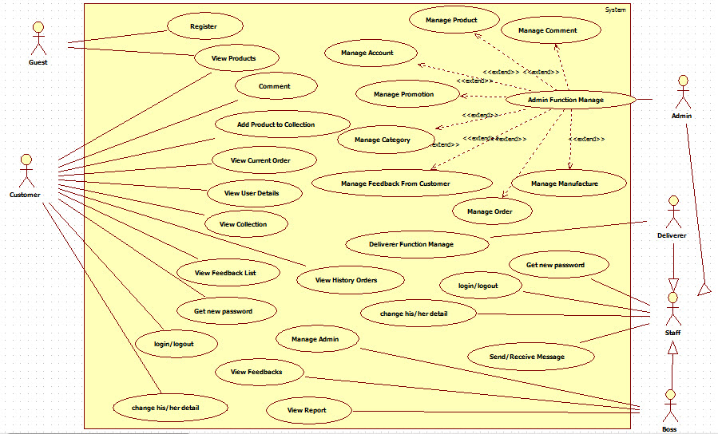

Figure C-6 System Overview UseCase

### List of use case

#### <Boss>Overview Use Case

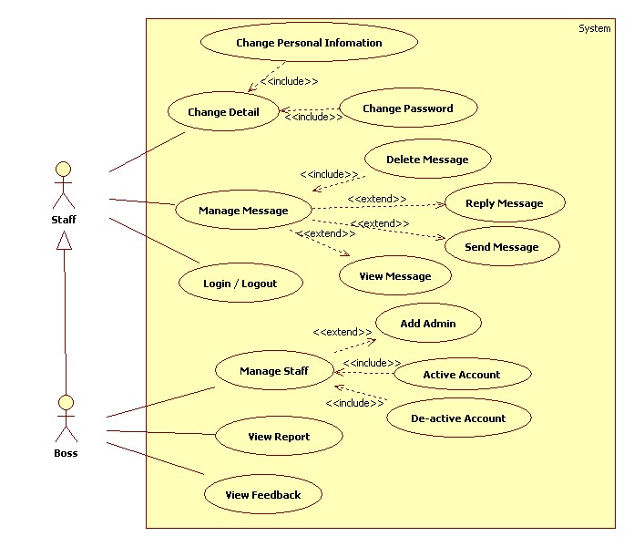

Figure C-7 Boss Overview UseCase

#### <Boss>Add Admin

Use Case Diagram

**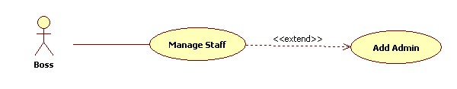**

Figure C-8 Boss Add Admin UseCase

**Use Case Specification**

|  |  |  |  |  |
| --- | --- | --- | --- | --- |
| **USE CASE – Add Admin Specification** | | | | |
| **Use case No.** | UCB001 | **Use case version** | | 1.0 |
| **Use case name** | Add Admin | | | |
| **Author** | TrungNM | | | |
| **Date** | 01/10/2012 | **Priority** | Normal | |
| **Actor:**  Boss  **Summary:**  This use case is used to create an admin account for system.  **Goal:**  Create a admin account  **Triggers:**  On the manage Admin page, click on “Thêm người quản trị” and Add Admin page will be showed, then input info, then click “Thêm” button to finish  **Preconditions:**  N/A  **Post Conditions:**  Account can login into system.  **Main Success Scenario:**   |  |  |  | | --- | --- | --- | | Step | Actor Action | System Response | | 1 | Click on “Thêm người quản trị” to request register on Manage Admin Page | System will response Add Admin page with the register form. | | 2 | nter information into text fields |  | | 3 | Click on “Thêm” button (submit button) to finish | System will show the success pae or transfer to Manage Admin page. |   **Alternative Scenario:**   |  |  |  | | --- | --- | --- | | Step | Actor Action | System Response | | 1 | Click on “Thêm người quản trị” to request register on Manage Admin Page | System will response Register page with the register form. | | 2 | Enter information into text fields |  | | 3 | Click on “Xóa” button (submit button) to finish | System clears all information in the fields, and ser can fill in again. |   **Exceptions:**   |  |  |  | | --- | --- | --- | | Step | Actor Action | System Response | | 1 | Return Register Page. | Display “Tên tài khoản’UserName’đã tồn tại”. |   **Relationships:**  N/A  **Business Rules:**  **N/A** | | | | |

**Screen**

**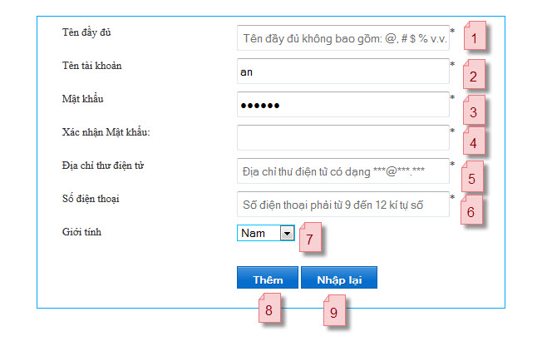**

Figure C-9 Boss Add Admin Screen

|  |  |  |  |  |  |  |
| --- | --- | --- | --- | --- | --- | --- |
| Field Name | Description | Read only | Mandatory | Control Type | Data type | Length |
| (1)Full name | Full name | N | Y | Textbox | String | 50 |
| (2)User name | User name | N | Y | Textbox | String | 20 |
| (3)Password | Password | N | Y | Textbox | String | 20 |
| (4)Password retype | Retype password | N | Y | Textbox | String | 20 |
| (5)Email | Email | N | Y | Textbox | String | 50 |
| (6)Phone number | Phone | N | Y | Textbox | String | 20 |
| (7)Gender | Gender | N | Y | Dropdown box | String | >0 |

**Buttons/Hyperlink**

|  |  |  |  |  |
| --- | --- | --- | --- | --- |
| Function | Description | Available Criteria | Validation | Outcome |
| (8)Submit button | Click to create new account | Always | No | Create new account |
| (9)Reset button | Click to reset all fields to default value | Always | No | Clear all fields |

#### <Boss> De-active Account

This is a basic function and is not detailed here

Summary: Boss can use this function to de-active accounts include: admin and deliverer

#### <Boss> Active Account

This is a basic function and is not detailed here

Summary: Boss can use this function to active accounts include: admin and deliverer

#### <Boss> View Feedback

**Use Case Diagram**

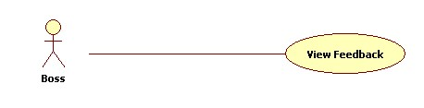

Figure C-10 Boss View Feedback UseCase

**Use Case Specification**

|  |  |  |  |  |
| --- | --- | --- | --- | --- |
| **USE CASE – View Feedback Specification** | | | | |
| **Use case No.** | CB004 | **Use case version** | | 1.0 |
| **Use case name** | View Feedback | | | |
| **Author** | TrungNM | | | |
| **Date** | 01/10/2012 | **Priority** | Normal | |
| **Actor:**  Boss  **Summary:**  When customer has any feedbacks, boss can read to know about customer’s need, the good and not good of system.  **Goal:**  Read the feedbacks of customer.  **Triggers:**  On Boss main page, click on “Quản lí feedback”. A list of feedbacks will be showed to boss can read.  **Preconditions:**  There must be at least one feedback for boss to view  **Post Conditions:**  Show all feedbacks that customer send.  **Main Success Scenario:**   |  |  |  | | --- | --- | --- | | Step | Actor Action | System Response | | 1 | Click on “Quản lí feedback” on Boss Main Page. | System will show the list of Feedbacks. | | 2 | Choose a feedback | System will show the content of Feedback was chosen. |   **Alternative Scenario:**  N/A  **Exceptions:**  N/A  **Relationships:**  N/A  **Business Rules:**  N/A | | | | |

**Screen**

**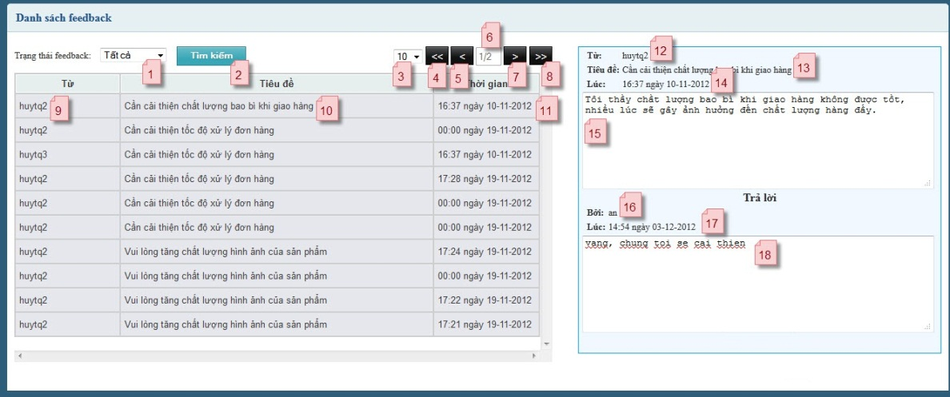**

Figure C-11 Boss View Feedback Screen

|  |  |  |  |  |  |  |
| --- | --- | --- | --- | --- | --- | --- |
| Field Name | Description | Read only | Mandatory | Control Type | Data type | Length |
| (1)Feedback Status | List of feedback status | N | N | Dropdown box | String | >0 |
| (3)Items number | Number of items will display in page | N | N | Dropdown box | String | >0 |
| (6)Page number | Number of pages | Y | N | Text box | String | >0 |
| (9)Feedback by | Name of customer who feedback | Y | Y | Div | String | >0 |
| (10)Feedback title | Title of feedback | Y | Y | Div | String | >0 |
| (11)Feedback time | Time of feedback | Y | Y | Div | String | >0 |
| (12)Feedback by | Name of customer who feedback | Y | Y | Div | String | >0 |
| (13Feedback title | Title of feedback | Y | Y | Div | String | >0 |
| (14)Feedback time | Time of feedback | Y | Y | Div | String | >0 |
| (15)Feedback content | Content of feedback | Y | Y | Text area | String | MAX |
| (16)Reply by | Name of admin who reply feedback | Y | Y | Div | String | >0 |
| (17)Reply time | Time when admin replied feedback | Y | Y | Div | String | >0 |
| (18)Reply content | Content of reply | N | Y | Text area | String | MAX |

**Button/Link**

|  |  |  |  |  |
| --- | --- | --- | --- | --- |
| Function | Description | Available Criteria | Validation | Outcome |
| (2)Search feedback button | Click to filter feedback base on filter conditions | Always | No | Show list of feedback base on search conditions |
| (4)Go to first page button | Click to go to first page of list | Always | No | Go to first page of list |
| (5)Go to previous page button | Click to go to previous page of list | Always | No | Go to previous page |
| (7)Go to next page button | Click to go to next page of list | Always | No | Go to next page |
| (8)Go to last page button | Click to go to last page of list | Always | No | Go to last page |

#### <Boss> View Report

**Use Case Diagram**

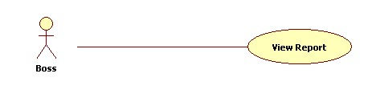

Figure C-12 Boss View Report UseCase

**Use Case Specification**

|  |  |  |  |  |
| --- | --- | --- | --- | --- |
| **USE CASE – View Report Specification** | | | | |
| **Use case No.** | UCB005 | **Use case version** | | 1.0 |
| **Use case name** | View Report | | | |
| **Author** | TrungNM | | | |
| **Date** | 02/10/2012 | **Priority** | Normal | |
| **Actor:**  Boss  **Summary:**  At the end of the week, month or year, boss can view all report about the duration that system was run to know about system boss manage to make system better in future.  **Goal:**  Show the reports.  **Triggers:**  On Boss main page, click on” Quản lý báo cáo”. Then, a list of reports will be showed.  **Preconditions:**  There must be at least one report for boss to view  **Post Conditions:**  Show all reports.  **Main Success Scenario:**   |  |  |  | | --- | --- | --- | | Step | Actor Action | System Response | | 1 | Click on “Quản lý báo cáo” on Boss Main Page. | System will show the Report Page. | | 2 | Choose a report type, and the duration date | System will show the content of Report was chosen. | | 3 | At the “Danh sách sản phẩm” report, boss can choose view product list report follow categoies | System will show the result |   **Alternative Scenario:**  N/A  **Exceptions:**  N/A  **Relationships:**  N/A  **Business Rules:**  N/A | | | | |

#### <Staff> Overview Use Case

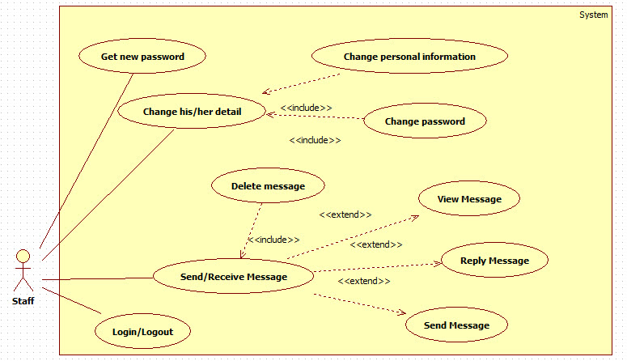

Figure C-13 Staff Overview UseCase

#### <Staff>Login

**Use Case Diagram**

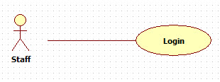

Figure C-14 Staff Login UseCase

**<Optional> Use Case Specification**

**Screen**

**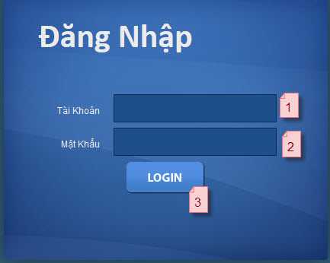**

Figure C-15 Staff Login Screen

|  |  |  |  |  |  |  |
| --- | --- | --- | --- | --- | --- | --- |
| Field Name | Description | Read only | Mandatory | Control Type | Data type | Length |
| (1)Account name | Staff account name | N | Y | Textbox | String | 20 |
| (2)Password | Staff password | N | Y | Textbox | String | 20 |

**Buttons/Hyperlink**

|  |  |  |  |  |
| --- | --- | --- | --- | --- |
| Function | Description | Available Criteria | Validation | Outcome |
| (3)Login button | Click to login | Always | No | Login to system |

#### <Staff>Logout

This is a basic function and is not detailed here

Summary: Staff can use this function to log out of system

#### <Staff> View Notification

**Use Case Diagram**

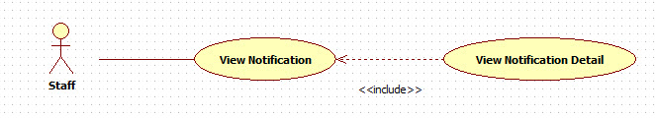

Figure C-16 View Notification UseCase

**Use Case Specification**

|  |  |  |  |  |
| --- | --- | --- | --- | --- |
| **USE CASE – View Notification** | | | | |
| **Use case No.** | UCS003 | **Use case version** | | 1.0 |
| **Use case name** | View Notification | | | |
| **Author** | TrungNM | | | |
| **Date** | 02/10/2012 | **Priority** | Normal | |
| **Actor:**  Staff (Boss, admin, deliverer)  **Summary:**  **Goal:**  View Notification  **Triggers:**  Staff want to view current notification  **Preconditions:**  Logged as staff success  **Post Conditions:**  **Main Success Scenario:**   |  |  |  | | --- | --- | --- | | Step | Actor Action | System Response | | 1 | Click n “Trang chủ” on header | Systems show all notification related to that user |   **Alternative Scenario:**  N/A  **Exceptions:**  N/A  **Relationships:**  N/A  **Business Rules:** | | | | |

**Screen**

**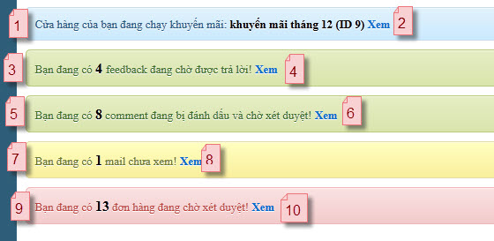**

Figure C-17 View Notification Screen

|  |  |  |  |  |  |  |
| --- | --- | --- | --- | --- | --- | --- |
| Field Name | Description | Read only | Mandatory | Control Type | Data type | Length |
| (1)Promotion Notification | Notification about current promotion on server | Y | N | Div | String | >0 |
| (3)Feedback Notification | Notification about current feedback (no reply) | Y | N | Div | String | >0 |
| (5)Comment Notification | Notification about current comment (being flagged) | Y | N | Div | String | >0 |
| (7)Email Notification | Notification about current mail (not viewed) | Y | N | Div | String | >0 |
| (9)Order Notification | Notification about current order (status waiting) | Y | N | Div | String | >0 |

**Buttons/Hyperlink**

|  |  |  |  |  |
| --- | --- | --- | --- | --- |
| Function | Description | Available Criteria | Validation | Outcome |
| (2)Promotion detail link | Click to view detail of it promotion | Always | No | redirect to promotion detail page |
| (4)Feedback link | Click to go to feedback list page | Always | No | Redirect to feedback list page |
| (6)Comment link | Click to go to comment list | Always | No | Redirect to comment list page |
| (8)Mail link | Click to go to inbox | Always | No | Redirect to inbox page |
| (10)Order link | Click to go to order page | Always | No | Redirect to order list page |

#### <Staff> Get new Password

This is a basic function and is not detailed here

Summary: Staff can use this function to get new password using email

#### <Staff>Change Personal Information

This is a basic function and is not detailed here

Summary: Staff can use this function to update their personal detail information

#### <Staff> Change password

This is a basic function and is not detailed here

Summary: Staff used this function to change their password

#### <Staff> Send Private Message

This is a basic function and is not detailed here

Summary: Staff used this function to send a message

#### <Staff> View Inbox Message

This is a basic function and is not detailed here

Summary: Staff used this function to view a message in inbox

#### <Staff> View Outbox Message

This is a basic function and is not detailed here

Summary: Staff used this function to view a message in outbox

#### <Staff> Reply Private Message

This is a basic function and is not detailed here

Summary: Staff used this function to reply a message

#### <Staff> Delete Private Message

This is a basic function and is not detailed here

Summary: Staff used this function to delete a message

#### <Admin> Overview Use Case

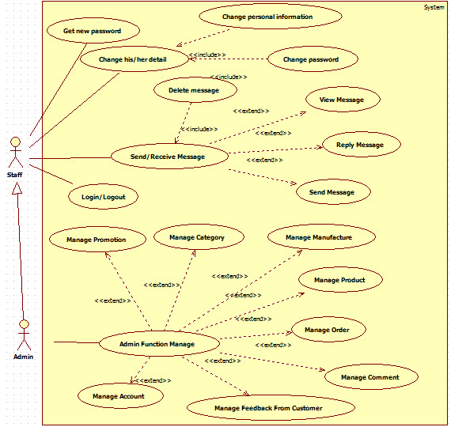

Figure C-18 Admin Overview UseCase

#### <Admin> Manage Product (lv2)

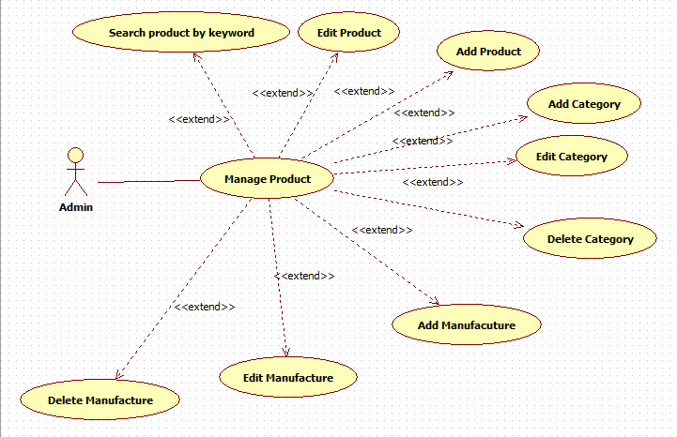

Figure C-19 Admin Manage Product UseCase

#### <Admin> Manage Order (lv2)

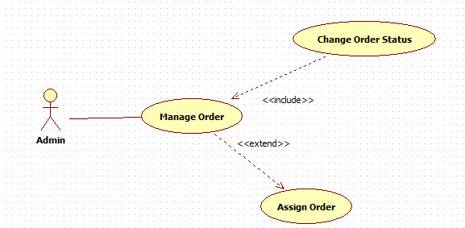

Figure C-20 Admin Manage Order UseCase

#### <Admin> Manage Feedback (lv2)

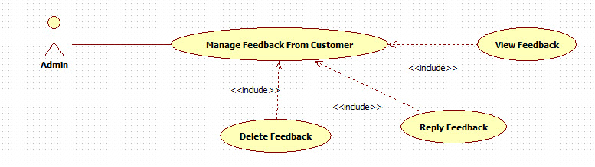

Figure C-21 Admin Manage Feedback UseCase

#### <Admin> Manage Promotion (lv2)

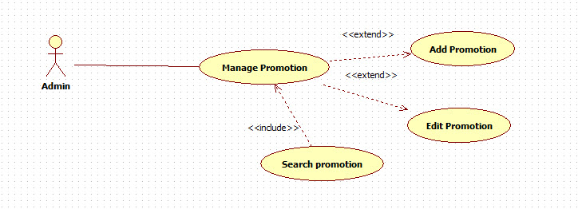

Figure C-22 Admin Manage Promotion UseCase

#### <Admin> Manage Comment (lv2)

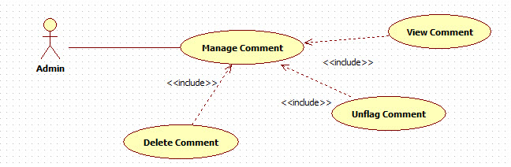

Figure C-23 Admin Manage Comment

#### <Admin> Manage Account (lv2)

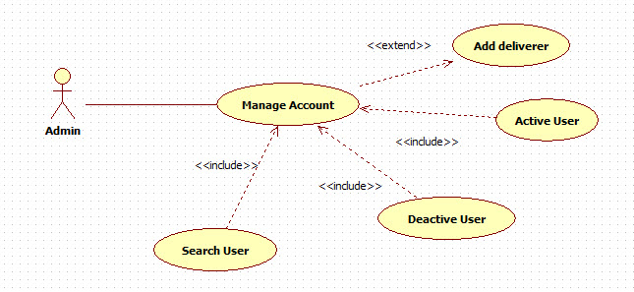

Figure C-24 Admin Manage Account UseCase

#### <Admin> Add Product

Use case diagram

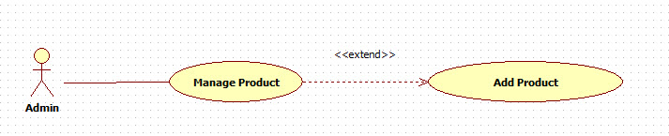

Figure C-25 Admin Add Product UseCase

Use case specification

|  |  |  |  |  |
| --- | --- | --- | --- | --- |
| **USE CASE- Add New Product** | | | | |
| **Use-case No.** | UCA001 | **Use-case Version** | | 1.0 |
| **Use-case Name** | Add new product | | | |
| **Author** | AnHN | | | |
| **Date** | 1/10/2012 | **Priority** | Normal | |
| **Actor**:  Admin  **Summary**:  Admin will use this function to add a new product to database  **Goal**:  Admin add a product successful  **Triggers**:  Admin want to add new product  **Preconditions**:  Admin logged successful to system  **Post Conditions**: N/A  **Main Success Scenario:**   |  |  |  | | --- | --- | --- | | Step | Actor Action | System Response | | 1 | Select “Quản lí sản phẩm” | System display list of product in database | | 2 | Click “Thêm sản phẩm” | System redirect to Add Product Page | | 3 | Input product information |  | | 4 | Click “Lưu” | System validate and send information to servlet |   **Alternative Scenario**:   |  |  |  | | --- | --- | --- | | Step | Actor Action | System Response | | 1 | Select “Quản lí sản phẩm” | System display list of product in database | | 2 | Click “Thêm sản phẩm” | System redirect to Add Product Page | | 3 | Input product information |  | | 4 | Click “Trở lại trang trước” | System redirect back to product page |   **Exceptions – Website under maintenance** :   |  |  |  | | --- | --- | --- | | Step | Actor Action | System Response | | 1 | Select “Quản lí sản phẩm” | System display list of product in database | | 2 | Click “Thêm sản phẩm” | System redirect to Add Product Page | | 3 | Input product information |  | | 4 | Click “Lưu” | System validate invalid input and show warning to admin |   **Relationships**:  **Business Rules**: N/A | | | | |

**Screen**

**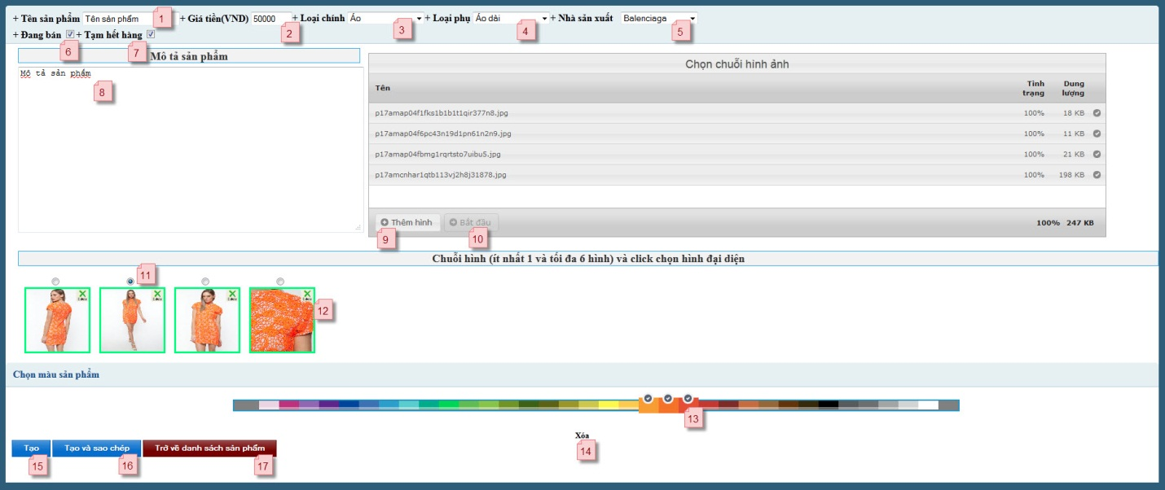**

Figure C-26 Admin Add Product UseCase

|  |  |  |  |  |  |  |
| --- | --- | --- | --- | --- | --- | --- |
| Field Name | Description | Read only | Mandatory | Control Type | Data type | Length |
| (1) Product Name | Name of product | N | Y | Text box | String | 50 |
| (2)Product Price | Price of product | N | Y | Text box | String | 8 |
| (3)Root Category | List of root product categories | N | Y | Dropdown box | String | 50 |
| (4)Sub Category | List of sub product categories | N | Y | Dropdown box | String | 50 |
| (5)Manufacture | Manufacture of product | N | Y | Dropdown box | String | 50 |
| (6)Product Selling | Check if product is selling or not | N | N | Checkbox | Checkbox | N/A |
| (7)Product Sold Out | Check if product is sold out or not | N | N | Checkbox | Checkbox | N/A |
| (8)Product Descript | Description of product | N | Y | Text area | String | MAX |
| (11)Present Image | Check for choose picture present | N | Y | Checkbox | Checkbox | N/A |

**Buttons/Hyperlink**

|  |  |  |  |  |
| --- | --- | --- | --- | --- |
| Function | Description | Available Criteria | Validation | Outcome |
| (9)Add picture button | Click to add picture for upload (multi upload) | Always | No | Open file dialog for choose picture |
| (10)Begin upload button | Click to begin upload chosen pictures | Only when there picture ready to upload | Become unavailable when reached max picture allow | Begin upload file to server |
| (12)Delete picture link | Click to remove picture from image series | Only when there picture available | No | Remove current image |
| (13)Color pick link | Click to choose color for product | Always | No | Choose color for product |
| (14)Clear all color link | Click to clear all clicked color | Always | No | Reset all color to default |
| (15)Add product button | Click to finish and add new product to database | Always | Validate all input field | Add product and reset all field |
| (16)Add product and keep all current information for new product creation (button) | Click to finish, add new product to database and keep previous product information for next product create | Always | Validate all input field | Add product and keep all field for product create |
| (17)Back to product show page | Click to go to product show page | Always | No | Click to go to product show page |

#### <Admin>View Product Detail

This is a basic function and is not detailed here

Summary: Admin use this function to view product detail

#### <Admin>View Product List

This is a basic function and is not detailed here

Summary: Admin use this function to view product list

#### <Admin> Edit Product

This function is similar to add product (UCA001)

Summary: Admin use this function to edit specific product

#### <Admin> Search Product By keyword

This is a basic function and is not detailed here

Summary: Admin use this function to filter or search specific products, search condition include: search by name, root category, sub category, manufacture, selling status, store status and by ID

#### <Admin> Add Root Category

This is a basic function and is not detailed here

Summary: Admin use this function to add new root category

#### <Admin> Add Sub Category

This is a basic function and is not detailed here

Summary: Admin use this function to add new sub category

#### <Admin> Edit Category

This is a basic function and is not detailed here

Summary: Admin use this function to edit root and sub category

#### <Admin> Delete Sub Category

This is a basic function and is not detailed here

Summary: Admin use this function to delete sub category

#### <Admin> Delete Root Category

This is a basic function and is not detailed here

Summary: Admin use this function to delete root category

#### <Admin> Add Manufacture

This is a basic function and is not detailed here

Summary: Admin use this function to add new manufacture

#### <Admin> Edit Manufacture

This is a basic function and is not detailed here

Summary: Admin use this function to edit manufacture

#### <Admin> Delete Manufacture

This is a basic function and is not detailed here

Summary: Admin use this function to delete manufacture

#### <Admin>Search Order by keyword

This is a basic function and is not detailed here

Summary: Admin use this function to search order includes: order status, customer name, customer account, and deliverer name, deliverer account, from date, to date and by ID

#### <Admin>View Order Detail

This is a basic function and is not detailed here

Summary: Admin use this function to view order detail

#### <Admin>View Order List

This is a basic function and is not detailed here

Summary: Admin use this function to view list of order

#### <Admin> Assign Order

Use case diagram

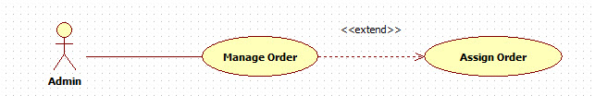

Figure C-27 Admin Assign Order UseCase

Use case specification

|  |  |  |  |
| --- | --- | --- | --- |
| **USE CASE- Assign Order** | | | |
| **Use-case No.** | UCA014 | **Use-case Version** | 1.0 |
| **Use-case Name** | Assign order to deliverer | | |
| **Author** | AnHN | | |
| **Date** | 1/10/2012 | **Priority** | Normal |
| **Actor**:  Admin  **Summary**:  Admin will use this function to assign an order to deliverer  **Goal**:  Admin assign order successful  **Triggers**:  Admin want to assign order  **Preconditions**:  Admin logged successful to system  **Post Conditions**: N/A  **Main Success Scenario:**   |  |  |  | | --- | --- | --- | | Step | Actor Action | System Response | | 1 | Select “Quản lí đơn hàng” | System Display list of orders which customer requested | | 2 | Click on order title | System Redirect to order detail page | | 3 | Type or choose deliver name on list | System Send request to servlet and get response | | 4 | Click “Duyệt” | System Send information to servlet |   **Alternative Scenario**:   |  |  |  | | --- | --- | --- | | Step | Actor Action | System Response | | 1 | Select “Quản lí đơn hàng” | System Display list of orders which customer requested | | 2 | Click on order title | System Redirect to order detail page | | 3 | Type or choose deliver name on list | System Send request to servlet and get response | | 4 | Click “Trở về trang trước” | System Redirect back to order list |   **Exceptions – Duplicate deliverer assign :**   |  |  |  | | --- | --- | --- | | tep | Actor Action | System Response | | 1 | Select “Quản lí đơn hàng” | System Display list of orders which customer requested | | 2 | Click on order title | System Redirect to order detail page | | 3 | Type or choose deliver name on list | System Send request to servlet and get response | | 4 | Click “Duyệt” | System Invalid deliverer name warning |   **Relationships**:  **Business Rules**: | | | |

**Screen**

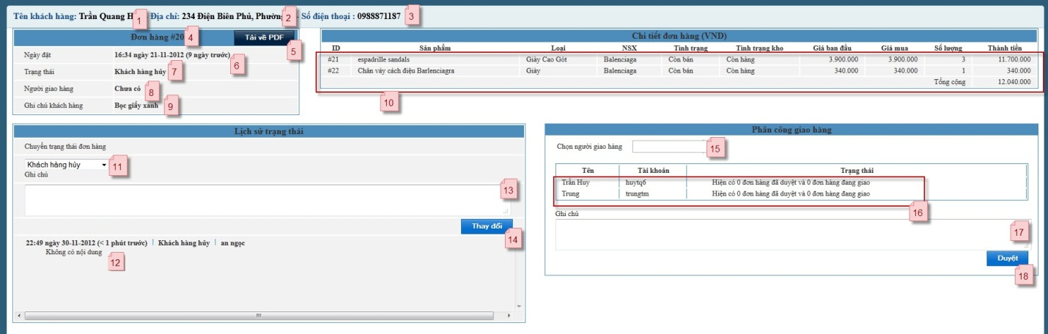

Figure C-28 Admin Assign Order Screen

|  |  |  |  |  |  |  |
| --- | --- | --- | --- | --- | --- | --- |
| Field Name | Description | Read only | Mandatory | Control Type | Data type | Length |
| (1) Customer Name | Name of customer | Y | Y | Div | String | 50 |
| (2)Customer Address | Address of customer | Y | Y | Div | String | 50 |
| (3)Customer Phone | Phone of customer | Y | Y | Div | String | 12 |
| (4)Order ID | ID of order | Y | Y | Div | String | 10 |
| (6)Order Date | Date of order | Y | Y | Div | String | 10 |
| (7)Order Status | Status of order | Y | Y | Div | String | 20 |
| (8)Deliverer Name | Name of deliverer | Y | Y | Div | String | 50 |
| (9)Customer Note | Note of customer | Y | Y | Div | String | MAX |
| (10)Orders Product List | Products of order | Y | Y | Div |  |  |
| (15)Deliverer Name | Name of deliverer | Y | Y | Text box | String | 50 |
| (16)List of deliverer | List of deliverer and their status | Y | Y | Div |  |  |
| (17)Note | Order Status | N | N | Text area | String | MAX |

**Button/Link**

|  |  |  |  |  |
| --- | --- | --- | --- | --- |
| Function | Description | Available Criteria | Validation | Outcome |
| (18)Assign Order button | Click to assign order to selected deliverer | Always | Yes, whenever there selected deliverer | Assign order to deliverer |

#### <Admin> Change Order Status

This is a basic function and is not detailed here

Summary: Admin use this function to change status of order

#### <Admin> Export PDF Order Detail

This is a basic function and is not detailed here

Summary: Admin use this function export order detail as PDF file

#### <Admin> View Comments

This is a basic function and is not detailed here

Summary: Admin use this function to view comments

#### <Admin> Unflag Comment

This is a basic function and is not detailed here

Summary: Admin use this function to un-flag comment which had been flagged by customer

#### <Admin> Delete Comment

This is a basic function and is not detailed here

Summary: Admin use this function to un-flag comment which had been flagged by customer

#### <Admin> View Feedback

This is a basic function and is not detailed here

Summary: Admin use this function to view a feedback

#### <Admin> Reply Feedback

This is a basic function and is not detailed here

Summary: Admin use this function to reply a feedback

#### <Admin>Delete Feedback

This is a basic function and is not detailed here

Summary: Admin use this function to delete specific feedback

#### <Admin> Search Account

This is a basic function and is not detailed here

Summary: Admin use this function to search accounts include: search by account name, full name, email, phone number, gender, account type, account status

#### <Admin> Active User

This is a basic function and is not detailed here

Summary: Admin use this function to active a user

#### <Admin>De-active User

This is a basic function and is not detailed here

Summary: Admin use this function to de-active a user

#### <Admin>View Promotion List

This is a basic function and is not detailed here

Summary: Admin use this function to view list of promotion

#### <Admin> Add New Promotion

Use case diagram

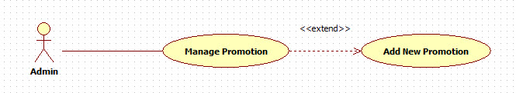

Figure C-29 Admin Add New Promotion

Use case specification

|  |  |  |  |  |
| --- | --- | --- | --- | --- |
| **USE CASE- Add New promotion** | | | | |
| **Use-case No.** | UCA028 | **Use-case Version** | | 1.0 |
| **Use-case Name** | **Add New promotion** | | | |
| **Author** | AnHN | | | |
| **Date** | 1/10/2012 | **Priority** | Normal | |
| **Actor**:  Admin  **Summary**:  Admin will use this function to add new promotion  **Goal**:  Admin add promotion successful  **Triggers**:  Admin want to add promotion  **Preconditions**:  Admin logged successful to system  **Post Conditions**: N/A  **Main Success Scenario:**   |  |  |  | | --- | --- | --- | | Step | Actor Action | System Response | | 1 | Select “Thêm đợt khuyến mãi” | System redirect to add new promotion page | | 2 | Type promotion detail and choose product promotion |  | | 3 | Click “Lưu” | System send information to servlet |   **Alternative Scenario**:  **Exceptions**:  **Relationships**:  **Business Rules**: | | | | |

**Screen**

**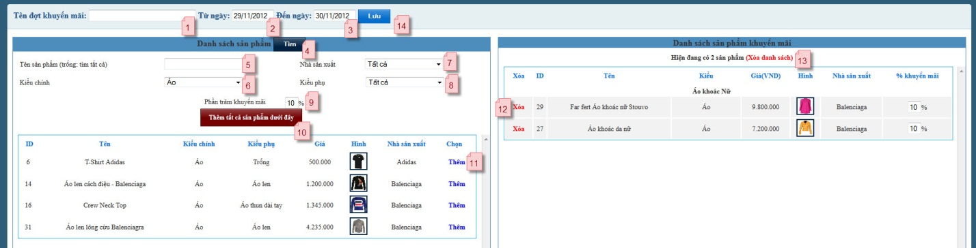**

Figure C-30 Admin Add New Promotion Screen

|  |  |  |  |  |  |  |
| --- | --- | --- | --- | --- | --- | --- |
| Field Name | Description | Read only | Mandatory | Control Type | Data type | Length |
| (1) Promotion Name | Name of promotion | N | Y | Text box | String | 50 |
| (2)Start date | Start date of promotion | Y | Y | Date picker | String | 10 |
| (3)End date | End Date of promotion | Y | Y | Date picker | String | 10 |
| (5)Product Name | Name of product that need to search | N | N | Text box | String | 50 |
| (6)Root Category | Root category list admin need to search | N | N | Dropdown box | String | 50 |
| (7)Manufacture | Manufacture list admin need to search | N | N | Dropdown box | String | 50 |
| (8)Sub Category | Sub category list admin need to search | N | N | Dropdown box | String | 50 |
| (9)Discount | Discount rate for product | N | Y | Text box | String | 2 |

**Button/Link**

|  |  |  |  |  |
| --- | --- | --- | --- | --- |
| Function | Description | Available Criteria | Validation | Outcome |
| (14)Save Promotion button | Click to add new promotion | Always | Yes, validate date range and product available for promotion | Add new promotion |
| (4)Search button | Click to begin search products based on condition | Always | No | Search products |
| (10)Add all products | Click to add all below product to promotion table | Always | No | Add all products |
| (11)Add product | Add selected product to promotion table | Always | No | Add product promotion |
| (12)Remove product | Remove selected product from promotion table | Always | No | Remove product promotion |
| (13)Clear promotion table | Remove all product from promotion | Always | No | Remove whole promotion table |

#### <Admin> View Promotion Detail

This is a basic function and is not detailed here

Summary: Admin use this function to view promotion detail

#### <Admin> Edit Promotion

This function is similar to add new promotion (UCA028)

Summary: Admin use this function to edit an promotion

#### <Admin> Search Promotion

This is a basic function and is not detailed here

Summary: Admin use this function to search a promotion include: promotion name, from date, to date and by ID

#### <Deliverer> Overview

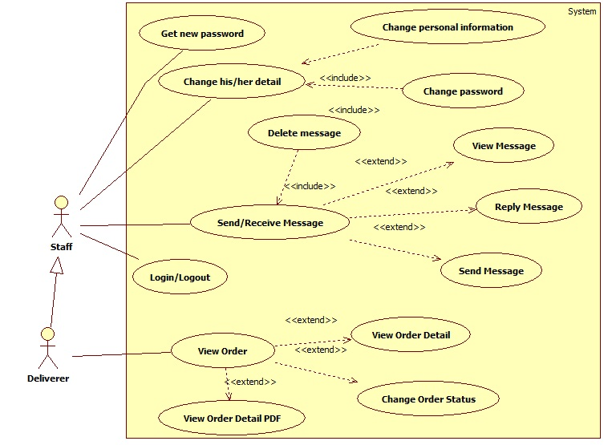

Figure C-31 Deliverer Overview UseCase

#### <Deliverer>View Order Detail

This is a basic function and is not detailed here

Summary: Deliverer use this function to view order detail

#### <Deliverer> View Order Detail PDF

This is similar to export PDF in admin use case (UCA016)

Summary: Deliverer use this function to export PDF order detail

#### <Deliverer> Change Order Deliver Status

This is a basic function and is not detailed here

Summary: Deliverer use this function to change order status

#### <Customer/Guest> Overview

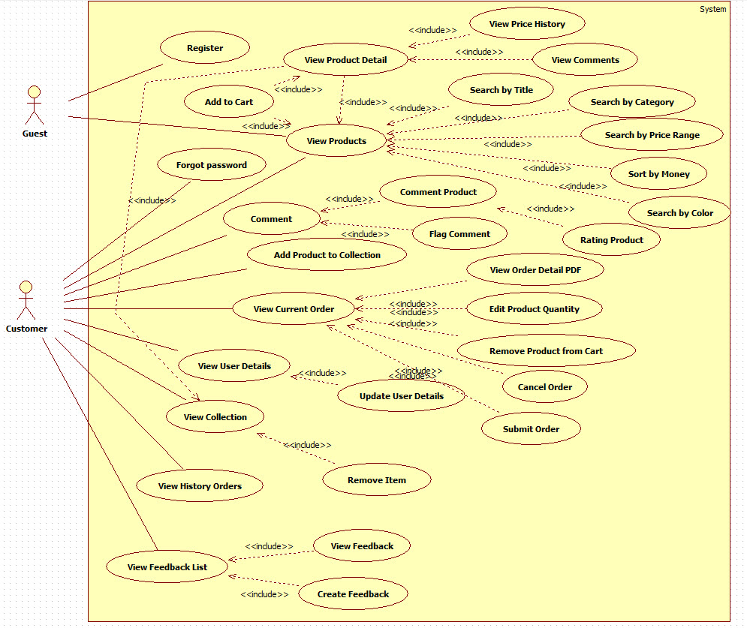

Figure C-32 Customer/Guest Overview UseCase

#### <Customer > Login

Use case diagram

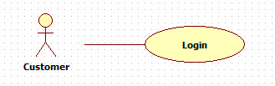

Figure C-33 Customer Login UseCase

<Optional> Use case specification

**Screen**

**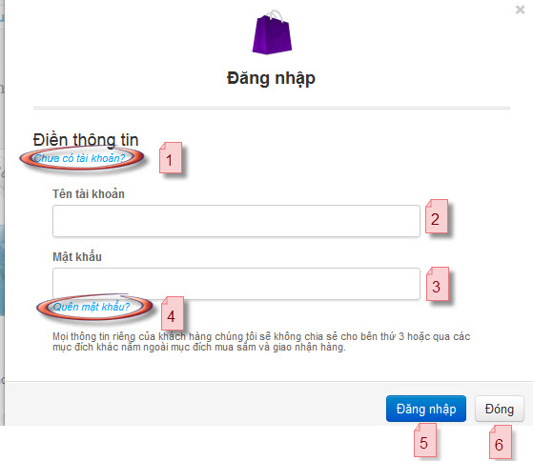**

Figure C-34 Customer Login Screen

|  |  |  |  |  |  |  |
| --- | --- | --- | --- | --- | --- | --- |
| Field Name | Description | Read only | Mandatory | Control Type | Data type | Length |
| (2)Account name | Customer account name | N | Y | Textbox | String | 20 |
| (3)Password | Password | N | Y | Textbox | String | 20 |

**Button/Link**

|  |  |  |  |  |
| --- | --- | --- | --- | --- |
| Function | Description | Available Criteria | Validation | Outcome |
| (1)Register link | Click to open register page | Always | No | Show register page |
| (4)Forgot password link | Click to open recovery password page | Always | No | Open reset password page |
| (5)Login button | Click to login | Always | No | Login to page |
| (6)Close button | Click to close current windows | Always | No | Close current windows |

#### <Customer> Logout

This is a basic function and is not detailed here

Summary: Customer use this function to log out from system

#### <Customer/Guest> View Product List

This is a basic function and is not detailed here

Summary: Customer or guest can view product list

#### <Customer/Guest> View Product Detail

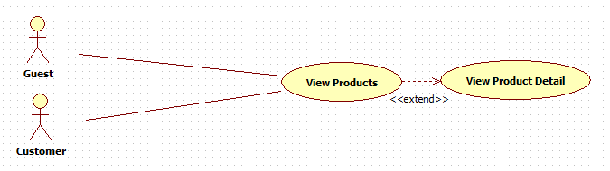Use case diagram

Figure C-35 Customer/Guest View Product Detail UseCase

Use case specification

|  |  |  |  |  |
| --- | --- | --- | --- | --- |
| **USE CASE- View Product Detail** | | | | |
| **Use-case No.** | UCC004 | **Use-case Version** | | 1.0 |
| **Use-case Name** | **View Product Detail** | | | |
| **Author** | HuyTQ | | | |
| **Date** | 1/10/2012 | **Priority** | Normal | |
| **Actor**:  Guest, Customer  **Summary**:  Show all details of a product after actor click it in the list  **Goal**:  All related information of clicked product will be display  **Triggers**:  Click on product on the products list ([ref. UCC001](#_<Customer>_View_Products))  **Preconditions**:  Actor viewing list of Product and click on particular product image  **Post Conditions**: N/A  **Main Success Scenario:**   |  |  |  | | --- | --- | --- | | Step | Actor Action | System Response | | 1 | Click on image of product on product list | Lead user to detail page and show details of clicked product on screen |   **Alternative Scenario**:   |  |  |  | | --- | --- | --- | | Step | Actor Action | System Response | | 1 | Click on image of product on Collection list | Lead user to detail page and show details of clicked product on screen |   **Exceptions – Error Occurs**:   |  |  |  | | --- | --- | --- | | Step | Actor Action | System Response | | 1 | Click on image of product on Collection list | Lead user to error page with content “Hệ thống không tìm ra được trang quý khách yêu cầu. Bạn có thể quay lại trang trước đó hoặc trở về trang chủ bằng biểu tượng trên góc trái màn hình. Xin cảm ơn.” |   **Exceptions – Product not Found Occurs**:   |  |  |  | | --- | --- | --- | | Step | Actor Action | System Response | | 1 | Click on image of product on Collection list | Lead user to error page with content “Sản phẩm không tìm thấy  Xin vui lòng thử tìm kiếm lại sau.” |   **Relationships**: View Products List Use Case, View Collection Use Case  **Business Rules**: N/A | | | | |

**Screen**

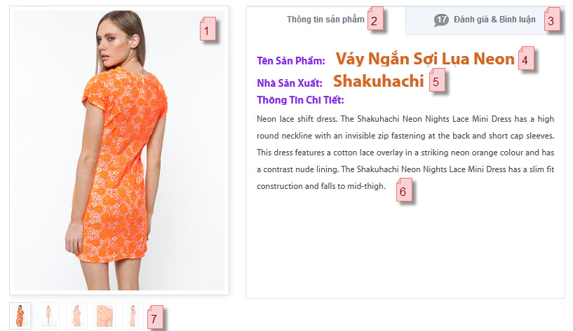

Figure C-36 Customer/Guest View Product Detail Screen

|  |  |  |  |  |  |  |
| --- | --- | --- | --- | --- | --- | --- |
| Field Name | Description | Read only | Mandatory | Control Type | Data type | Length |
| (1)Present Image | Image present for the product | Y | Y | Image |  |  |
| (4)Product Name | Name of product | Y | Y | Div | String | >0 |
| (5)Manufacture Name | Name of manufacture | Y | Y | Div | String | >0 |
| (6)Product Description | Description of product | Y | Y | Div | String | >0 |

**Button/Link**

|  |  |  |  |  |
| --- | --- | --- | --- | --- |
| Function | Description | Available Criteria | Validation | Outcome |
| (2)Product detail tab link | Click to open product detail tab | Always | No | Show product detail tab |
| (3)Comment product tab | Click to open comment tab | Always | No | Show comment tab |
| (7)Image series | Hover to zoom picture | Always | No | Hover to replace present image |

#### <Customer/Guest> View Price History

This is a basic function and is not detailed here

Summary: Customer or guest can view change of product price

#### <Customer/Guest> View Comments

This is a basic function and is not detailed here

Summary: Customer or guest can view comments

#### <Customer> Rating Product

This is a basic function and is not detailed here

Summary: Customer rating product

#### <Customer> Flag Comment

This is a basic function and is not detailed here

Summary: Customer use this function to flag comment which they think is bad, admin will review these flagged comments.

#### <Customer> Add Product to Collection

Use case diagram

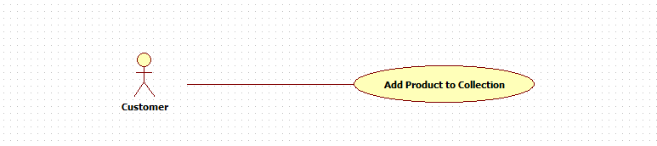

Figure C-37 Customer Add Product to Collection UseCase

Use case specification

|  |  |  |  |  |
| --- | --- | --- | --- | --- |
| **USE CASE- Add Product to Collection** | | | | |
| **Use-case No.** | UCC010 | **Use-case Version** | | 1.0 |
| **Use-case Name** | Add Product to Collection | | | |
| **Author** | HuyTQ | | | |
| **Date** | 1/10/2012 | **Priority** | Normal | |
| **Actor**:  Customer  **Summary**:  Customer will use this function for adding product to their collection  **Goal**:  Customer added product successful to their collection.  **Triggers**:  Customer view details of a Products and click “Thêm vào sưu tập”  **Preconditions**:  Customer logged in system and view details of a product ([ref. UCC002](#_<Customer>_View_Product)) or view products List.  **Post Conditions**:  Added successful notification display on Customer Screen.  **Main Success Scenario:**   |  |  |  | | --- | --- | --- | | Step | Actor Action | System Response | | 1 | Customer click on image of product on product List | Display details of corresponding product | | 2 | Customer click button “Thêm vào sưu tập” | Display “Thêm vào sưu tập thành công” |   **Alternative Scenario**:   |  |  |  | | --- | --- | --- | | tep | Actor Action | System Response | | 1 | Customer click on Heart icon of product on product List | Display “Thêm vào sưu tập thành công” |   **Exceptions – Adding fail**:   |  |  |  | | --- | --- | --- | | Step | Actor Actio | System Response | | 1 | *Same as Main Scenaio.* | | | 2 | Customer click button “Thêm vào sưu tập” | Display “Thêm vào sưu tập thất bại” |   **Exceptions – Product already in collection**:   |  |  |  | | --- | --- | --- | | Step | Actor Action | System Response | | 1 | *Same as Alternative Scenario.* | | | 2 | Customer click button “Thêm vào sưu tập” | Display “Sản phẩm đã có trong bộ sưu tập” |   **Relationships**: View Product Detail Use Case  **Business Rules**: N/A | | | | |

**Screen**

**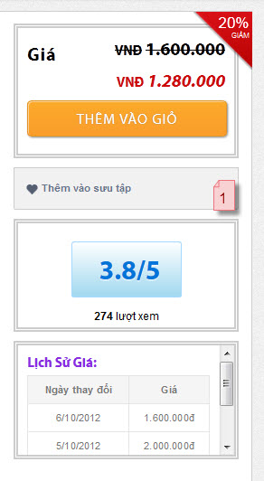**

Figure C- 38 Customer Add Product to Collection Screen

**Button/Link**

|  |  |  |  |  |
| --- | --- | --- | --- | --- |
| Function | Description | Available Criteria | Validation | Outcome |
| (1)Add to collection link | Click to add current product to collection | Always | No | Add product to collection |

#### <Customer/Guest> Add To Cart

This is a basic function and is not detailed here

Summary: Customer or guest can add product to their cart

#### <Customer > View Current Order

This is a basic function and is not detailed here

Summary: Customer can view their current order

#### <Customer/Guest> Remove Product from Cart

This is a basic function and is not detailed here

Summary: Customer or guest can remove their product from cart

#### <Customer/Guest> Edit Product Quantity

This is a basic function and is not detailed here

Summary: Customer can edit quantity of their product in cart

#### <Customer> Submit Order

This is a basic function and is not detailed here

Summary: Customer able to submit their order

#### <Customer> Cancel Order

This is a basic function and is not detailed here

Summary: Customer use this function to cancel their newly order, order must be in status ‘Chờ xử lý’ to allow canceling.

#### <Customer>View Detail Order PDF

This is a basic function and is not detailed here

Summary: Customers download their order detail as PDF file

#### <Customer> View User Detail

This is a basic function and is not detailed here

Summary: Customers use this function view their detail information

#### <Customer> Update User Detail

This is a basic function and is not detailed here

Summary: Customer can update their detail information

#### <Customer> View Collection

Use case diagram

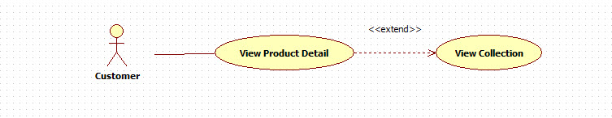

Figure C-39 Customer View Collection UseCase

Use case specification

|  |  |  |  |  |
| --- | --- | --- | --- | --- |
| **USE CASE- View Collection** | | | | |
| **Use-case No.** | UCC019 | **Use-case Version** | | 1.0 |
| **Use-case Name** | View Collection | | | |
| **Author** | HuyTQ | | | |
| **Date** | 1/10/2012 | **Priority** | Normal | |
| **Actor**:  Customer  **Summary**:  Customer will use this function for viewing their collection.  **Goal**:  Collection of Customer display on the screen.  **Triggers**:  Customer view Products List Page and click “Bộ sưu tập<number>” on menu bar for viewing their collection.  **Preconditions**:  Customer logged successful to system.  **Post Conditions**:  **Main Success Scenario:**   |  |  |  | | --- | --- | --- | | Step | Actor Action | System Response | | 1 | Go to website | Loading products list page | | 2 | Log in | Reload page | | 3 | Click “Bộ sưu tập<number>” on menu bar | Show Customer collection page. |   **Alternative Scenario**: N/A  **Exceptions – Loggin Require**:   |  |  |  | | --- | --- | --- | | Step | Actor Action | System Response | | 1 | Go to Collection page by URL input manual | Send user to the Customer homepage |   **Relationships**: View Products List Use Case  **Business Rules**: N/A | | | | |

**Screen**

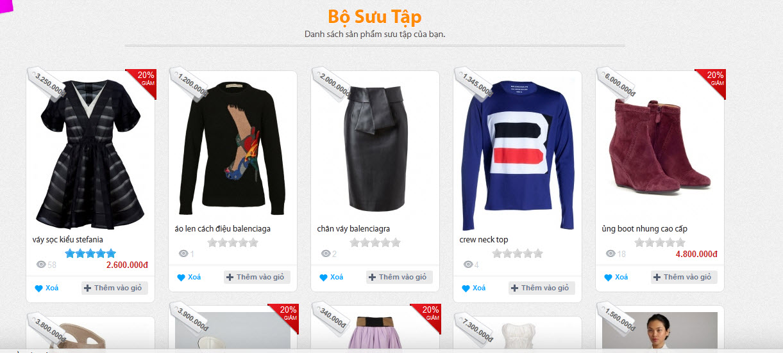

Figure C-40 Customer View Collection Screen

#### <Customer> Remove Item

This is a basic function and is not detailed here

Summary: Customers can remove product from their collection

#### <Customer/Staff> Get new password

Use case diagram

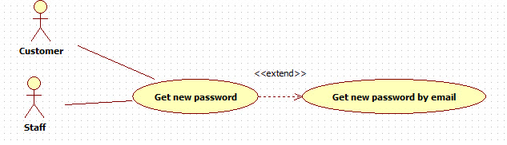

Figure C-41 Customer/Staff Get New Password UseCase

Use case specification

|  |  |  |  |  |
| --- | --- | --- | --- | --- |
| **USE CASE- Get new password by email** | | | | |
| **Use-case No.** | UCC021 | **Use-case Version** | | 1.0 |
| **Use-case Name** | Get new password by email | | | |
| **Author** | HuyTQ | | | |
| **Date** | 1/10/2012 | **Priority** | Normal | |
| **Actor**:  Customer, Staff  **Summary**:  Customer/Staff will use this function get new password when they forgot their old password  **Goal**:  Customer/ Staff get new password success  **Triggers**:  Customer/ Staff want to get new password when he/she forget old password  **Preconditions**:  **Post Conditions**:  **Main Success Scenario:**   |  |  |  | | --- | --- | --- | | Step | Actor Action | System Response | | 1 | Go to website | Loading products list page | | 2 | Click on ‘Đăng nhập’ | Load pop up for login | | 3 | Click “Quên mật khẩu?’ | Redirect to change password page |   **Alternative Scenario**: N/A  **Exceptions – Loggin Require**:  **Relationships**:  **Business Rules**: N/A | | | | |

**Screen**

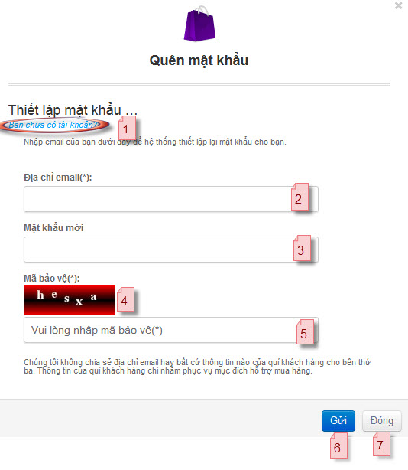

Figure C-42 Customer/Staff Get New Password Screen

|  |  |  |  |  |  |  |
| --- | --- | --- | --- | --- | --- | --- |
| Field Name | Description | Read only | Mandatory | Control Type | Data type | Length |
| (2)Email | Requester email | N | Y | Textbox | String | >0 |
| (3)New password | New password | N | Y | Textbox | String | 20 |
| (4)Captcha | Captcha | Y | Y | Image |  |  |
| (5)Type Captcha | Type in captcha | N | Y | Textbox | String | 10 |

**Button/Link**

|  |  |  |  |  |
| --- | --- | --- | --- | --- |
| Function | Description | Available Criteria | Validation | Outcome |
| (1)Create account link | Click to register new account | Always | No | Redirect to register page |
| (6)Send button | Click to submit request | Always | Yes, email must exist, password must at least 5 character | Send active link to requester email box |
| (7)Close button | Click to close current windows | Always | No | Close current windows, return to previous page |

#### <Customer> View Histories Order

Use case diagram

Figure C-43 Customer View Histories Order UseCase

Use case specification

|  |  |  |  |  |
| --- | --- | --- | --- | --- |
| **USE CASE- View History Orders** | | | | |
| **Use-case No.** | UCC022 | **Use-case Version** | | 1.0 |
| **Use-case Name** | View History Orders | | | |
| **Author** | HuyTQ | | | |
| **Date** | 1/10/2012 | **Priority** | Normal | |
| **Actor**:  Customer  **Summary**:  Customer will use this function for viewing and keep track of their submitted Orders.  **Goal**:  All Orders and their status of Customer display on the screen.  **Triggers**:  Customer view Products List Page and click “Đơn đặt hàng<number>” on menu bar for viewing their Orders.  **Preconditions**:  Customer logged successful to system.  **Post Conditions**:  All Customers’ submitted Orders display on the screen.  **Main Success Scenario:**   |  |  |  | | --- | --- | --- | | Step | Actor Action | System Response | | 1 | Go to website | Loading products list page | | 2 | Log in | Reload page | | 3 | Click “Đơn đặt hàng” on menu bar | Show customer orders page. |   **Alternative Scenario**: N/A  **Exceptions – Loggin Require**:   |  |  |  | | --- | --- | --- | | Step | Actor Action | System Response | | 1 | Go to Products list page | Loading the page | | 2 | Click “Đơn đặt hàng” on menu bar | Send user to the Customer homepage |   **Relationships**: View Products List Use Case  **Business Rules**: N/A | | | | |

**Screen**

**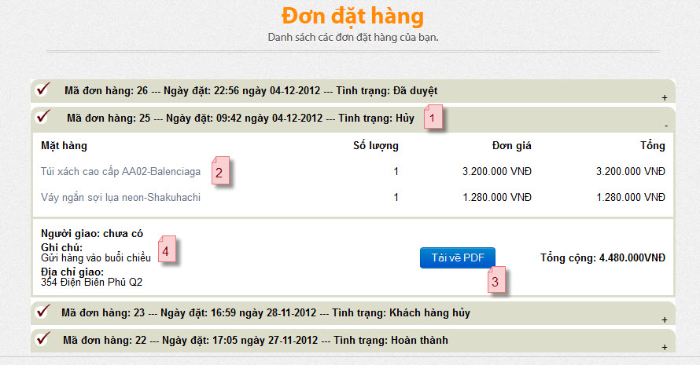**

Figure C-44 View Histories Order Screen

|  |  |  |  |  |  |  |
| --- | --- | --- | --- | --- | --- | --- |
| Field Name | Description | Read only | Mandatory | Control Type | Data type | Length |
| (1)Order title | Order summary | Y | Y | Tr | String | >0 |
| (2)Product Order Detail | Product in order | Y | Y | Div | String | >0 |
| (4)Delivering detail | Detail for delivering | Y | Y | Div | String | >0 |

**Button/Link**

|  |  |  |  |  |
| --- | --- | --- | --- | --- |
| Function | Description | Available Criteria | Validation | Outcome |
| (3)Save PDF button | Click to save order as PDF | Always | No | Save PDF |

#### <Customer/Guest> View Feedback List

This is a basic function and is not detailed here

Summary: Customer and guest can view feedback list

#### <Customer/Guest> View Feedback

This is a basic function and is not detailed here

Summary: Customer or guest can view feedback detail

#### <Customer> Create feedback

This is a basic function and is not detailed here

Summary: Customer can create new feedback

#### <Customer/Guest> Search by Title

This is a basic function and is not detailed here

Summary: Customer and guest can search product by product name

#### <Customer/Guest> Search by Categories

This is a basic function and is not detailed here

Summary: Customer and guest can filter product by category

#### <Customer> Search by Color

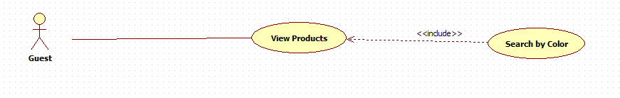Use case diagram

Figure C-45 Customer Search by Color UseCase

<Optional>Use case specification

**Screen**

****

**Button/Link**

Figure C-46 Customer Search by Color Screen

|  |  |  |  |  |
| --- | --- | --- | --- | --- |
| Function | Description | Available Criteria | Validation | Outcome |
| (2)Color pick | Click to choose selected color for search | Always | No | Search all product related to selected color |

#### <Customer/Guest> Sort Product

This is a basic function and is not detailed here

Summary: Customer or guest can sort product list by conditions (newest, highest price, lowest price, highest rating and lowest rating)

#### <Customer/Guest>Search by manufacture

This is a basic function and is not detailed here

Summary: Customer and guest can search product by manufacture

#### <Customer/Guest> Search by Price Range

Use case diagram

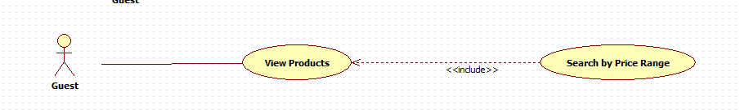Figure C-47 Customer/Guest Search by Price Range UseCase

<Optional>Use case specification

**Screen**

**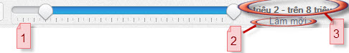**

Figure C-48 Customer/Guest Search by Price Range Screen

|  |  |  |  |  |  |  |
| --- | --- | --- | --- | --- | --- | --- |
| Field Name | Description | Read only | Mandatory | Control Type | Data type | Length |
| (1)Price range selection | Range of price for product | N | N | Div |  |  |
| (3)Price range text | Text range for price filter | Y | N | Div | String | >0 |

**Button/Link**

|  |  |  |  |  |
| --- | --- | --- | --- | --- |
| Function | Description | Available Criteria | Validation | Outcome |
| (2)Clear link | Click to reset filter condition to default value | Always | No | Selection reset to 0 |

## Software System Attribute

### Reliability

* Initial data must be collected carefully and correctly
* The database must be backed up regularly and can be recovered if necessary
* Rate of fault occurrence (ROFO): a number of 0.005 is acceptable. It means that it is acceptable to have five failures happen in each 1000 operational time units (e.g. 5 failures per 1000 hours of operation).
* Mean Time Between Failures (MTBF): 1 month
* Mean Time To Repair (MTTR): immediately when admin finds out problems or someone attacks website.
* Maximum Bugs or Defect Rate: 05 bugs / KLOC
* Bugs or Defect Rate:
  + Minor bugs: bugs related to GUI
  + Significant bugs: bugs related to business logic
  + Criticalbugs*: function can’t execute correctly, completely loss of data, disconnect to the server*

### Availability

* Systems have to run 23.30 hours 7 days.
* System can turn off while upgrading and must display an alternative maintenance page for users before 24 hours.
* Percentage of time available is about 95-97%. We cannot control cases of force majeure such as power failure, disconnected network…

### Security

* Privacy: the system should provide protection method for protecting user information from outside or from other users. All the information of users must not be available for anyone or software that is not part of the system. User password is also invisible for the system administrator.
* The system must provide methods to prevent common security attacks. Example: SQL Injection
* Secure information of customers should not be stored on customer’s machine.

### Maintainability

* Not more than 1 hour spent correcting any identified fault (corrective maintenance)
* Each new function point (system enhancement) shall be implementable within 2 working days (perfective maintenance).
* Each new change required to adapt to changes in environment shall be implementable within 2 working days (adaptive maintenance).

### Portability

* Database can use SQL Server

### Performance

* The system should be able to run on standard computer with internet connection and that computer must be able to run Fire Fox browser.
* Response of system: 90% should be within 2 sec, except for downloading which more time is acceptable.

## ERD diagram

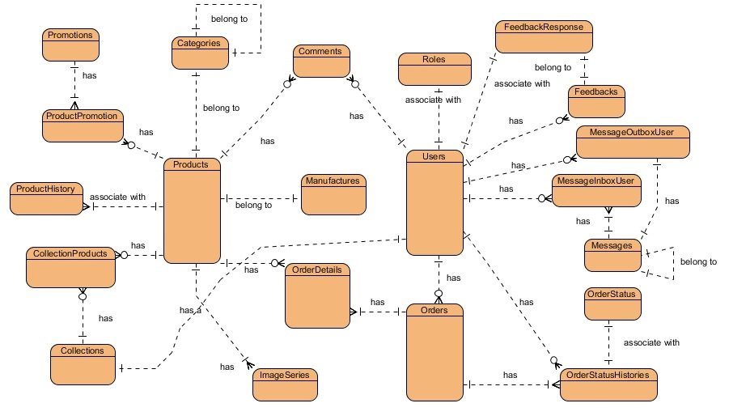

**Updated ERD**

Figure C-49 ERD Diagram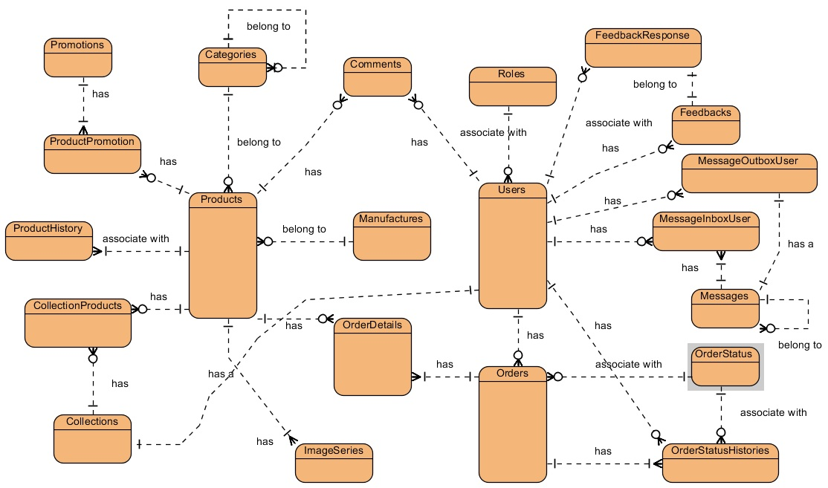

# Software Design Description

## Design Overview

This document describes the technical and user interface design of the E-Fashion system. It includes the system architectural design, the detailed description of components, and detailed design of classes. It also includes the sequence diagrams, database design, and design of user interface.

The architectural design describes the overall architecture of the system, and the architecture of each main component. It will describe the role of each component.

The component design describes more detail about main components. It will describe how sub-components communicate together, and their responsibilities.

The detailed design describes static and dynamic structure for each component. It includes class diagrams, class explanations, algorithms of some important methods, and sequence diagrams of all use cases.

The user interface design describes the layout of the system. It also includes description of links between webpages, by a page flow diagram.

The database design describes entities, relationship between entities, and their details.

Document Overview:

* Section I: Overview
* Section II: Architectural Design
* Section III: Component Design
* Section IV: Detailed Design
* Section V: Sequence Diagrams
* Section VI: User Interface Design
* Section VII: Database Design
* Section VIII: Supporting Information

## System Architectural Design

**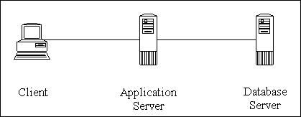**

Figure D-50 3 Tiers Physical Architecture

**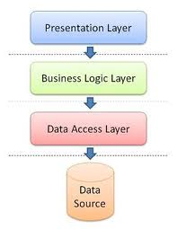**

Figure D-51 3 Layers Logical Architecture at Application Server

### Choice of System Architecture

Architecture of E-Fashion system is three-tier architecture. It makes a separation between the Presentation Tier (Client Tier), the Application Tier (Business Logic Tier/Middle Tier), and the Data Tier.

Each tier is located in physically separated computers and communicates with each other through the Internet. The tiers will communicate only to their adjacent neighbors; the Presentation Tier will interact directly with the Application Tier and not directly with Data Tier.

We choose three-tier architecture because of its strong benefits:

* It is possible to change the contents of any one of tiers without having to make corresponding changes in any of the others.
* Any changes to business rules can therefore be made in one place and be instantly available throughout the whole application.
* Improved data integrity, since all updates go through the Application Tier, the Application Tier can ensure that only valid data is allowed to be updated in the database.
* Security is improved since it can be implemented at multiple levels (not just the database). Since the client does not have direct access to the database, it is more difficult for a client to obtain unauthorized data.
* Location independence.
* Hardware, operating system, software chosen to suitability of purpose.
* Enables parallel development of the different tiers of the application.

### Discussion of Alternative Designs

In this section, we will discuss about two-tier architecture.

* Advantages of two-tier architecture over three-tier:
  + Simpler structure, therefore easier to maintain.
  + In general, it is more difficult to build a three-tier application compared to a two-tier application.
* Disadvantages of two-tier architecture over three-tier:
  + Less security.
  + More code to distribute to client workstations, therefore more resources needed for client workstation.
  + Requires client modification if database changes.

Because E-Fashion is a web application and is going to grow in functionality, but three-tier architecture is more suitable for web applications and two -tier architecture is inadequate for medium to large systems, so we choose three-tier one.

### Description of System Interface

Entities of the above diagram are:

* **Presentation Tier:** This is the top most level of the system and is the one that everyone sees and uses. This tier is responsible for communication with users (receives command from user, outputs result, shows messages to user, asks for user confirmation, etc.). It hosts the presentation components.

This tier includes Internet browsers running on personal computers, or tablets.

The web browsers will interact with the Web Application via HTTP protocol.

* **Application Tier:** This tier is pulled out from the Presentation Tier and controls application’s functionality by performing detailed processing. This tier transfers data between the two other tiers. It is responsible for hosting all the application’s business components which is follow 3 layers architecture.
* **Data Tier:** This tier consists of database server(s) and is responsible for storing, retrieving, and updating data. It hosts the databases that the application requires.

## Component Diagram

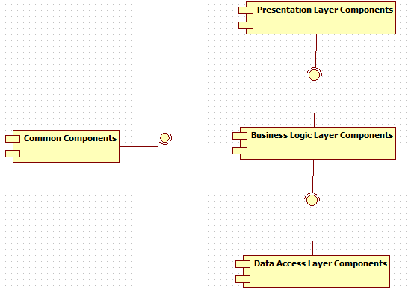

Figure D-52 Component Diagram

The architecture of E-Fashion Application Tier is Three Layers Architecture. Inside each layer, there are some components that handle one or some specific functions.

### Presentation Layer’s Components

This component has responsibility to deliver the front end to the users and accept their inputs. It will be developed by using JSP combines with JavaScript and CSS.

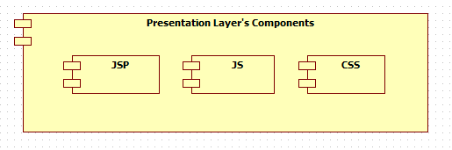

Figure D-53 Presentation Layer's Components

### Business Logic Layer’s Components

This component contains all business logic for the system. It includes business layer object classes, data transfer object classes, servlets …

These components have responsibility to process importing data, validation, transferring data to presentation layer or data access layer.

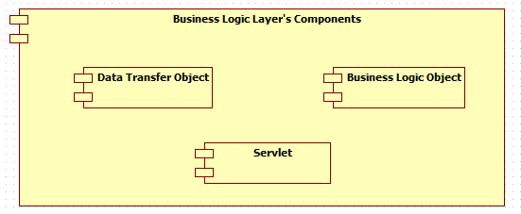

Figure D-54 Business Layer's Components

### Data Access Layer’s Components

This component contains all data access objects which is responsible for accessing data in database system component and exchange data information with database for the system. It includes data access classes.

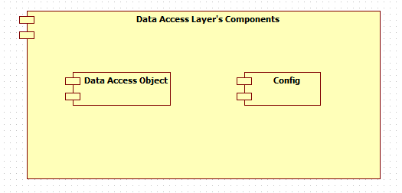

Figure D-55 Data Access Layer's Components

### Common Component

This component contains common logic that can be used throughout the application. It also contains library use for Formatter or validation, Cryptography, Emailer container…

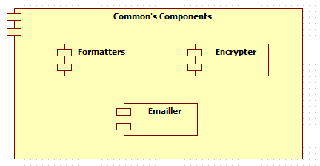

Figure D-56 Common Components

## Detailed Description of Components

### JSP Components (Presentation Layer’s Components) (Optional)

### Servlet Components (Business Layer’s Components)

#### Class Diagram

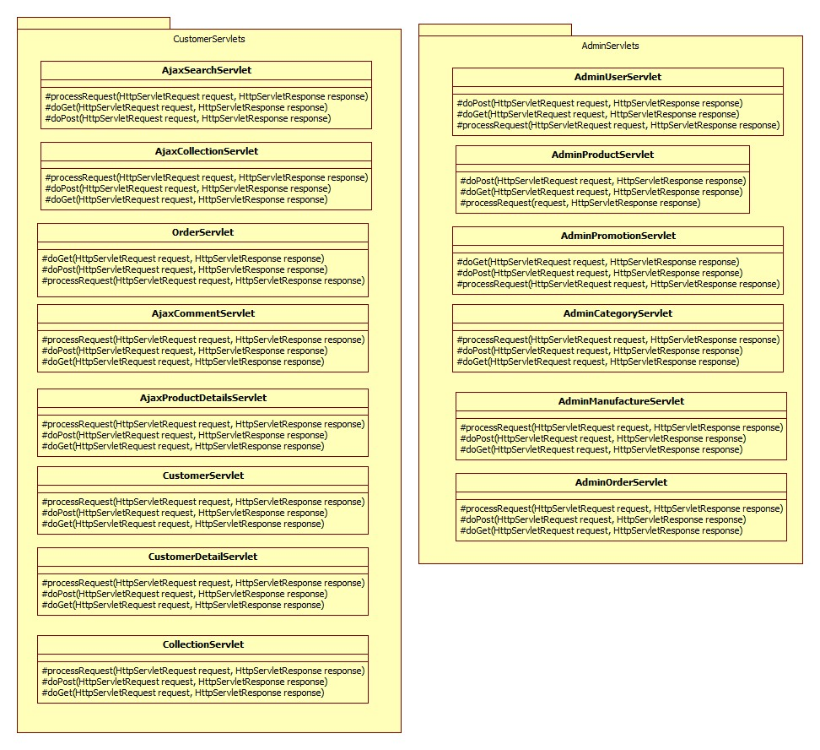

**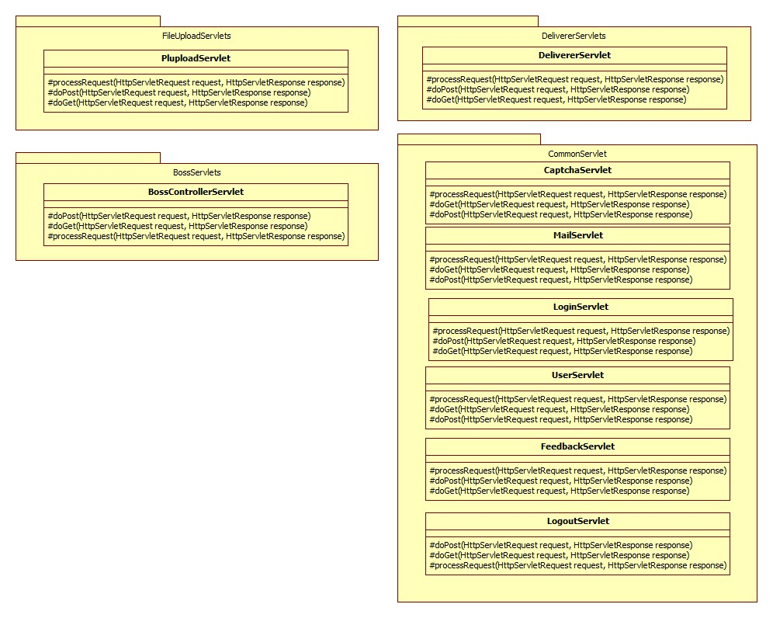**

Figure D-57 Servlet Components

#### Class Diagram Explanation

##### **AjaxSearchServlet Class (Optional)**

##### **AjaxCollectionServlet Class (Optional)**

##### **AjaxOrderServlet Class (Optional)**

##### **BossControllerServlet Class (Optional)**

##### **AdminUserServlet Class (Optional)**

##### **AdminProductServlet Class (Optional)**

##### **DelivererServlet Class (Optional)**

##### **AdminPromotionServlet Class (Optional)**

##### **LoginServlet Class (Optional)**

##### **LogoutServlet Class (Optional)**

##### **RegisterServlet Class (Optional)**

##### **PluploadServlet Class (Optional)**

##### **UploadServlet Class (Optional)**

##### **AjaxCommentRatingServlet (Optional)**

##### **AjaxProductDetailsServlet (Optional)**

##### **AjaxOrderServlet (Optional)**

##### **UserDetailsServlet (Optional)**

##### **FeedbackServlet (Optional)**

##### **MailServlet (Optional)**

##### **Captcha Servlet (Optional)**

### Data Transfer Object (Business Layer’s Components)

#### Class Diagram

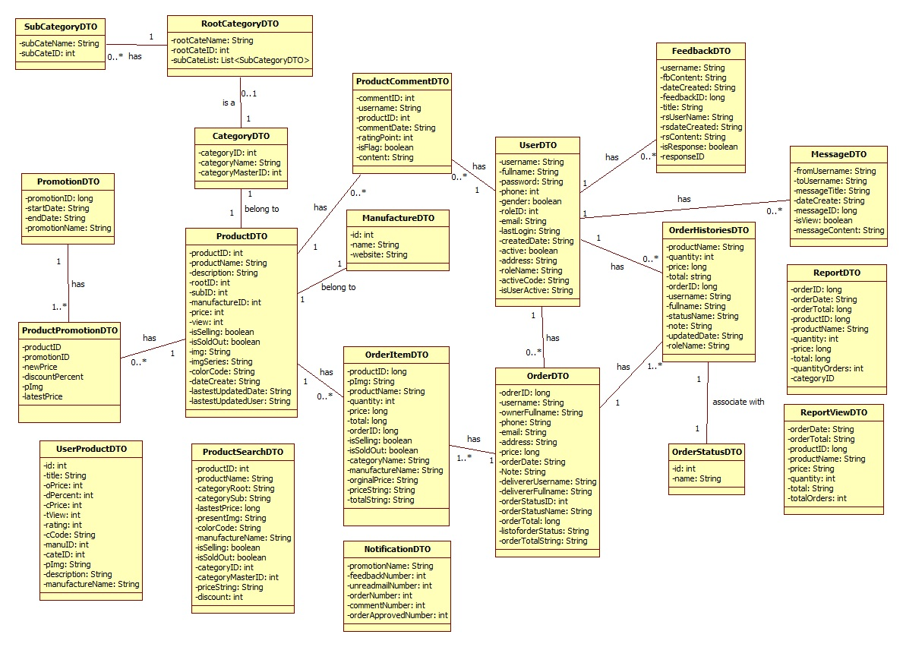

Figure D-58 Data Transfer Object Class

#### Class Explanation

##### **ProductDTO**

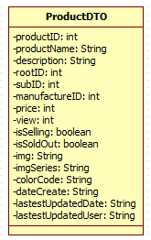

This class’s responsibility is containing data of product for create, update, edit product

**Attributes**

|  |  |  |  |
| --- | --- | --- | --- |
| **Attribute** | **Type** | **Visibility** | **Description** |
| **productID** | Integer | private | ID of product |
| **productName** | String | private | Name of product |
| **description** | String | private | Description of product |
| **categoryID** | Integer | private | ID of category |
| **manufactureID** | Integer | private | ID of manufacture |
| **Price** | Integer | private | Price of product |
| **View** | Integer | private | View of product |
| **isSelling** | Boolean | private | Check if product is sell |
| **isSoldOut** | Boolean | private | Check if product issold ou |
| **presentImg** | String | private | Image of product |
| **colorCode** | String | private | Color of product |
| **dateCreated** | String | private | Created date of product |
| **lastestUpdatedDate** | String | private | Last update date of product |
| **lastestUpdatedUser** | String | private | Last update user of product |

##### **ManufactureDTO**

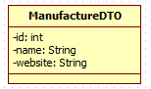

This class’s responsibility is containing data of manufacture for create, update

**Attributes**

|  |  |  |  |
| --- | --- | --- | --- |
| **Attribute** | **Type** | **Visibility** | **Description** |
| **id** | Integer | private | ID of manufacture |
| **name** | String | private | Name of manufacture |
| **website** | String | private | Website of manufacture |

##### **CategoryDTO**

Figure D-59 CategoryDTO

This class’s responsibility is containing data of category for create, update

**Attributes**

|  |  |  |  |
| --- | --- | --- | --- |
| **Attribute** | **Type** | **Visibility** | **Description** |
| **categoryID** | Integer | private | ID of category |
| **categoryName** | String | private | Name of category |
| **categoryMasterID** | Integer | private | ID of category master |

##### **PromotionDTO**

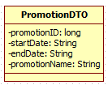

This class’s responsibility is containing promotion data for create and update

**Attributes**

|  |  |  |  |
| --- | --- | --- | --- |
| **Attribute** | **Type** | **Visibility** | **Description** |
| **promotionID** | long | private | ID of promotion |
| **startDate** | String | private | Start date of promotion |
| **endDate** | String | private | End date of promotion |
| **promotionName** | String | Private | Name of promotion |

##### **ProductPromotionDTO**

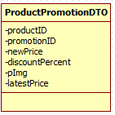

This class’s responsibility is containing data of promotion’s product for create, update

**Attributes**

|  |  |  |  |
| --- | --- | --- | --- |
| **Attribute** | **Type** | **Visibility** | **Description** |
| **productID** | long | private | ID of product |
| **promotionID** | long | private | ID of promotion |
| **newPrice** | long | private | New price of promotion’s product |
| **discountPercent** | int | private | Discount Percent of Product |
| **pImg** | String | private | Present image of product |
| **latestPrice** | Long | private | Original latest Price of product |

##### **OrderDTO**

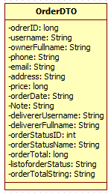

This class’s responsibility is containing data of order for create, update

**Attributes**

|  |  |  |  |
| --- | --- | --- | --- |
| **Attribute** | **Type** | **Visibility** | **Description** |
| **orderID** | long | private | ID of order |
| **username** | String | private | Username of order person |
| **ownerFullname** | String | private | Full name of order person |
| **phone** | String | private | Phone of order person |
| **email** | String | private | email of order person |
| **price** | Integer | private | Price of Product |
| **orderDate** | String | private | Created date of order |
| **Note** | String | private | Note of order |
| **delivererUsername** | String | private | Order’s handled deliverer username |
| **delivererFullname** | String | private | Order’s handled deliverer fullname |
| **orderStatusID** | Integer | private | Status ID of order |
| **orderStatusName** | String | private | Status Name of order |
| **orderTotal** | Long | private | Total price of order |
| **listoforderStatus** | String | private | Status in list string of order |
| **orderTotalString** | String | private | Total price in String form |

##### **UserDTO**

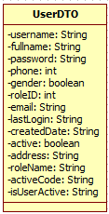

This class’s responsibility is containing data of user for create, update

**Attributes**

|  |  |  |  |
| --- | --- | --- | --- |
| **Attribute** | **Type** | **Visibility** | **Description** |
| **username** | String | private | User name |
| **fullname** | String | private | Full name of user |
| **password** | String | private | Password of user |
| **phone** | Integer | private | Phone of user |
| **gender** | Boolean | private | Gender of user |
| **roleID** | Integer | private | Role |
| **email** | String | private | Email |
| **lastlogin** | String | private | Last login time |
| **createdDate** | String | private | Created date |
| **active** | Boolean | private | Check if user is active |
| **address** | String | private | address |
| **roleName** | String | private | Role name of User Object |
| **activeCode** | String | private | activeCode when user register |
| **isUserActive** | String | private | Status of active Code when user active through the link |

##### **OrderItemDTO**

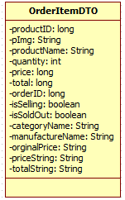

This class was used to contain the attributes of order single item.

**Attribute**

|  |  |  |  |
| --- | --- | --- | --- |
| **Parameter** | **Type** | **Visibility** | **Description** |
| **productID** | long | private | Id of product |
| **pImg** | String | private | Image icon of product |
| **price** | Long | private | Price of product |
| **total** | long | private | Total of all quantity of that product in order |
| **orderID** | long | private | ID of item’s order |
| **quantity** | int | private | Quantity of product |
| **productName** | String | private | Name of Product |
| **isSelling** | boolean | private | Status selling of product |
| **isSoldOut** | boolean | private | Status Sold out of product |
| **categoryName** | String | private | Category Name of product |
| **manufactureName** | String | private | Manufacturer’s Name of product |
| **orginalPrice** | String | private | Original price of Product |
| **totalString** | String | private | Total price in String form format |

##### **OrderHistoriesDTO**

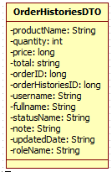

This class was used to contain the attributes of order histories detail, it is a viewable object to show information of order histories.

**Attribute**

|  |  |  |  |
| --- | --- | --- | --- |
| **Parameter** | **Type** | **Visibility** | **Description** |
| **productName** | String | private | The name of products |
| **quantity** | Integer | private | Quantity of products |
| **price** | long | private | Price of product |
| **total** | String | private | Total of all product in order |
| **orderID** | long | private | ID of order |
| **orderHistoriesID** | long | private | ID Histories of order |
| **username** | String | private | Username of making change user |
| **fullname** | String | private | Fullname of making change user |
| **statusName** | String | private | Changed Status Name of order |
| **note** | String | private | Note of user who make change |
| **updateDate** | String | private | Date update status in String form format |
| **roleName** | String | private | Role name of user who make change |

##### **ProductCommentDTO**

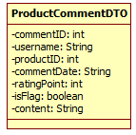

This class was used to contain the attributes of Comment.

**Attribute**

|  |  |  |  |
| --- | --- | --- | --- |
| **Parameter** | **Type** | **Visibility** | **Description** |
| **commentID** | Integer | private | Comment ID |
| **Username** | String | private | Username who is author of comment |
| **productID** | Integer | private | ID of commented product |
| **ratingPoint** | Integer | private | Rating for product included with comment |
| **isFlag** | Boolean | private | Flag status of comment |
| **content** | String | private | Content of comment |

##### **MessageDTO**

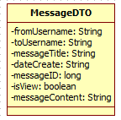

This class was used to contain the attributes of message information.

**Attribute**

|  |  |  |  |
| --- | --- | --- | --- |
| **Parameter** | **Type** | **Visibility** | **Description** |
| **fromUsername** | String | private | User that send message |
| **toUsername** | String | private | User that receipt message |
| **messageTitle** | String | private | Title of message |
| **dateCreate** | String | private | Date that message was created |
| **messageID** | long | private | Id of message |
| **isView** | boolean | private | Message was viewed or not |
| **messageContent** | String | private | Content of Message |

##### **MessageContentDTO**

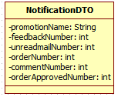

This class was used to contain the attributes of Notification content

**Attribute**

|  |  |  |  |
| --- | --- | --- | --- |
| **Parameter** | **Type** | **Visibility** | **Description** |
| **promotionName** | String | private | Name of current promotion |
| **feedbackNumber** | Integer | private | Number of feedback waiting for response |
| **unreadmailNumber** | Integer | private | Number of unread internal mail box |
| **orderNumber** | Integer | private | Number of order waiting for approve |
| **orderApprovedNumber** | Integer | private | Number of approved orders |
| **commentNumber** | Integer | private | Number of flaged comment waiting for handling |

##### **FeedbackDTO**

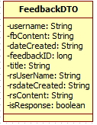

This class was used to contain the attributes of feedback information to manage feedbacks.

**Attribute**

|  |  |  |  |
| --- | --- | --- | --- |
| **Parameter** | **Type** | **Visibility** | **Description** |
| **username** | String | private | User name of the person that send feedback |
| **fbContent** | String | private | Content of feedback |
| **dateCreated** | String | private | Date that feedback was created |
| **feedbackID** | long | private | Id of feedback |
| **title** | String | private | Title of feedback |
| **rsUserName** | String | private | Username of response user |
| **rsdateCreated** | String | private | Response date Created |
| **rsContent** | String | private | Response content |
| **isResponse** | boolean | private | Status of feedback |

##### **ReportDTO**

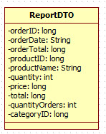

This class was used to contain the attributes of report information.

**Attribute**

|  |  |  |  |
| --- | --- | --- | --- |
| **Parameter** | **Type** | **Visibility** | **Description** |
| **orderID** | long | private | Id of order |
| **orderDate** | String | private | Date of making order |
| **updateDate** | String | private | Date updated order |
| **orderTotal** | long | private | Total price of order |
| **productID** | long | private | Id of product |
| **productName** | String | private | Name of product |
| **quantity** | Integer | private | Quantity of product |
| **price** | long | private | Price of product |
| **total** | long | private | Total of product item |
| **quantityOrder** | Int | Private | Total quatity of order |
| **categoryID** | Long | Private | ID of category |

##### **ReportViewDTO**

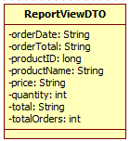

This class was used to contain the attributes of report view object; it is a viewable object to show information of report View.

**Attribute**

|  |  |  |  |
| --- | --- | --- | --- |
| **Parameter** | **Type** | **Visibility** | **Description** |
| **orderDate** | String | private | Date create order |
| **orderTotal** | String | private | Total price of order in String format |
| **productID** | long | private | Id of product |
| **productName** | String | private | Name of product |
| **price** | String | private | Price of product item in String format |
| **quantity** | Integer | private | Quantity of Product item |
| **total** | String | private | Total of product item in string format |
| **totalOrders** | Integer | private | Number of total orders |

##### **OrderStatusDTO**

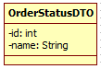

This class’s responsibility is containing data of order status in an object, for transferring from method to method throughout the system.

**Attributes**

|  |  |  |  |
| --- | --- | --- | --- |
| **Attribute** | **Type** | **Visibility** | **Description** |
| **id** | Integer | private | ID of status |
| **name** | String | private | Name of status |

##### **ProductSearchDTO**

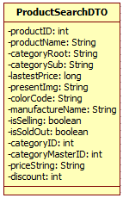

This class’s responsibility is containing data of Product for Search in Backend, for transferring from method to method throughout the system.

**Attributes**

|  |  |  |  |
| --- | --- | --- | --- |
| **Attribute** | **Type** | **Visibility** | **Description** |
| **productID** | long | private | ID of product |
| **productName** | String | private | Name of product |
| **categoryRoot** | String | private | Root category of product |
| **categorySub** | String | private | Sub category of product |
| **lastestPrice** | long | private | Lastest price of product |
| **presentImg** | String | private | Img of product |
| **colorCode** | String | private | Color code of product |
| **manufactureName** | String | private | Manufacturer name of product |
| **isSelling** | boolean | private | Status selling of product |
| **isSoldOut** | boolean | private | Status sold out of product |
| **categoryID** | int | private | Category ID of item |
| **categoryMasterID** | int | private | Master id category of item |
| **priceString** | String | private | Price in String format of item |
| **discount** | Integer | private | Discount percent of item |

##### **UserProductDTO**

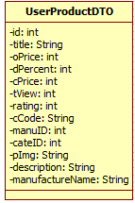

This class’s responsibility is containing data of UserProduct in an object, for transferring from method to method throughout the system.

Attributes

|  |  |  |  |
| --- | --- | --- | --- |
| **Attribute** | **Type** | **Visibility** | **Description** |
| **id** | Integer | private | ID product |
| **title** | String | private | Title of product |
| **oPrice** | long | private | Latest Original Price |
| **dPercent** | Integer | private | Discount Percent |
| **cPrice** | long | private | Current Price(= oPrice if not discount) |
| **tView** | long | private | Total View of product |
| **rating** | double | private | Rating of Product |
| **cCode** | String | private | Color Code of product |
| **manuID** | Integer | private | Manufacture ID of product |
| **cateID** | Integer | private | Category ID of product |
| **pImg** | String | private | Represent Picture of product |
| **description** | String | private | Description of product |
| **manufactureName** | String | private | Manufacturer Name of product |

##### **SubCategoryDTO**

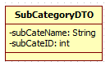

This class’s responsibility is containing data list of Sub Category in an object, for transferring from method to method throughout the system.

Attributes

|  |  |  |  |
| --- | --- | --- | --- |
| **Attribute** | **Type** | **Visibility** | **Description** |
| **subCateName** | String | private | Name of Sub Category |
| **subCateID** | Integer | private | ID of sub category |

##### **RootCategoryDTO**

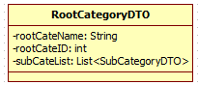

This class’s responsibility is containing data list of Root Category in an object, for transferring from method to method throughout the system.

Attributes

|  |  |  |  |
| --- | --- | --- | --- |
| **Attribute** | **Type** | **Visibility** | **Description** |
| **rootCateName** | String | private | Name of Sub Category |
| **rootCateID** | Integer | private | ID of sub category |
| **subCateList** | List<SubCategoryDTO> | private | List of its sub category |

### Data Access Object

#### Class Diagram

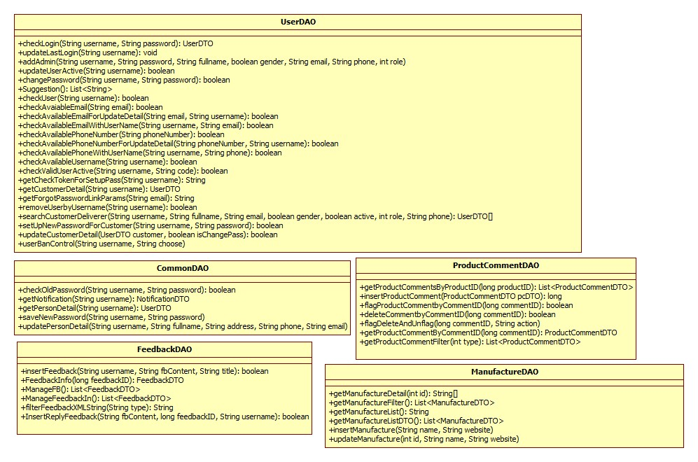

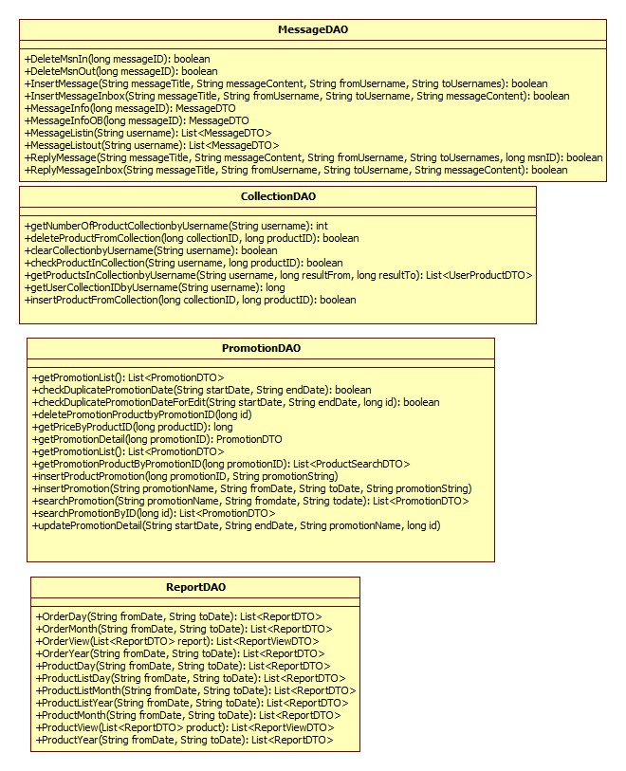

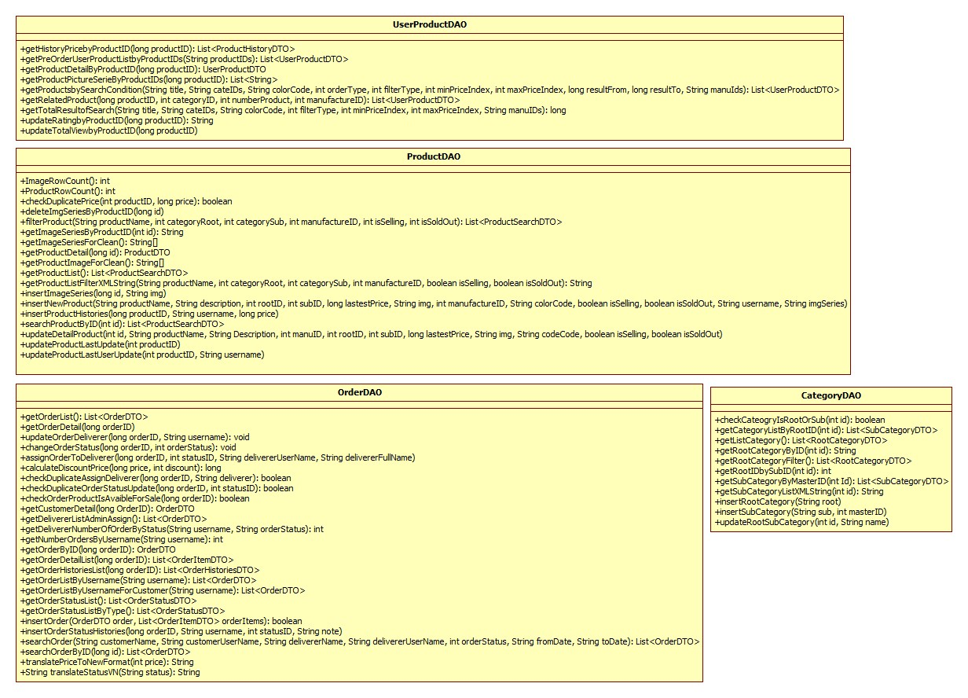

Figure D-60 Class Diagram

#### Class Explanation

##### **ProductDAO**

Responsible for accessing table in database and return desired data in object form

**Attribute**

N/A

**Operation**

void insertNewProduct(String productName, String description, int rootID, int subID, int latestPrice, String img, int manufactureID, String colorCode, boolean isSelling, boolean isSoldOut, String username, String imgSeries)

Insert new product to database

**Parameter and return:**

|  |  |  |
| --- | --- | --- |
| **Parameter** | **Type** | **Description** |
| **productName** | String | Name of product |
| **description** | String | Description of product |
| **rootID** | Integer | Root category of product |
| **subID** | Integer | ID of sub category |
| **latestPrice** | long | Price of product |
| **img** | String | Image icon of product |
| **manufactureID** | Integer | ID of manufacture |
| **colorCode** | String | Color of product |
| **isSelling** | Boolean | Check if product is selling |
| **isSoldOut** | Boolean | Check if product sold out |
| **Username** | String | User who create product |
| **imgSeries** | String | Series image of product |
| **dateCreated** | String | Date created of product |

**void updateDetailProduct(long id, String productName, String Description, int manuID, int rootID, int subID, long lastestPrice, String img, String codeCode, boolean isSelling, boolean isSoldOut)**

Update detail of an exist product

**Parameter and return:**

|  |  |  |
| --- | --- | --- |
| **Parameter** | **Type** | **Description** |
| **id** | Integer | ID of product |
| **productName** | String | Name of product |
| **Description** | String | Description of product |
| **manuID** | Integer | ID of manufacture |
| **rootID** | Integer | ID of root category |
| **subID** | Integer | ID of sub category |
| **lastestPrice** | long | Price of product |
| **img** | String | Present image of product |
| **colorCode** | String | Color of product |
| **isSelling** | Boolean | Check if product is selling |
| **isSoldOut** | Boolean | Check if product sold out |

**int ImageRowCount()**

Get all image of product in number.

**Parameter and return:**

|  |  |  |
| --- | --- | --- |
| **Parameter** | **Type** | **Description** |
| **return** | Integer | Number of image |

int ProductRowCount()

Get number of all product in database

**Parameter and return:**

|  |  |  |
| --- | --- | --- |
| **Parameter** | **Type** | **Description** |
| **return** | Integer | Number of product |

boolean checkDuplicatePrice(long productID, long price)

Check duplicate price when edit product

**Parameter and return:**

|  |  |  |
| --- | --- | --- |
| **Parameter** | **Type** | **Description** |
| **productID** | Long | Product ID |
| **price** | Long | Price of product |
| **return** | boolean | Check status |

void deleteImgSeriesByProductID(long id)

Delete all image of product by its id

**Parameter and return:**

|  |  |  |
| --- | --- | --- |
| **Parameter** | **Type** | **Description** |
| id | long | ID of product |

List< ProductSearchDTO > filterProduct(String productName, int categoryRoot, int categorySub, int manufactureID, int isSelling, int isSoldOut)

Get list of product by filter

**Parameter and return:**

|  |  |  |
| --- | --- | --- |
| **Parameter** | **Type** | **Description** |
| **productName** | String | Name of product |
| **categoryRoot** | Integer | Category root ID |
| **categorySub** | Integer | Category sub ID |
| **isSelling** | boolean | Status selling of product |
| **isSoldOut** | boolean | Status sold out of product |
| **return** | List<ProductSearchDTO > | List of result product |

List<ProductSearchDTO> getProductList()

Get list of product

**Parameter and return:**

|  |  |  |
| --- | --- | --- |
| **Parameter** | **Type** | **Description** |
| **return** | List< ProductSearchDTO > | List of product |

String[] getProductImageForClean() (Optional)

ProductDTO getProductDetail(long id) (Optional)

String getProductListFilterXMLString(String productName, int categoryRoot, int categorySub, int manufactureID, boolean isSelling, boolean isSoldOut)

Get product List for filter into XML String

**Parameter and return:**

|  |  |  |
| --- | --- | --- |
| **Parameter** | **Type** | **Description** |
| **productName** | String | Name of product |
| **categoryRoot** | Integer | Root category of product |
| **categorySub** | Integer | Sub category of product |
| **manufactureID** | Integer | ID of manufacture |
| **isSelling** | boolean | Status selling of product |
| **isSoldOut** | boolean | Status sold out of product |
| **return** | String | XML String of products |

**void insertImageSeries(long id, String img) (Optional)**

void insertProductHistories(long productID, String username, int price) (Optional)

List<ProductSearchDTO> searchProductByID(long id) (Optional)

void updateProductLastUpdate(long productID) (Optional)

void updateProductLastUserUpdate(int productID, String username) (Optional)

##### **OrderDAO**

Responsible for accessing table in database for handling Order

**Attribute**

N/A

**Operation**

List<OrderDTO> getOrderList()

Get list of order

**Parameter and return:**

|  |  |  |
| --- | --- | --- |
| **Parameter** | **Type** | **Description** |
| **return** | List<OrderDTO> | List of order |

OrderDTO getOrderDetail(long orderID)

Get order detail

**Parameter and return:**

|  |  |  |
| --- | --- | --- |
| **Parameter** | **Type** | **Description** |
| **return** | OrderDTO | Order detail |

boolean insertOrder(OrderDTO order, List<OrderItemDTO> orderItems)

Insert an order

**Parameter and return:**

|  |  |  |
| --- | --- | --- |
| **Parameter** | **Type** | **Description** |
| **order** | OrderDTO | Order object |
| **orderItems** | List<OrderItemDTO> | List items in order |
| **return** | boolean | Result of insert process |

void updateOrderDeliverer(int orderID, String username)

Change deliverer of order

**Parameter and return:**

|  |  |  |
| --- | --- | --- |
| **Parameter** | **Type** | **Description** |
| **orderID** | Integer | ID of order |
| **username** | String | Username |

List<OrderDTO> searchOrder(String customerName, String customerUserName, String delivererName, String delivererUserName, int orderStatus, String fromDate, String toDate): List<OrderDTO>

Search order

**Parameter and return:**

|  |  |  |
| --- | --- | --- |
| **Parameter** | **Type** | **Description** |
| **createdDate** | String | Created date of order |
| **customerName** | String | Name of customer |
| **delivererUsername** | String | Name of deliverer |
| **orderStatus** | Integer | Status ID of order |
| **fromDate** | String | From date |
| **toDate** | String | To Date |
| **return** | List<OrderDTO> | Order detail |

void changeOrderStatus(long orderID, int orderStatus)

Change order status

**Parameter and return:**

|  |  |  |
| --- | --- | --- |
| **Parameter** | **Type** | **Description** |
| **orderID** | long | ID of order |
| **orderStatus** | Integer | Status of order |

void assignOrderToDeliverer(long orderID, int statusID, String delivererUserName, String delivererFullName)

Assign Order to Deliverer

**Parameter and return:**

|  |  |  |
| --- | --- | --- |
| **Parameter** | **Type** | **Description** |
| **orderID** | String | ID of order |
| **statusID** | Integer | Status id |
| **delivererUserName** | String | Username of deliverer |
| **delivererFullName** | String | Full name of deliverer |

##### **PromotionDAO**

Responsible for accessing table in database to handle promotion functions

**Attribute**

N/A

**Operation**

**List<PromotionDTO> getPromotionList()**

Get list of Promotions

**Parameter and return:**

|  |  |  |
| --- | --- | --- |
| **Parameter** | **Type** | **Description** |
| **return** | List<PromotionDTO> | List of Promotion |

PromotionDTO getPromotionDetail(long promotionID)

Get product promotion details

**Parameter and return:**

|  |  |  |
| --- | --- | --- |
| **Parameter** | **Type** | **Description** |
| **promotionID** | long | ID of promotion |
| **return** | PromotionDTO | Promotion detail object |

insertProductPromotion(long promotionID, String promotionString)

Insert new product promotion

**Parameter and return:**

|  |  |  |
| --- | --- | --- |
| **Parameter** | **Type** | **Description** |
| **promotionID** | long | Promotion ID |
| **promotionString** | String | Name of Promotion |

**long getPriceByProductID(long productID)**

Get price of product

**Parameter and return:**

|  |  |  |
| --- | --- | --- |
| **Parameter** | **Type** | **Description** |
| **productID** | long | Product ID |
| **return** | long | Price of product |

**List<ProductSearchDTO> getPromotionProductByPromotionID(long promotionID)**

Get promotion Products by promotion ID

**Parameter and return:**

|  |  |  |
| --- | --- | --- |
| **Parameter** | **Type** | **Description** |
| **promotionID** | long | Promotion ID |
| **return** | List<ProductSearchDTO> | Return result of product in promotion |

**updatePromotionDetail(String startDate, String endDate, String promotionName, long id)**

Update detail of promotion

**Parameter and return:**

|  |  |  |
| --- | --- | --- |
| **Parameter** | **Type** | **Description** |
| **startDate** | String | Start date of promotion |
| **endDate** | String | End date of promotion |
| **promotionName** | String | Name of promotion |

**deletePromotionProductbyPromotionID(long id)**

delete promotion Product

**Parameter and return:**

|  |  |  |
| --- | --- | --- |
| **Parameter** | **Type** | **Description** |
| **id** | long | Promotion ID |

**boolean checkDuplicatePromotionDateForEdit(String startDate, String endDate, long id)**

Check duplicates Promotion Date for Edit promotion

**Parameter and return:**

|  |  |  |
| --- | --- | --- |
| **Parameter** | **Type** | **Description** |
| **startDate** | String | Start Date of promotion |
| **endDate** | String | End Date of promotion |
| **return** | boolean | Return check result |

**List<PromotionDTO> searchPromotion(String promotionName, String fromdate, String todate)**

Search promotion in date range

**Parameter and return:**

|  |  |  |
| --- | --- | --- |
| **Parameter** | **Type** | **Description** |
| **promotionName** | String | Name of promotion |
| **fromdate** | String | Date begin range |
| **todate** | String | Date end range |
| **return** | List<PromotionDTO> | Return results search action |

##### **ManufactureDAO (optinal)**

Responsible for accessing table and handle Manufacture related functions manipulate with database

##### **UserDAO (optional)**

Responsible for accessing table and handle User related functions manipulate with database

##### **MessageDAO (optinal)**

Responsible for accessing table and handle Message related functions manipulate with database

##### **FeedbackDAO (optional)**

Responsible for accessing table and handle Feedback related functions manipulate with database

##### **ProductCommentDAO (optional)**

Responsible for accessing table and handle Comment related functions manipulate with database

##### **CollectionDAO (optional)**

Responsible for accessing table and handle Collection related functions manipulate with database

##### **CategoryDAO (optional)**

Responsible for accessing table and handle Category related functions manipulate with database

##### **ReportDAO (optional)**

Responsible for accessing table and handle Report related functions manipulate with database

##### **CommonDAO (optional)**

Responsible for accessing table and supporting other DAOs

##### **UserProductDAO (optional)**

Responsible for accessing table and handle User Product related functions manipulate with database

### Business Logic Object (Optional)

#### Class Diagram (Optional)

#### Class Diagram Explanation (Optional)

##### **ProductBLO (Optional)**

##### **OrderBLO(Optional)**

##### **PromotionBLO(Optional)**

##### **ManufactureBLO(Optional)**

##### **CategoryBLO(Optional)**

##### **MessageBLO(Optional)**

##### **FeedbackBLO(Optional)**

##### **CommonBLO(Optional)**

##### **UserProductBLO(Optional)**

##### **CollectionBLO(Optional)**

##### **ProductCommentBLO(Optional)**

##### **CollectionBLO(Optional)**

##### **UserBLO(Optional)**

##### **ReportBLO(Optional)**

### Sequence Diagram

#### <Customer> Search Product

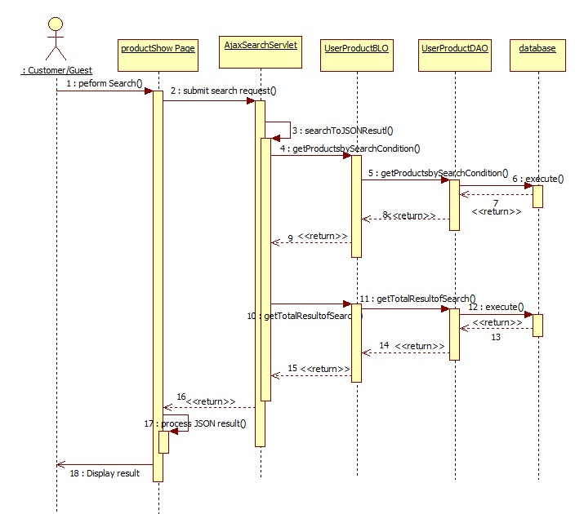

Figure D-61 Customer Search Product Sequence

#### <Customer>Add to collection

This is basic function and not detailed here

Summary: Customer use this function to add items to collection

#### <Customer>Making Order

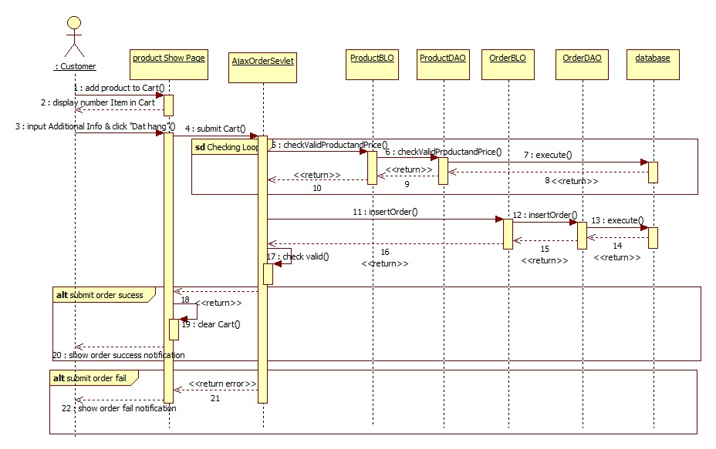

Figure D-62 Customer Add to collection

#### <Customer>Remove Product from Collection

This is basic function and not detailed here

Summary: Admin use this function to remove product from their collection

#### <Customer>View Orders

This is basic function and not detailed here

Summary: Customer use this function to view their orders

#### <Customer>Post Comment

This is basic function and not detailed here

Summary: Customer use this function post a comment

#### <Admin>Edit Category

This is basic function and not detailed here

Summary: Admin use this function to edit category

#### <Admin>Delete Category

This is basic function and not detailed here

Summary: Admin use this function to add new category

#### <Admin>Add Category

This is basic function and not detailed here

Summary: Admin use this function to add new category

#### <Admin>Add Manufacture

This is basic function and not detailed here

Summary: Admin use this function to add new category

#### <Admin>Edit Manufacture

This is basic function and not detailed here

Summary: Admin use this function to add new category

#### <Admin>Delete Manufacture

This is basic function and not detailed here

Summary: Admin use this function to add new category

#### <Admin>Add Product

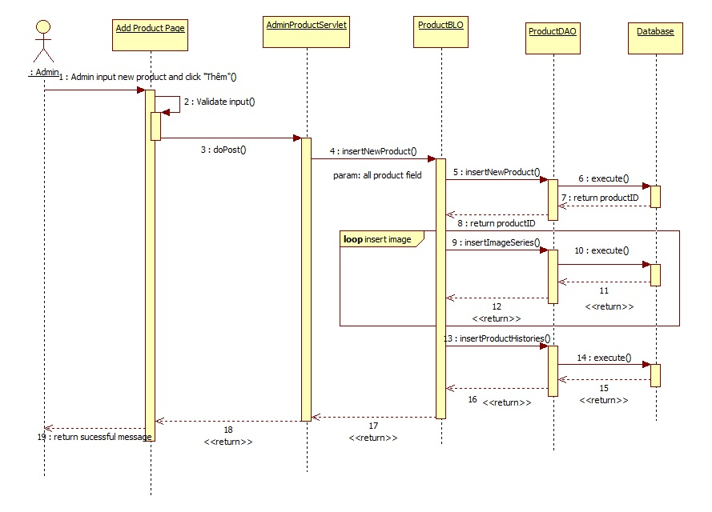

Figure D-63 Admin Add Product Sequence

#### <Admin>Edit Product

This function is similar to add product

Summary: Admin use this function edit product

#### <Admin>Add Promotion

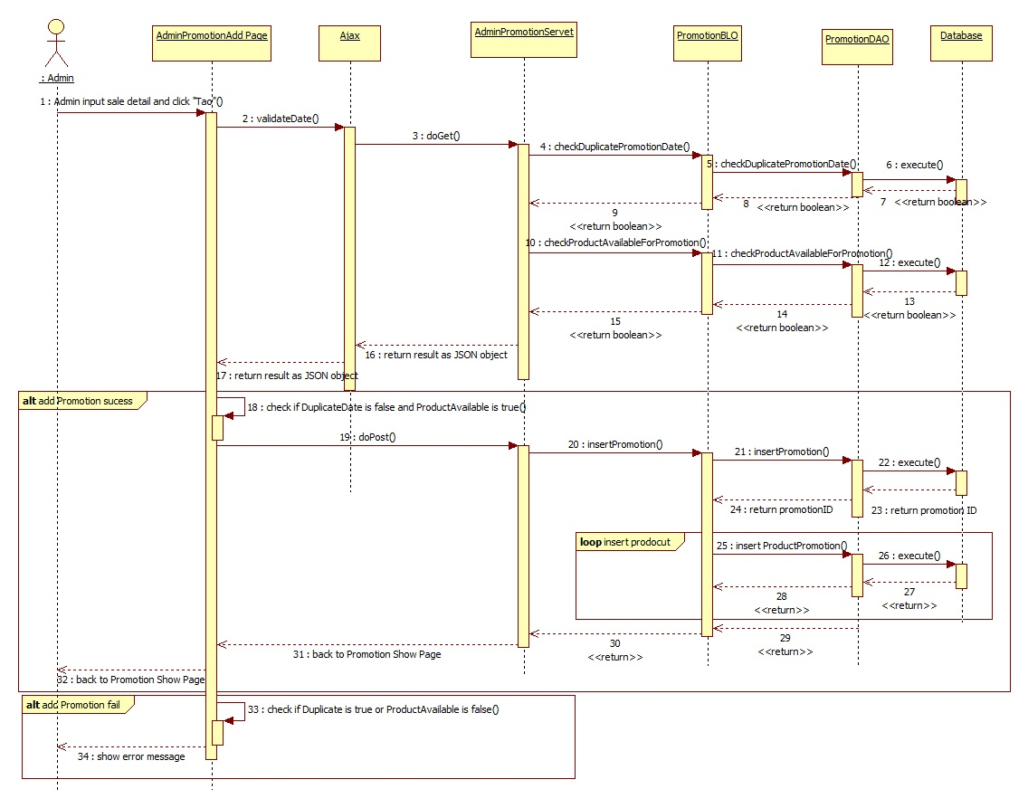

#### <Admin>Edit Promotion

This function is similar to Add Product

Summary: Admin use this function to edit promotion

#### <Admin>Export PDF

This is basic function and not detailed here

Summary: Admin use this function to export order detail as PDF

#### <Admin>View Order

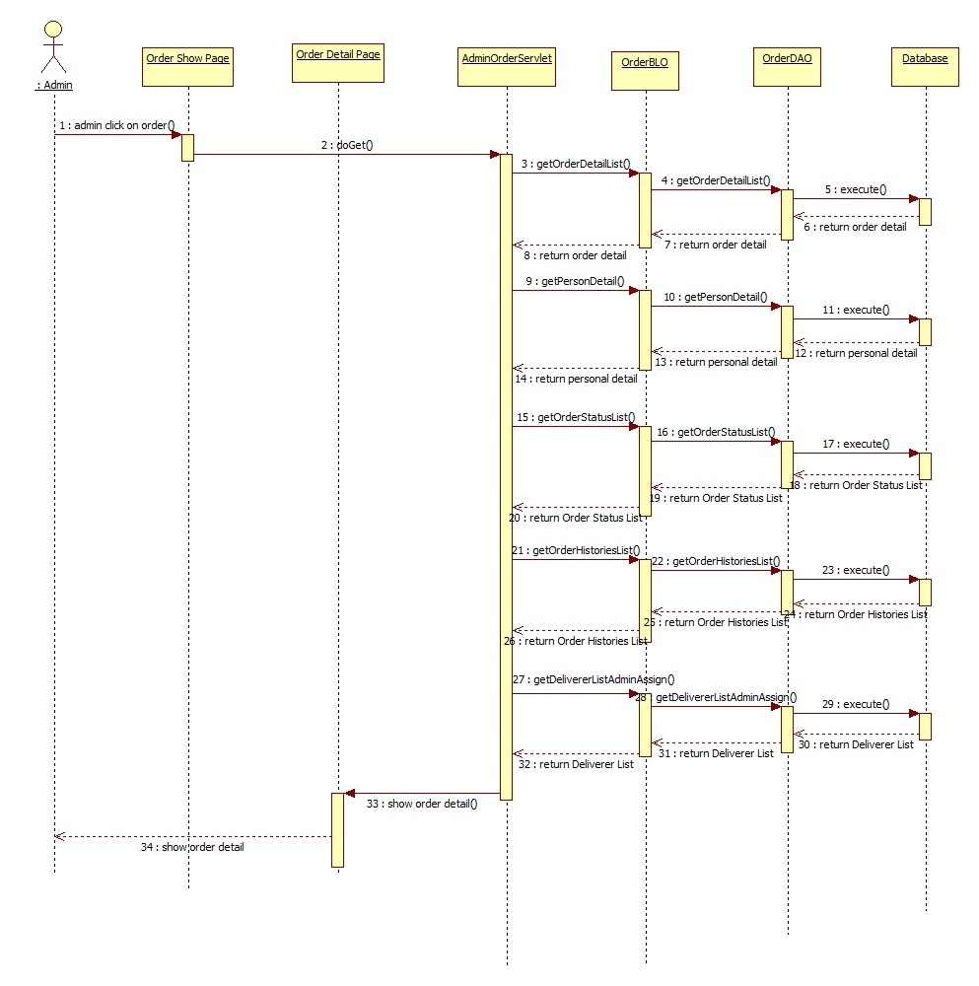

Figure D-64 Admin View Order Sequence

#### <Admin>Assign Order

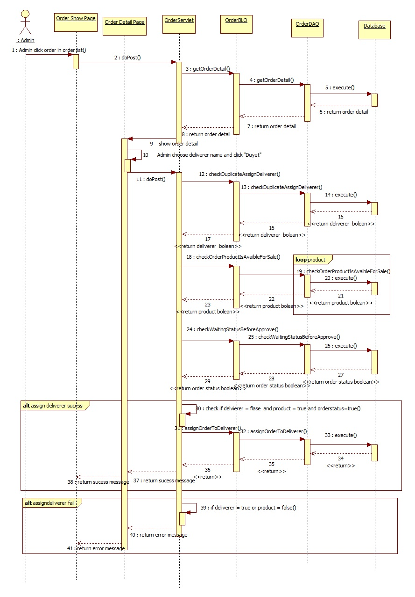

Figure D-65 Admin Assign Order Sequence

#### <Admin>Change Order Status

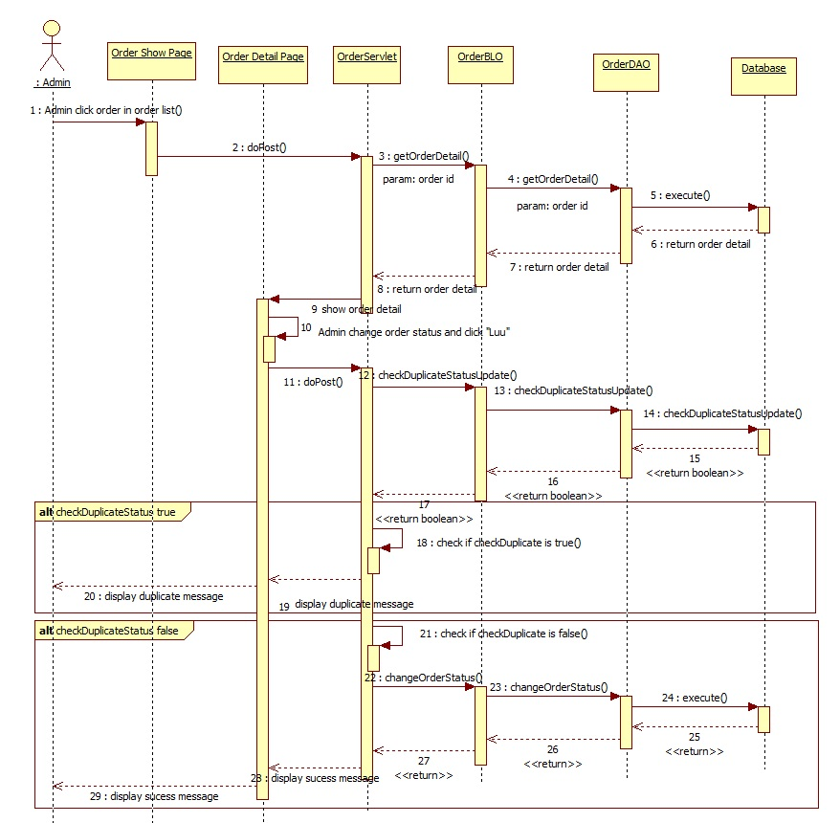

Figure D-66 Admin Change Order Status Sequence

#### <Admin>Reply Feedback

This is basic function and not detailed here

Summary: Admin use this function to reply feedback to customer

#### <Admin>Search Product

This is basic function and not detailed here

Summary: Admin use this function to search product

#### <Admin>Search Promotion

This is basic function and not detailed here

Summary: Admin use this function to search promotion

#### <Admin>Set Account Status

This is basic function and not detailed here

Summary: Admin use this function to change account status

#### <Admin>Show notification

This is basic function and not detailed here

Summary: Admin use this function to view notification

#### <Admin>Filter comment

This is basic function and not detailed here

Summary: Admin use this function to filter comment by status (Tất cả, bị đánh dấu)

#### <Admin>Delete comment

This is basic function and not detailed here

Summary: Admin use this function to delete a comment

#### <Admin> Unflag comment

This is basic function and not detailed here

Summary: Admin use this function to unflag a comment

#### <Admin>View Feedback

This is basic function and not detailed here

Summary: Admin use this function to view feedback detail

#### <Boss>Add Admin

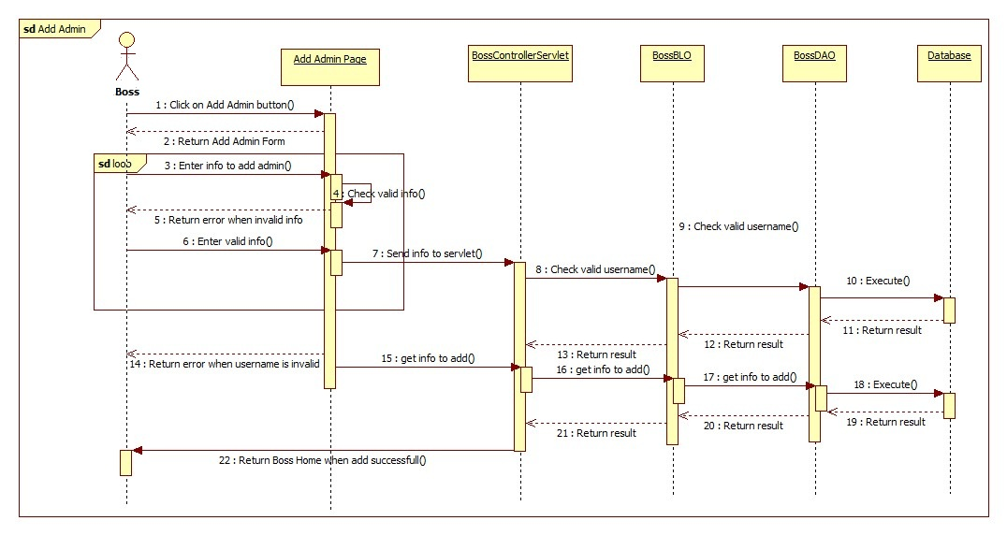

Figure D-67 Boss Add Admin Sequence

#### <Boss>View Account List

This is basic function and not detailed here

Summary: Boss use this function to view list of account

#### <Boss> View Report

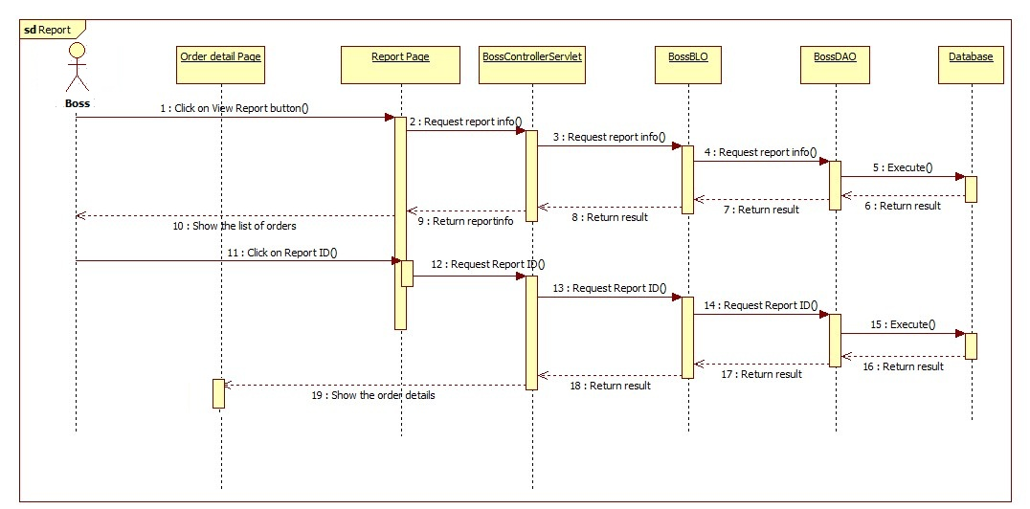

Figure D-68 Boss View Report

#### <Boss>View Feedback

This is basic function and not detailed here

Summary: Boss use this function to view a feedback

#### <Staff>Delete Message

This is basic function and not detailed here

Summary: Staff use this function to delete a message

#### <Staff>View Message

This is basic function and not detailed here

Summary: Staff use this function to view a message

#### <Staff>Send Message

This is basic function and not detailed here

Summary: Staff use this function to send a message

#### <Deliverer>Change Order Status

This is basic function and not detailed here

Summary: Deliverer use this function to change order status

#### <Deliverer>View Order Detail

This is basic function and not detailed here

Summary: Deliverer use this function to view order detail

## Database Design

### Database Diagram

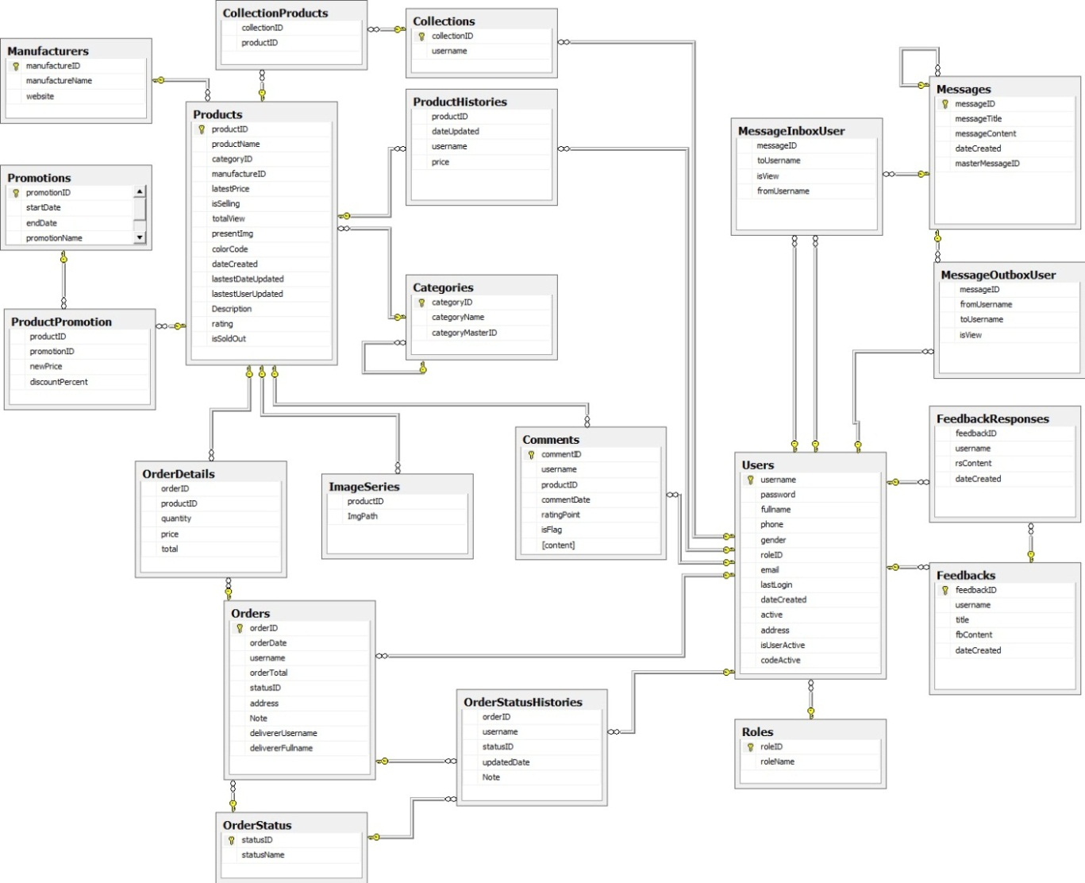

Figure D-69 Database Diagram

### Tables

|  |  |
| --- | --- |
| **Table Name** | **Description** |
| Products | Store detail of product |
| Manufacturers | Store detail of manufacturer |
| Promotions | Store detail of promotion |
| ProductPromotion | Store list of product use in promotion |
| OrderDetails | Store list of product which customer ordered |
| Orders | Store detail of order |
| Collection Products | Store detail customer’s favored products list |
| ImageSeries | Store image series of product |
| OrderStatus | Store list of status of order |
| Collections | Store customer’s product collection |
| Product Histories | Store update histories of product |
| Categories | Store detail of category |
| Comments | Store user’s comment |
| OrderStatusHistories | Store order change histories |
| Message Inbox User | Store message of user |
| MessageOutboxUser | Store message of user outbox |
| Messages | Store detail of message |
| FeedbackResponses | Store feedback response content |
| Users | Store detail of user |
| Roles | Store detail of role |

Table D-6 Database Table List

### Table Detail

#### Categories Table

|  |  |  |  |  |  |
| --- | --- | --- | --- | --- | --- |
| **Column Name** | **Type** | **Null** | **Unique** | **P/F Key** | **Description** |
| categoryID | int |  | X | PK,FK | ID of category |
| categoryName | nvarchar(50) |  |  |  | Name of category |
| categoryMasterID | Boolean | X |  |  | ID of master category |

Table D-7 Categories

#### CollectionProducts Table

|  |  |  |  |  |  |
| --- | --- | --- | --- | --- | --- |
| **Column Name** | **Type** | **Null** | **Unique** | **P/F Key** | **Description** |
| collectionID | bigint |  | X | FK | Id of collection |
| productID | bigint |  |  | FK | Id of product |

Table D-8 CollectionProducts

#### Collections Table

|  |  |  |  |  |  |
| --- | --- | --- | --- | --- | --- |
| **CoColumn Name** | **Type** | **Null** | **Unique** | **P/F Key** | **Description** |
| collectionID | bigint |  | X | PK/FK | Id of collection |
| username | varchar(20) |  |  |  | Username of user |

Table D-9 Collections

#### Comments Table

|  |  |  |  |  |  |
| --- | --- | --- | --- | --- | --- |
| **CoColumn Name** | **Type** | **Null** | **Unique** | **P/F Key** | **Description** |
| commentID | bigint |  | X | PK/FK | Id of comment |
| username | varchar(20) |  |  |  | Username of user |
| productID | bigint |  |  | FK | Id of product |
| commentDate | smalldatetime |  |  |  | Datemade comment |
| ratingPoint | decimal(3, 1) | X |  |  | Point of rating |
| isFlag | bit |  |  |  | Status of bad comment |
| [content] | nvarchar(150) |  |  |  | Content of comment |

Table D-10 Comments

#### FeedbackResponses Table

|  |  |  |  |  |  |
| --- | --- | --- | --- | --- | --- |
| **CoColumn Name** | **Type** | **Null** | **Unique** | **P/F Key** | **Description** |
| feedbackID | bigint |  |  | FK | Id of feedback |
| username | varchar(20) |  |  |  | Username of user |
| rsContent | nvarchar(300) |  |  |  | Content of response |
| dateCreated | smalldatetime | X |  |  | Date create comment |

Table D-11 FeedbackResponse

#### Feedbacks Table

|  |  |  |  |  |  |
| --- | --- | --- | --- | --- | --- |
| **CoColumn Name** | **Type** | **Null** | **Unique** | **P/F Key** | **Description** |
| feedbackID | bigint |  | X | PK/FK | Id of feedback |
| username | varchar(20) |  |  |  | Username of user |
| title | nvarchar(70) |  |  |  | Title of feedback |
| fbContent | nvarchar(400) |  |  |  | Content of feedback |
| dateCreated | smalldatetime | X |  |  | Date created feedback |

Table D-12 Feedbacks

#### ImageSeries Table

|  |  |  |  |  |  |
| --- | --- | --- | --- | --- | --- |
| **CoColumn Name** | **Type** | **Null** | **Unique** | **P/F Key** | **Description** |
| productID | bigint |  |  | FK | Id of product |
| ImgPath | nvarchar(80) |  |  |  | Image name of image |

Table D-13 ImageSeries

#### Manufactures Table

|  |  |  |  |  |  |
| --- | --- | --- | --- | --- | --- |
| **Column Name** | **Type** | **Null** | **Unique** | **P/F Key** | **Description** |
| manufactureID | int |  | X | PK/FK | Id of manufacture |
| manufactureName | nvarchar(100) |  |  |  | Name of manufacture |
| website | nvarchar(100) | X |  |  | Website of manufacture |

Table D-14 Manufacture

#### MessageInboxUser Table

|  |  |  |  |  |  |
| --- | --- | --- | --- | --- | --- |
| **CoColumn Name** | **Type** | **Null** | **Unique** | **P/F Key** | **Description** |
| messageID | bigint |  |  | FK | Id of message |
| fromUsername | varchar(20) |  |  |  | Username of author of message |
| toUsername | varchar(20) |  |  |  | Username of receiver |
| isView | bit |  |  |  | Message viewed or not |

Table D-15 MessageInboxUser

#### MessageOutboxUser Table

|  |  |  |  |  |  |
| --- | --- | --- | --- | --- | --- |
| **CoColumn Name** | **Type** | **Null** | **Unique** | **P/F Key** | **Description** |
| messageID | bigint |  |  | FK | Id of message |
| fromUsername | varchar(20) |  |  |  | Username of author of message |
| toUsername | varchar(20) |  |  |  | String of username of receivers |
| isView | bit |  |  |  | Message viewed or not |

Table D-16 MessageOutboxUser

#### Messages Table

|  |  |  |  |  |  |
| --- | --- | --- | --- | --- | --- |
| **CoColumn Name** | **Type** | **Null** | **Unique** | **P/F Key** | **Description** |
| messageID | bigint |  | X | PK/FK | ID of message |
| messageTitle | nvarchar(80) |  |  |  | Title of message |
| messageContent | nvarchar(MAX) |  |  |  | Content of message |
| dateCreated | smalldatetime | X |  |  | Date created message |
| masterMessageID | bigint |  |  |  | Master ID message if this is a reply message |

Table D-17 Messages

#### OrderDetails Table

|  |  |  |  |  |  |
| --- | --- | --- | --- | --- | --- |
| **CoColumn Name** | **Type** | **Null** | **Unique** | **P/F Key** | **Description** |
| orderID | bigint |  | X | PK/FK | Id of order |
| productID | bigint |  |  | FK | Id of product |
| quantity | int |  |  |  | Quantity of detail item |
| price | bigint |  |  |  | Price of detail item |
| total | bigint |  |  |  | Total of detail |

Table D-18 OrderDetails

#### Orders Table

|  |  |  |  |  |  |
| --- | --- | --- | --- | --- | --- |
| **CoColumn Name** | **Type** | **Null** | **Unique** | **P/F Key** | **Description** |
| orderID | bigint |  |  | PK/FK | Id of order |
| orderDate | smalldatetime |  |  |  | Date created order |
| username | varchar(20) |  |  |  | Username of orderer |
| orderTotal | bigint |  |  |  | Total price of order |
| statusID | int |  |  | FK | Status id of order |
| address | nvarchar(100) | X |  |  | Address of order |
| Note | nvarchar(200) | X |  |  | Note of order |
| delivererUsername | varchar(20) |  |  |  | Username of deliverer |
| delivererFullname | nvarchar(50) |  |  |  | Fullname of deliverer |

Table D-19 Orders

#### OrderStatus Table

|  |  |  |  |  |  |
| --- | --- | --- | --- | --- | --- |
| **CoColumn Name** | **Type** | **Null** | **Unique** | **P/F Key** | **Description** |
| statusID | int |  | X | PK/FK | Id of status |
| statusName | varchar(30) |  |  |  | Name of status |

Table D-20 OrderStatus

#### OrderStatusHistories Table

|  |  |  |  |  |  |
| --- | --- | --- | --- | --- | --- |
| **CoColumn Name** | **Type** | **Null** | **Unique** | **P/F Key** | **Description** |
| orderID | bigint |  |  | FK | ID of order |
| username | varchar(20) |  |  |  | Username of changer |
| statusID | int |  |  | FK | Status ID changer |
| updatedDate | datetime | X |  |  | Update Date |
| Note | nvarchar(200) | X |  |  | Note changed |

Table D-21 OrderStatusHistories

#### ProductHistories Table

|  |  |  |  |  |  |
| --- | --- | --- | --- | --- | --- |
| **CoColumn Name** | **Type** | **Null** | **Unique** | **P/F Key** | **Description** |
| productID | bigint |  |  | FK | Id of product |
| dateUpdated | datetime | X |  |  | Date update |
| username | varchar(20) |  |  |  | Username of changer |
| price | bigint |  |  |  | New Price |

Table D-22 ProductHistories

#### ProductPromotion Table

|  |  |  |  |  |  |
| --- | --- | --- | --- | --- | --- |
| **CoColumn Name** | **Type** | **Null** | **Unique** | **P/F Key** | **Description** |
| productID | bigint |  |  | FK | Id of product |
| promotionID | bigint |  |  | FK | Id of promotion |
| newPrice | bigint |  |  |  | New Price after calculate discount percent |
| discountPercent | int |  |  |  | discountPercent |

Table D-23 ProductPromotion

#### Products Table

|  |  |  |  |  |  |
| --- | --- | --- | --- | --- | --- |
| **CoColumn Name** | **Type** | **Null** | **Unique** | **P/F Key** | **Description** |
| productID | bigint |  | X | PK/FK | Id of product |
| productName | nvarchar(100) |  |  |  | Name of product |
| categoryID | int |  |  | FK | Id of category |
| manufactureID | int |  |  | FK | Id of manufacture |
| latestPrice | bigint |  |  |  | latestPrice of product |
| isSelling | bit |  |  |  | Status of Selling |
| totalView | bigint |  |  |  | Total view of user |
| presentImg | nvarchar(255) |  |  |  | presentImg icon |
| colorCode | nvarchar(MAX) |  |  |  | Color Code |
| dateCreated | smalldatetime | X |  |  | Date Created product |
| lastestDateUpdated | smalldatetime | X |  |  | Lastest date update |
| lastestUserUpdated | varchar(20) | X |  |  | Lastest date update |
| Description | nvarchar(MAX) | X |  |  | Decription of product |
| rating | decimal(3, 1) | X |  |  | Rating of product |
| isSoldOut | bit |  |  |  | Sold out status |

Table D-24 Products

#### Promotions Table

|  |  |  |  |  |  |
| --- | --- | --- | --- | --- | --- |
| **CoColumn Name** | **Type** | **Null** | **Unique** | **P/F Key** | **Description** |
| promotionID | bigint |  | X | PK/FK | Id of promotion |
| promotionName | Nvarchar(50) |  |  |  | Name of promotion |
| startDate | smalldatetime |  |  |  | Start Date |
| endDate | smalldatetime |  |  |  | End Date |

Table D-25 Promotions

#### Roles Table

|  |  |  |  |  |  |
| --- | --- | --- | --- | --- | --- |
| **CoColumn Name** | **Type** | **Null** | **Unique** | **P/F Key** | **Description** |
| roleID | int |  | X | PK/FK | Id of role |
| roleName | varchar(10) |  |  |  | Name of role |

Table D-26 Roles

#### Users Table

|  |  |  |  |  |  |
| --- | --- | --- | --- | --- | --- |
| **CoColumn Name** | **Type** | **Null** | **Unique** | **P/F Key** | **Description** |
| username | varchar(20) |  | X | PK/FK | Username of user |
| password | varchar(50) |  |  |  | Password of user |
| fullname | nvarchar(50) |  |  |  | Fullname of user |
| phone | varchar(20) | X |  |  | Phone of user |
| gender | bit |  |  |  | Gender of user |
| roleID | int |  |  | FK | Id of role |
| email | nvarchar(50) | X |  |  | Email of user |
| lastLogin | smalldatetime |  |  |  | Last time login |
| dateCreated | smalldatetime |  |  |  | Date Created |
| active | bit |  |  |  | Active status |
| address | nvarchar(200) | X |  |  | Address of user |
| isUserActive | bit |  |  |  | User active status |
| codeActive | Varchar(50) |  |  |  | Code Active |

Table D-27 Users

## Page Flow diagram

### Customer/Guest page flow

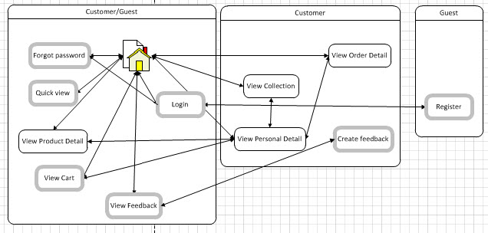

Figure D-70 Customer/Guest Page Flow

### Staff page flow

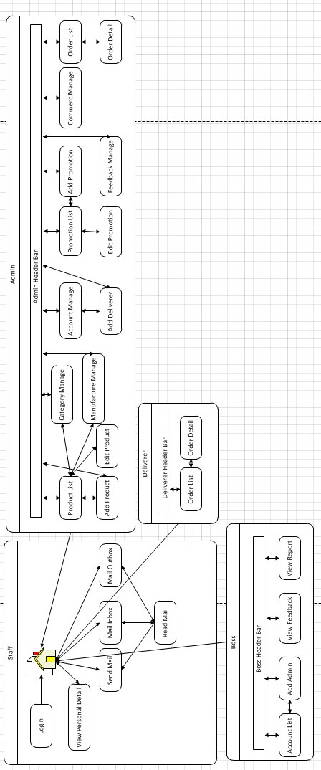

Figure D-71 Staff Page Flow

### Access right

* Everyone can access page in "Customer/Guest" group without logged into the system
* Guest after logged into the system will become customer and can access to pages in "Customer" group and "Customer/Guest" group except register page (only for guest)
* Staff inlcude: boss, admin, deliverer
* User after logged into management site, they become Staff and can access to all pages in "Staff" group
* User logged into system with role boss can access pages in "Staff" and "Boss" group
* User logged into system with role admin can access pages in "Staff" and "Admin" group
* User logged into system with role deliverer can access pages in "Staff" and "Deliverer" group

# Software Test Document

## Introduction

### System Overview

* This document describes plan and methodologies used in testing stage, an important step for grading the quality of product before packaging it. Testing group would plan, manage and execute the process of testing. Testers must execute and pass all test cases and technical details of system features.
* The testing group is also the coding group of E-Fashion. The system is developed based on three-tier architecture with J2EE web application framework.

### Test Approach

* Test approach defines goal and scope of system testing, overall strategy to be adopted, activities to be completed, general resources required, methods and processes to be used for testing. It also describes activities, dependencies and effort required to conduct system testing.
* The goal of testing is finding out remaining bugs, telling developing team about those bugs, and they will fix it before releasing. All members would participate in testing the system. This phase will use localhost as hosting for executing testing process.
* The process of testing stage includes Unit Testing, Component Testing, Integration Testing and System Testing levels. Unit Testing uses white box method, while the other levels uses black box. However, this document only includes features which are in System Testing. There is at least one time to do Systems Testing by outside people who are not member of the developing team. The testing team and outside people do all testing work before the project manager executes the final test.

## Test Plan

### Feature to be tested

#### <Guest/Customer> Search by Title

Test if customer or guest can search product by product name

#### <Guest/Customer> Search by Category

Test if customer or guest can search product by product category

#### <Guest/Customer> Search by Price

Test if customer or guest can search product by product price

#### <Guest/Customer> Search by Manufacture

Test if customer or guest can search by manufacture

#### <Guest/Customer> Sort Product

Test if customer or guest can sort product by its attribute

#### <Guest/Customer> Filter Product

Test if customer or guest can filter product by its attribute

#### <Guest/Customer> Search by Color

Test if customer or guest can search product by product color

#### <Guest/Customer> View Product Detail

Test if customer or guest can view product detail

#### <Guest> Register

Test if guest can register new account

#### <Guest/Customer> Add To Cart

Test if customer or guest can add product to their cart

#### <Customer> Comment/Rating Product

Test if customer can comment and rating specific product

#### <Guest/Customer> View Current Cart

Test if customer or guest can view their cart

#### <Customer> Submit Cart

Test if customer can submit their cart for ordering

#### <Customer> View User Detail

Test if customer can view their detail

#### <Customer> Update Detail

Test if customer can update their detail

#### <Customer> Add To Collection

Test if customer can add their favorted product to their own collection

#### <Customer>View Collection

Test if customer can view their collection

#### <Customer> Remove from Collection

Test if customer can remove product from their collection

#### <Customer> View History Order

Test if customer can view their histories order

#### <Guest/Customer> Quick View Product

Test if customer or guest can quick view product

#### <Boss> Manage Feedback

Test if boss can view feedback

#### <Boss> Add Admin

Test if boss can add new admin

#### <Boss> View Report

Test if boss can view business report

#### <Staff> Compose Message

Test if staff can compose new message

#### <Staff> View Message

Test if staff can view their message in mail box

#### <Staff> Reply Message

Test if staff can reply message

#### <Staff> Change his/her detail

Test if staff can changes their personal information

#### <Deliverer> View Order

Test if deliverer can view orders

#### <Deliverer> Search by Keyword

Test if deliverer can search order by its attribute

#### <Deliverer> Search by DropDown List

Test if deliverer can search order base on attribute in dropdown box

#### <Deliverer> Change Order Status

Test if deliverer can change order status

#### <Deliverer> View Detail Page

Test if deliverer can view order detail

#### <Admin> Add New Product

Test if admin can add new product

#### <Admin> Product Search

Test if admin can search product base on its attribute

#### <Admin> Product Category Modify

Test if admin can add and modify a category

#### <Admin> Product Manufacture Modify

Test if admin can add and modify a manufacture

#### <Admin> Order Search

Test if admin can search order base on its attribute

#### <Admin> Order View/Change Status

Test if admin can view order detail and change order status

#### <Admin> Add Promotion

Test if admin can add a new promotion

#### <Admin> Search User by Name

Test if admin can search user by username

#### <Admin> Search User by Dropdown List

Test if admin can search user base on its attribute

#### <Admin> Add Deliverer

Test if admin can add a new deliverer

#### <Admin> Manage Account

Test if admin can active/deactive a account

### Feature not to be tested

N/A

### Testing Tools and Environment

Server:

- Hardware: Intel Core i5 2.30 GHz, 4 G RAM, 500G HDD

- OS: Win 7 Profession

- DBMS: Microsoft SQL Server 2008

- Web server: Internet information service 7

Client:

- Hardware: Intel Core i5 2.30 GHz, 4 G RAM, 500G HDD

- OS: Win 7 Profession

- Brower: FireFox 13

## Test Case

### Customer/Guest Test Case

#### <Guest/Customer> View Product (homepage)

This is basic function and its test cases are not detailed here. There are 1 test cases for testing this function, ID GCVP -1

#### <Guest/Customer > Search By Title

This is basic function and its test cases are not detailed here. There are 6 test cases for testing this function, ID from GCSBTT -1 -> GCSBTT -6

#### <Guest/Customer> Search By Category

This is basic function and its test cases are not detailed here. There are 6 test cases for testing this function, ID from GCSBC -1 -> GCSBC -6

#### <Guest/Customer> Search By Price

This is basic function and its test cases are not detailed here. There are 3 test cases for testing this function, ID from GCSBPR -1 -> GCSBPR -3

#### <Guest/Customer> Search By Manufacture

This is basic function and its test cases are not detailed here. There are 5 test cases for testing this function, ID from GCSBM -1 -> GCSBM -5

#### <Guest/Customer> Sort Product

This is basic function and its test cases are not detailed here. There are 7 test cases for testing this function, ID from GCSP -1 -> GCSP 7

#### <Guest/Customer> Filter Product

This is basic function and its test cases are not detailed here. There are 7 test cases for testing this function, ID from GCFP -1 -> GCFP -7

#### <Guest/Customer> Search By Color

This is basic function and its test cases are not detailed here. There are 5 test cases for testing this function, ID from GCSBCO -1 -> GCSBCO -5

#### <Guest/Customer> View Product Detail

This is basic function and its test cases are not detailed here. There are 6 test cases for testing this function, ID from GCVPD -1 -> GCVPD -6

#### <Guest> Register

|  |  |  |  |  |  |  |  |
| --- | --- | --- | --- | --- | --- | --- | --- |
| ID | Test Case Description | Test Case Procedure | Expected Output | Inter-test case Dependence | Result | Test date | Note |
|  | Register Test load page | | | | | | |
|  | Steps  Go to Product index page  Click on “Đăng nhập” on header  Click on “Chưa có tài khoản” anchor link | | | | | | |
| [GR-01] | Test Register page | .Go to website homepage  .Click on “ Đăng nhập” button  .Click on “Chưa có tài khoản” link | Register page is displayed. The content includes:  Title: “Đăng ký tài khoản”  Labels:  + Tên Tài Khoản (Username)  + Mật khẩu (password)  + Họ và Tên (fullname)  + Địa chỉ (address)  + Số điện thoại (phone)  + Email (email)  Buttons:  + “Tạo tài khoản” (Submit)  + “Đóng” (Close) |  | Pass | Nov-12-2012 |  |
| [GR-02] | Test Register Validation Blank Field | .Go to register page  .Don't input information  .Click to "Tạo tài khoản" button | Display message errors at mandatory fields (\*):  username: “Tên tài khoản yêu cầu tối thiểu 5 ký tự (không tính khoảng cách)”  password: “Mật khẩu yêu cầu tối thiểu 6 ký tự (không tính khoảng cách)”  fullname: “Vui lòng nhập vào họ tên của bạn.”  address: “Vui lòng nhập vào địa chỉ của bạn.”  phone: “Vui lòng nhập vào số điện thoại”  email: “Vui lòng nhập vào địa chỉ Email” | [GR-01] | Pass | Nov-12-2012 |  |
| [GR -03] | Test Register Validation Phone Field | .Go to register page  .Input “asdzxcasd” for phone field  .Click to "Tạo tài khoản" button | Display message errors at mandatory fields (\*) but the phone field have error:  Phone: “Số điện thoại không hợp lệ”. | [GR -01] | Pass | Nov-12-2012 |  |
| [GR -04] | Test Register Validation Email Field | .Go to register page  .Input “asdzxcasd” for email field  .Click to "Tạo tài khoản" button | Display message errors at mandatory fields (\*) but the email field have error:  Email: “Email không hợp lệ”. | [GR -01] | Pass | Nov-12-2012 |  |
| [GR -05] | Register successfully | .Go to register page  .Input valid information  .Click to "Tạo tài khoản" button | Display Register Successfully “Đăng ký thành công, hệ thống sẽ đăng nhập dùm bạn trong giây lát” alert and auto login and reload page in 2 seconds. | [GR -01] | Pass | Nov-12-2012 | In default, no color selected equal remove search color out of search condition |
| [GR -06] | Test Register Validation with existed username | .Go to register page  .Input valid information with input existed username  .Click “Tạo tài khoản” | Display message error on error field “Tên tài khoản đã tồn tại.” | [GR -01] | Pass | Nov-12-2012 |  |
| [GR -07] | Test Register Validation with existed phone | .Go to register page  .Input valid information with input existed phone  .Click “Tạo tài khoản” | Display message error on error field “Số điện thoại đã tồn tại.” | [GR -01] | Pass | Nov-12-2012 |  |
| [GR -08] | Test Register Validation with existed email | .Go to register page  .Input valid information with input existed email  .Click “Tạo tài khoản” | Display message error on error field “Địa chỉ email đã tồn tại.” | [GR -01] | Pass | Nov-12-2012 |  |
| [GR -09] | Test Register Validation with password have special character | .Go to register page  .Input valid information with input password have special character  .Click “Tạo tài khoản” | Display message error on password field “Mật khẩu không được dùng ký tự đặc biệt.” | [GR -01] | Pass | Nov-12-2012 |  |
| [GR -10] | Test Register Validation with password have special character | .Go to register page  .Input valid information with input password have special character  .Click “Tạo tài khoản” | Display message error on password field “Mật khẩu không được dùng ký tự đặc biệt.” | [GR -01] | Pass | Nov-12-2012 |  |
| [GR -11] | Test Register Validation with username have special character | .Go to register page  .Input valid information with input username have special character  .Click “Tạo tài khoản” | Display message error on username field “Tên tài khoản không được dùng ký tự đặc biệt.” | [GR -01] | Pass | Nov-12-2012 |  |
| [GR -12] | Test Register page: Exit button | .Go to register page  .Click on close “Đóng” button | Register form disappear | [GR -01] | Pass | Nov-12-2012 |  |

#### <Guest/Customer> Add To Cart

|  |  |  |  |  |  |  |  |  |
| --- | --- | --- | --- | --- | --- | --- | --- | --- |
| ID | Test Case Description | | Test Case Procedure | Expected Output | Inter-test case Dependence | Result | Test date | Note |
|  | Add to Cart button loading | | | | | | | |
|  | Steps  Go to Product index page  Click “Thêm vào giỏ” on any product | | | | | | | |
| [GCATC-01] | Test page loading with “Thêm vào giỏ” button | .Go to website homepage | | Page load with products load in container page |  | Pass | Nov-12-2012 |  |
|  | Add to Cart function result | | | | | | | |
| [GCATC -02] | Test add product to cart in homepage | .Click on “Thêm vào giỏ” button | | Show notify that product has been added to cart and increase number of item in header bar to 1. | [GCATC-01] | Pass | Nov-12-2012 |  |
| [GCATC -03] | Test add product to cart in quick view page | .Hover on any product and click on “Xem nhanh”  .Click on “Thêm vào giỏ” (the Orange button) when viewing quick view page | | Show notify that product has been added to cart and increase number of item in header bar to 1. | [GCATC-01] | Pass | Nov-12-2012 |  |
| [GCATC -04] | Test add product to cart in view details page | .Click on image of product for going to view product details page  .Click on “Thêm vào giỏ” (the Orange button) when viewing details page | | Show notify that product has been added to cart and increase number of item in header bar to 1. | [GCATC-01] | Pass | Nov-12-2012 |  |

#### <Customer> Comment/Rating Product

This is basic function and its test cases are not detailed here. There are 10 test cases for testing this function, ID from CCRP -1 -> CCRP -10

#### <Guest/Customer> View Current Cart

This is basic function and its test cases are not detailed here. There are 8 test cases for testing this function, ID from GCVCC -1 -> GCVCC -8

#### <Customer> Submit Cart

This is basic function and its test cases are not detailed here. There are 4 test cases for testing this function, ID from CSC -1 -> CSC -4

#### <Customer> View User Detail

This is basic function and its test cases are not detailed here. There are 1 test cases for testing this function, ID CVUD -1

#### <Customer> Update Detail

This is basic function and its test cases are not detailed here. There are 10 test cases for testing this function, ID from CUD -1 -> CUD -10

#### <Customer> Add To Collection

This is basic function and its test cases are not detailed here. There are 3 test cases for testing this function, ID from CATC -1 -> CATC -3

#### <Customer> View Collection

This is basic function and its test cases are not detailed here. There are 1 test cases for testing this function, ID CVC -1

#### <Customer> Remove from Collection

This is basic function and its test cases are not detailed here. There are 2 test cases for testing this function, ID from CRFC -1 -> CRFC -2

#### <Customer> View History Order

This is basic function and its test cases are not detailed here. There are 2 test cases for testing this function, ID from CVHO -1 -> CVHO -2

#### <Guest/Customer> Quick View Product

This is basic function and its test cases are not detailed here. There are 3 test cases for testing this function, ID from GCQVP -1 -> GCQVP -3

### Boss Test Case

#### <Boss>Manage Feedback

This is basic function and its test cases are not detailed here. There are 2 test cases for testing this function, ID from BMF -1 -> BMF -2

#### <Boss> Add Admin

|  |  |  |  |  |  |  |  |
| --- | --- | --- | --- | --- | --- | --- | --- |
| ID | Test Case Description | Test Case Procedure | Expected Output | Inter-test case Dependence | Result | Test date | Note |
|  | Add Admin | | | | | | |
|  | Steps:  Login successful with role is boss  Clicks “Thêm Admin” button in “Quản lí nhân viên” button when move mouse over | | | | | | |
| [ADD-01] | Test Add Admin Page | Boss go to Boss page and clicks “Thêm Admin” | Add Admin page is displayed, and content includes:  Fullname (“Tên đầy đủ”)  Username(“Tên tài khoản”)  Password(“Mật khẩu”)  ConfirmPassword(“Xác nhận mật khẩu”)  Email(“Địa chỉ thư điện tử”)  Phone(“Số điện thoại”)  Gender(“Giới tính”)  Button “Thêm”  Button “Nhập lại” |  | Pass | Nov 13, 2012 |  |
| [ADD-02] | Test Add Admin validate | Go to Add Admin page  Input valid inform  Clicks “Thêm” button | Display add admin successful | [ADD-01] | Pass | Nov 13, 2012 |  |
| [ADD-03] | Test Add Admin validate | Go to Add Admin page  Do not input inform into all field  Clicks “Thêm” button | Display alert to request user input valid inform:  Fullname (“Vui lòng nhập Tên đầy đủ”)  Username(“Vui lòng nhập Tên tài khoản hợp lệ”)  Password(“Vui lòng nhập Mật khẩu hợp lệ”)  Email(“Vui lòng nhập Địa chỉ thư điện tử hợp lệ”)  Phone(“Vui lòng nhập Số điện thoại hợp lệ”) | [ADD-01] | Pass | Nov 13, 2012 |  |
| [ADD-04] | Test Add Admin validate | Go to Add Admin page  Do not input inform into fullname field  Clicks “Thêm” button | Display alert to request user input valid inform:  Fullname (“Vui lòng nhập Tên đầy đủ”) | [ADD-01] | Pass | Nov 13, 2012 |  |
| [ADD-05] | Test Add Admin validate | Go to Add Admin page  Do not input inform into fullname, username field  Clicks “Thêm” button | Display alert to request user input valid inform:  Fullname (“Vui lòng nhập Tên đầy đủ”)  Username(“Vui lòng nhập Tên tài khoản hợp lệ”) | [ADD-01] | Pass | Nov 13, 2012 |  |
| [ADD-06] | Test Add Admin validate | Go to Add Admin page  Do not input inform into fullname, username, password field  Clicks “Thêm” button | Display alert to request user input valid inform:  Fullname (“Vui lòng nhập Tên đầy đủ”)  Username(“Vui lòng nhập Tên tài khoản hợp lệ”)  Password(“Vui lòng nhập Mật khẩu hợp lệ”)  ConfirmPassword(“Xác nhận Mật khẩu không khớp”) | [ADD-01] | Pass | Nov 13, 2012 |  |
| [ADD-07] | Test Add Admin validate | Go to Add Admin page  Do not input inform into fullname, username, password, confirmPassword field  Clicks “Thêm” button | Display alert to request user input valid inform:  Fullname (“Vui lòng nhập Tên đầy đủ”)  Username(“Vui lòng nhập Tên tài khoản hợp lệ”)  Password(“Vui lòng nhập Mật khẩu hợp lệ”) | [ADD-01] | Pass | Nov 13, 2012 |  |
| [ADD-08] | Test Add Admin validate | Go to Add Admin page  Do not input inform into fullname, username, password, confirmPassword, Email field  Clicks “Thêm” button | Display alert to request user input valid inform:  Fullname (“Vui lòng nhập Tên đầy đủ”)  Username(“Vui lòng nhập Tên tài khoản hợp lệ”)  Password(“Vui lòng nhập Mật khẩu hợp lệ”)  Email(“Vui lòng nhập Địa chỉ thư điện tử hợp lệ”) | [ADD-01] | Pass | Nov 13, 2012 |  |
| [ADD-09] | Test Add Admin validate | Go to Add Admin page  Do not input inform into confirmPassword, field  Clicks “Thêm” button | Display alert to request user input valid inform:  ConfirmPassword(“Xác nhận Mật khẩu không khớp”) | [ADD-01] | Pass | Nov 13, 2012 |  |
| [ADD-10] | Test Add Admin validate | Go to Add Admin page  Input into username field with the length less than 6  Clicks “Thêm” button | Display alert to request user input valid inform:  Username(“Vui lòng nhập Tên tài khoản hợp lệ”) | [ADD-01] | Pass | Nov 13, 2012 |  |
| [ADD-11] | Test Add Admin validate | Go to Add Admin page  Input into password field with number of characters is less than 6 or more than 10  Clicks “Thêm” button | Display alert to request user input valid inform:  Password(“Vui lòng nhập Mật khẩu hợp lệ”) | [ADD-01] | Pass | Nov 13, 2012 |  |
| [ADD-12] | Test Add Admin validate | Go to Add Admin page  Input into Confirmpassword field by different value with password field  Clicks “Thêm” button | Display alert to request user input valid inform:  ConfirmPassword(“Xác nhận Mật khẩu không khớp”) | [ADD-01] | Pass | Nov 13, 2012 |  |
| [ADD-13] | Test Add Admin validate | Go to Add Admin page  Input into Email field with value that different with format  “---@----.---”  Clicks “Thêm” button | Display alert to request user input valid inform:  Email(“Vui lòng nhập Địa chỉ thư điện tử hợp lệ”) | [ADD-01] | Pass | Nov 13, 2012 |  |
| [ADD-14] | Test Add Admin validate | Go to Add Admin page  Input into Phone field with the number string is out of rank 10 - 12  Clicks “Thêm” button | Display alert to request user input valid inform:  Phone(“Vui lòng nhập Số điện thoại hợp lệ”) | [ADD-01] | Pass | Nov 13, 2012 |  |

#### <Boss> View Report

|  |  |  |  |  |  |  |  |
| --- | --- | --- | --- | --- | --- | --- | --- |
| ID | Test Case Description | Test Case Procedure | Expected Output | Inter-test case Dependence | Result | Test date | Note |
|  | Report | | | | | | |
|  | Steps:  Login successful and role is Boss  Clicks “Quản lý báo cáo” button | | | | | | |
| [RPT-01] | Test Report Page | Go to report page | Report page is displayed, and content includes:  From (“Từ”), thời gian khởi đầu  To(“Đến”), thời gian kết thúc  Select date(“ngày tháng năm”)  Button “Xem báo cáo” |  | Pass | Nov 13, 2012 |  |
| [RPT-02] | Test Report Page | Go to report page  Do not input inform into all field  Clicks “Xem báo cáo” button | Display alert to request user input valid inform:  “Vui lòng chọn ngày khởi điểm” | [RPT-01] | Pass | Nov 13, 2012 |  |
| [RPT-03] | Test Report Page | Go to report page  Do not input inform into To field  Clicks “Xem báo cáo” button | Display alert to request user input valid inform:  “Vui lòng chọn ngày kết thúc” | [RPT-01] | Pass | Nov 13, 2012 |  |
| [RPT-04] | Test Report Page | Go to report page  Input inform into all field  Choose”Ngày” in select box  Clicks “Xem báo cáo” button | Display the list of report about orders follow Day | [RPT-01] | Pass | Nov 13, 2012 |  |
| [RPT-05] | Test Report Page | Go to report page  Input inform into all field  Choose”Ngày” in select box  Clicks “Xem báo cáo” button  Clicks “Đơn hàng” link | Display the list of report about orders follow Day | [RPT-01] | Pass | Nov 13, 2012 |  |
| [RPT-06] | Test Report Page | Go to report page  Input inform into all field  Choose”Ngày” in select box  Clicks “Xem báo cáo” button  Clicks “Sản phẩm” link | Display the list of report about products follow Day | [RPT-01] | Pass | Nov 13, 2012 |  |
| [RPT-07] | Test Report Page | Go to report page  Input inform into all field  Choose”Ngày” in select box  Clicks “Xem báo cáo” button  Clicks “Danh sách sản phẩm” link | Display the list of report about products list follow Day | [RPT-01] | Pass | Nov 13, 2012 |  |
| [RPT-08] | Test Report Page | Go to report page  Input inform into all field  Choose”Tháng” in select box  Clicks “Xem báo cáo” button | Display the list of report about orders follow Month | [RPT-01] | Pass | Nov 13, 2012 |  |
| [RPT-09] | Test Report Page | Go to report page  Input inform into all field  Choose”Tháng” in select box  Clicks “Xem báo cáo” button  Clicks “Đơn hàng” link | Display the list of report about orders follow Month | [RPT-01] | Pass | Nov 13, 2012 |  |
| [RPT-10] | Test Report Page | Go to report page  Input inform into all field  Choose”Tháng” in select box  Clicks “Xem báo cáo” button  Clicks “Sản phẩm” link | Display the list of report about Products follow Month | [RPT-01] | Pass | Nov 13, 2012 |  |
| [RPT-11] | Test Report Page | Go to report page  Input inform into all field  Choose”Tháng” in select box  Clicks “Xem báo cáo” button  Clicks “Danh sách sản phẩm” link | Display the list of report about products List follow Month | [RPT-01] | Pass | Nov 13, 2012 |  |
| [RPT-12] | Test Report Page | Go to report page  Input inform into all field  Choose”Năm” in select box  Clicks “Xem báo cáo” button | Display the list of report about orders follow Year | [RPT-01] | Pass | Nov 13, 2012 |  |
| [RPT-13] | Test Report Page | Go to report page  Input inform into all field  Choose”Năm” in select box  Clicks “Xem báo cáo” button  Clicks “Đơn hàng” link | Display the list of report about orders follow Year | [RPT-01] | Pass | Nov 13, 2012 |  |
| [RPT-14] | Test Report Page | Go to report page  Input inform into all field  Choose”Năm” in select box  Clicks “Xem báo cáo” button  Clicks “Sản phẩm” link | Display the list of report about products follow Year | [RPT-01] | Pass | Nov 13, 2012 |  |
| [RPT-15] | Test Report Page | Go to report page  Input inform into all field  Choose”Năm” in select box  Clicks “Xem báo cáo” button  Clicks “Danh sách sản phẩm” link | Display the list of report about products List follow Year | [RPT-01] | Pass | Nov 13, 2012 |  |
| [RPT-16] | Test Report Page | Go to report page  Input inform into all field  Choose”Ngày” in select box  Clicks “Xem báo cáo” button | When there is not any information from database follow Day, display:  Không có report nào | [RPT-01] | Pass | Nov 13, 2012 |  |
| [RPT-17] | Test Report Page | Go to report page  Input inform into all field  Choose”Tháng” in select box  Clicks “Xem báo cáo” button | When there is not any information from database follow Month, display:  Không có report nào | [RPT-01] | Pass | Nov 13, 2012 |  |
| [RPT-18] | Test Report Page | Go to report page  Input inform into all field  Choose”Năm” in select box  Clicks “Xem báo cáo” button | When there is not any information from database follow Year, display:  Không có report nào | [RPT-01] | Pass | Nov 13, 2012 |  |

### Deliverer Test Case

#### <Deliverer>View Order

|  |  |  |  |  |  |  |  |
| --- | --- | --- | --- | --- | --- | --- | --- |
| ID | Test Case Description | Test Case Procedure | Expected Output | Inter-test case Dependence | Result | Test date | Note |
|  | Steps:  Go to website  Log in with role “Deliverer”  Click “Lịch giao hàng” tab on horizontal menu | | | | | | |
| [DCO-01] | Test page loading | Go to delivererMainPage and click “Lịch giao hàng” | Page load with a search bar on the top which contains a search textbox, a dropdownlist (OrderStatus) and Search button, a table display with first 10 result |  | Pass | Nov-12-2012 |  |
|  | Update OrderStatus | | | | | | |
| [DCO-05] | Test “Cập nhật” button | .Click “Cập nhật” button | Show ConfirmBox with contain to Deliverer confirm about their decide |  | Pass | Nov-12-2012 |  |
|  | Change OrderStatus | | | | | | |
| [DCO-06] | Test change OrderStatus | .Click “Cập nhật” button  .Click “OK” | OrderStatus changed with statusName chosen |  | Pass | Nov-12-2012 |  |
| [DCO-07] | Test change OrderStatus | .Click “Cập nhật” button  .Click “Cancel” | OrderStatus did not change with statusName chosen |  | Pass | Nov-12-2012 |  |
|  | View Detail Order | | | | | | |
| [DCO-08] | Test “Xem chi tiết” button | .Click “Xem chi tiết” button | Transfer to deliverrDetail successful |  | Pass | Nov-12-2012 |  |

#### <Deliverer>Search by Keyword

This is basic function and its test cases are not detailed here. There are 3 test cases for testing this function, ID from DSK -1 -> DSK -3

#### <Deliverer>Search by Dropdown List

This is basic function and its test cases are not detailed here. There are 3 test cases for testing this function, ID from DSD -1 -> DSD -3

#### <Deliverer>Change Order Status

This is basic function and its test cases are not detailed here. There are 7 test cases for testing this function, ID from DCOS -1 -> DCOS -7

#### <Deliverer>View Detail Page

This is basic function and its test cases are not detailed here. There are 2 test cases for testing this function, ID from DVD -1 -> DVD -2

### Staff Test Case

#### <Staff>Change his/her detail

This is basic function and its test cases are not detailed here. There are 5 test cases for testing this function, ID from ACD -1 -> ACD -5

#### <Staff> Reply Message

This is basic function and its test cases are not detailed here. There are 5 test cases for testing this function, ID from REP -1 -> REP -5

#### <Staff> View Message

This is basic function and its test cases are not detailed here. There are 4 test cases for testing this function, ID from BOX -1 -> BOX -4

#### <Staff> Compose Message

This is basic function and its test cases are not detailed here. There are 7 test cases for testing this function, ID from MES -1 -> MES -7

### Admin Test Case

#### <Admin>Add new product

|  |  |  |  |  |  |  |  |
| --- | --- | --- | --- | --- | --- | --- | --- |
| ID | Test Case Description | Test Case Procedure | Expected Output | Inter-test case Dependence | Result | Test date | Note |
|  | Add new product | | | | | | |
|  | Steps:  Login success as admin  Click ‘Thêm sản phẩm’ at header bar | | | | | | |
| [AP-1] | Test Add Product Page | Admin go to main page and click ‘Thêm sản phẩm’ | Add New Product Page appear include:  -Title and input:  + “Tên sản phẩm”  + “Giá tiền”  + “Loại chính”  + “Loại phụ”  + “Nhà sản xuất”  + “Đang bán”  + “Hàng trong kho”  + “Mô tả sản phẩm”  -Buttons:  + “Tải lên”  + “Tạo”  + “Trở về danh sách sản phẩm”  + “Tạo và sao chép”  -Picture multi-upload:  +“Chọn hình ảnh”  -Color picker bar:  + “Chọn màu sản phẩm” |  | Pass | Nov-12-2012 |  |
| [AP-2] | Add Product successful | 1.input ‘product1’ in ‘Tên sản phẩm’  2.Input ‘1111’ in ‘Giá tiền’  3.Choose one ‘Loại chính’  4.Input ‘123’ in ‘Mô tả’  5.Upload 1 present image  6.Upload 1 ‘chuỗi hình ảnh’  7.Pick white color  8.Choose ‘Adidas’ in ‘Nhà sản xuất’  9.Click ‘Tạo’ | Display add product successful message | [AP-1] | Pass | Nov-12-2012 |  |
| [AP-3] | Test Add Product Validation | 1.Leave ‘Tên sản phẩm’ blank 2.Click Tạo | Display error message ‘Tên sản phẩm không thể trống’ | [AP-1] | Pass | Nov-12-2012 |  |
| [AP-4] | Test Add Product Validation | 1.Leave ‘Giá tiền’ blank  2.Click Tạo | Display error message ‘Giá tiền không thể trống’ | [AP-1] | Pass | Nov-12-2012 |  |
| [AP-5] | Test Add Product Validation | 1.Leave ‘Loại chính’ as ‘mặc định’  2.Click Tạo | Display error message  ‘Hãy chọn một loại chính cho sản phẩm’ | [AP-1] | Pass | Nov-12-2012 |  |
| [AP-6] | Test Add Product Validation | 1.Leave ‘Nhà sản xuất’ as ‘mặc định’  2.Click Tạo | Display error message  ‘Hãy chọn một nhà sản xuất cho sản phẩm’ | [AP-1] | Pass | Nov-12-2012 |  |
| [AP-7] | Test Add Product Validation | 1.Leave ‘Mô tả sản phẩm’ blank  2.Click Tạo | Display error message  ‘Hãy nhập mô tả cho sản phẩm’ | [AP-1] | Pass | Nov-12-2012 |  |
| [AP-8] | Test Add Product Validation | 1.Leave ‘Hình đại diện’ blank  2.Click Tạo | Display error message  “Hãy chọn một hình đại diện cho sản phẩm” | [AP-1] | Pass | Nov-12-2012 |  |
| [AP-9] | Test Add Product Validation | 1.Leave ‘Chọn chuỗi sản phẩm’ blank  2.Click Tạo | Display error message  “Hãy chọn ít nhất một hình cho chuỗi hình” | [AP-1] | Pass | Nov-12-2012 |  |
| [AP-10] | Test Add Product Validation | 1.Leave ‘Màu sản phẩm’ blank  2.Click Tạo | Display error message  “Hãy chọn ít nhất một màu cho sản phẩm” | [AP-1] | Pass | Nov-12-2012 |  |
| [AP-11] | Test Add Product Validation | 1.Input ‘ab@#’ in ‘Tên sản phẩm’  2.Click Tạo | Display error message  “Tên sản phẩm không hợp lệ“ | [AP-1] | Pass | Nov-12-2012 |  |
| [AP-12] | Test Add Product Validation | 1.Input “<div>” ‘Tên sản phẩm’  2.Click Tạo | Display error message  “Tên sản phẩm không hợp lệ” | [AP-1] | Pass | Nov-12-2012 |  |
| [AP-13] | Test Add Product Validation | 1.Input “abc” in ‘Giá tiền’  2.Click Tạo | Display error message  “Giá tiền không hợp lệ “ | [AP-1] | Pass | Nov-12-2012 |  |
| [AP-14] | Test Add Product Validation | 1.Input ‘<div> a’ in ‘Giá tiền’  2.Click Tạo | Display error message  “Giá tiền không hợp lệ” | [AP-1] | Pass | Nov-12-2012 |  |
| [AP-15] | Test Add Product Validation | 1.Add more than 6 picture in ‘Chuỗi hình ảnh’  2.Click Tạo | Picture after first 6 pictures will not show up and display error message “Chỉ được phép upload tối đa 6 hình” | [AP-1] | Pass | Nov-12-2012 |  |
| [AP-16] | Test Add Product Create And Copy | 1.input ‘product1’ in ‘Tên sản phẩm’  2.Input ‘1111’ in ‘Giá tiền’  3.Choose one ‘Loại chính’  4.Input ‘123’ in ‘Mô tả’  5.Upload 1 present image  6.Upload 1 ‘chuỗi hình ảnh’  7.Pick white color  8.Choose ‘Adidas’ in ‘Nhà sản xuất’  9.Click ‘Tạo và sao chép’ | Successful create product and copy all field to create product page | [AP-1] | Pass | Nov-12-2012 |  |
| [AP-17] | Test Add Product | 1.Click ‘Trở về danh sách sản phẩm’ | Go to ‘Danh sách sản phẩm’ page | [AP-1] | Pass | Nov-12-2012 |  |
| [AP-18] | Test Add Product | 1.Input only space to ‘Tên sản phẩm’  2.Click ‘Tạo’ | Display error message  “Tên sản phẩm không được trống” | [AP-1] | Pass | Nov-12-2012 |  |
| [AP-19] | Test Add Product | 1.Input only space to ‘Mô tả sản phẩm’  2.Click ‘Tạo’ | Display error message  “Hãy nhập mô tả cho sản phẩm” | [AP-1] | Pass | Nov-12-2012 |  |
| [AP-20] | Test Add Product Validation | 1.input only space in ‘Mô tả sản phẩm’ blank  2.Click Tạo or ‘Tạo và sao chép’ | Display error message  ‘Hãy nhập mô tả cho sản phẩm’ | [AP-1] | Pass | Nov-12-2012 |  |
| [AP-21] | Test Add Product | 1.Input only space to ‘Giá tiền’  2.Click ‘Tạo’ | Display error message  “Giá tiền không hợp lệ” | [AP-1] | Pass | Nov-12-2012 |  |

#### <Admin>Product Search

This is basic function and its test cases are not detailed here. There are 9 test cases for testing this function, ID from PS-1 -> PS-9

#### <Admin>Product Category Modify

This is basic function and its test cases are not detailed here. There are 25 test cases for testing this function, ID from PC-1 -> PC-25

#### <Admin>Product Manufacture Modify

This is basic function and its test cases are not detailed here. There are 21 test cases for testing this function, ID from PM-1 -> PC-21

#### <Admin>Order Search

This is basic function and its test cases are not detailed here. There are 22 test cases for testing this function, ID from OS-1 -> OS-22

#### <Admin>Order View/Change Status

This is basic function and its test cases are not detailed here. There are 19 test cases for testing this function, ID from OD-1 -> OD-19

#### <Admin>Add Promotion

|  |  |  |  |  |  |  |  |
| --- | --- | --- | --- | --- | --- | --- | --- |
| ID | Test Case Description | Test Case Procedure | Expected Output | Inter-test case Dependence | Result | Test date | Note |
|  | Add Promotion | | | | | | |
|  | Steps:  Login success as admin  Click on ‘Thêm đợt khuyến mãi’ on header bar | | | | | | |
| [APM-1] | Test page load | 1. Click on ‘Thêm đợt khuyến mãi’ on header bar | Page load content include:  -Title and input:  +’Tên đợt khuyến mãi’ (textbox)  +’Từ ngày’ (date picker)  +’Đến ngày’ (date picker)  +’Tên sản phẩm’ (textbox)  +’Nhà sản xuất’ (dropdown)  +’Loại chính’ (dropdown)  +’Loại phụ’ (dropdown)  +’Phần tram khuyến mãi’ (textbox)  -Hyperlink:  +’Thêm tất cả sản phẩm dưới đây’  -Buttons:  +’Tìm’  +’Tạo đợt khuyến mãi’ |  | Pass | Nov-12-2012 |  |
| [APM-2] | Test Promotion Validation | 1.Leave ‘Tên đợt khuyến mãi’ blank  2.Click ‘Tạo đợt khuyến mãi’ | Display error message  “Tên đợt khuyến mãi không được trống” | [AMP-1] | Pass | Nov-12-2012 |  |
| [APM-3] | Test Promotion Validation | 1.Input ‘abc@#’ in ‘Tên đợt khuyến mãi’  2.Click ‘Tạo đợt khuyến mãi’ | Display error message  “Tên đợt khuyến mãi không hợp lệ” | [AMP-1] | Pass | Nov-12-2012 |  |
| [APM-4] | Test Promotion Validation | 1.Input only space in ‘Tên đợt khuyến mãi’  2.Click ‘Tạo đợt khuyến mãi’ | Display error message  “Tên đợt khuyến mãi không được trống” | [AMP-1] | Pass | Nov-12-2012 |  |
| [APM-5] | Test Promotion Validation | 1.Input ‘đợt đầu’ in ‘Tên đợt khuyến mãi’  2.Leave ‘Từ ngày’ blank  3.Click ‘Tạo đợt khuyến mãi’ | Display error message  “Thời gian không được trống” | [AMP-1] | Pass | Nov-12-2012 |  |
| [APM-6] | Test Promotion Validation | 1.Input ‘khuyến mãi’ in ‘Tên đợt khuyến mãi’  2.Leave ‘Đến ngày’ blank  3.Click ‘Tạo đợt khuyến mãi’ | Display error message  “Thời gian không được trống” | [AMP-1] | Pass | Nov-12-2012 |  |
| [APM-7] | Test Promotion Validation | 1.Input ‘abc’ in ‘Tên đợt khuyến mãi’  2.Pick one date in ‘Từ ngày’  3.Leave ‘Đến ngày’ blank  4.Click ‘Tạo đợt khuyến mãi’ | Display error message  “Thời gian không được trống” | [AMP-1] | Pass | Nov-12-2012 |  |
| [APM-8] | Test Promotion Validation | 1.Input ‘đợt đầu’ in ‘Tên đợt khuyến mãi’  2.Pick one date in ‘Đến ngày’  3.Leave ‘Từ ngày’ blank  4.Click ‘Tạo đợt khuyến mãi’ | Display error message  “Thời gian không được trống” | [AMP-1] | Pass | Nov-12-2012 |  |
|  | Add Promotion – Search Product | | | | | | |
| [APM-9] | Test Promotion Validation | 1.Leave ‘Tên sản phẩm’ blank  2.Click ‘Tìm’ | Display error message  “Hãy chọn 1 Loại chính” | [APM-1] | Pass | Nov-12-2012 |  |
| [APM-10] | Test Promotion Validation | 1.Input ‘abc@#’ in ‘Tên sản phẩm’  2.Click ‘Tìm’ | Display error message  “Tên sản phẩm không hợp lệ” | [APM-1] | Pass | Nov-12-2012 |  |
| [APM-11] | Test Promotion Validation | 1.Input only space character in ‘Tên sản phẩm’  2.Click ‘Tìm’ | Display error message  “Hãy chọn 1 Loại chính” | [APM-1] | Pass | Nov-12-2012 |  |
| [APM-12] | Test Promotion Validation | 1.Input ‘Áo’ in ‘Tên sản phẩm’  2.Click ‘Tìm’ | Show searched product name contain ‘Áo’ | [APM-1] | Pass | Nov-12-2012 |  |
| [APM-13] | Test Promotion Validation | 1.Input ‘Quần dài’ in ‘Tên sản phẩm’  2.Choose ‘Quần’ ‘Loại chính’  3.Choose ‘Tất cả’ ‘Nhà sản xuất’  4.Choose ‘Trống’ ‘Loại phụ’  5.Click ‘Tìm’ | Show searched product in ‘Danh sách sản phẩm’ has name contain ‘Quần dài’ | [APM-1] | Pass | Nov-12-2012 |  |

#### <Admin>Search User by Name

This is basic function and its test cases are not detailed here. There are 5 test cases for testing this function, ID from AMA -1 -> AMA -5

#### <Admin>Search User by Dropdown List

This is basic function and its test cases are not detailed here. There are 8 test cases for testing this function, ID from ASD -1 -> PS-8

#### <Admin>Add Deliverer

This is basic function and its test cases are not detailed here. There are 14 test cases for testing this function, ID from AAD -1 -> AAD -14

## 

## Check lists

### Checklist of Aesthetic Conditions

|  |  |  |  |  |
| --- | --- | --- | --- | --- |
| Questions | | Yes | No | N/A |
| 1 | Is the general screen background the correct color | X |  |  |
| 2 | Are the field prompts the correct color? | X |  |  |
| 3 | Are the field backgrounds the correct color | X |  |  |
| 4 | In read-only mode, are the field prompts the correct color? | X |  |  |
| 5 | In read-only mode, are the field backgrounds the correct color? | X |  |  |
| 6 | Are all the screens prompts specified in the correct screen font? | X |  |  |
| 7 | Is the text in all fields specified in the correct screen font? | X |  |  |
| 8 | Are all the fields prompts aligned perfectly on the screen? | X |  |  |
| 9 | Are all the fields edit boxes aligned perfectly on the screen? | X |  |  |
| 10 | Are all group boxes aligned correctly on the screen? | X |  |  |
| 11 | Should the screen be resizable? |  | X |  |
| 12 | Should the screen be minimize-able? | X |  |  |
| 13 | Are all the fields prompts spelt correctly? | X |  |  |
| 14 | Are all character or alpha-numeric fields left justified? This is the default unless otherwise specified | X |  |  |
| 15 | Are all numeric field’s right justified? This is the default unless otherwise specified | X |  |  |
| 16 | Is all the micro help text spelt correctly on this screen? | X |  |  |
| 17 | Is all the error message text spelt correctly on this screen? | X |  |  |
| 18 | Is all user inputs captured in upper case or lower case consistently? | X |  |  |
| 19 | Where the database requires a value (other than null) then this should be defaulted into fields. The user must either enter an alternative valid value or leave the default value intact. |  | X |  |
| 20 | Assure that all windows have a consistent look and feel. | X |  |  |
| 21 | Assure that all dialog boxes have a consistent look and feel. | X |  |  |

Table E-28 Checklist of Aesthtic Conditions

### 4.2 Checklist of Authorization

|  |  |  |  |  |
| --- | --- | --- | --- | --- |
| Questions | | Yes | No | N/A |
| 1 | Is there a defined standard for login usernames/passwords? | X |  |  |
| 2 | Are good aging procedures in place for passwords? |  | X |  |
| 3 | Are users locked out after a given number of password failures? |  | X |  |
| 4 | Is there a link for help (e.g., forgotten passwords?) | X |  |  |
| 5 | Is there a process for password administration? | X |  |  |
| 6 | Have authorization levels been defined? | X |  |  |
| 7 | Is management sign-off in place for authorizations? |  | X |  |

Table E-29 Checklist of Authorization

### 4.3 Checklist of Validation

|  |  |  |  |  |
| --- | --- | --- | --- | --- |
| Questions | | Yes | No | N/A |
| 1 | Does a failure of validation on every field cause a sensible user error message? | X |  |  |
| 2 | Is the user required to fix entries which have failed validation tests? | X |  |  |
| 3 | Have any fields got multiple validation rules and if so are all rules being applied? | X |  |  |
| 4 | If the user enters an invalid value and clicks on the OK button (i.e. does not TAB off the field) is the invalid entry identified and highlighted correctly with an error message? | X |  |  |
| 5 | For all numeric fields check whether negative numbers can and should be able to be entered. | X |  |  |
| 6 | For all numeric fields check the minimum and maximum values and also some mid-range values allowable? | X |  |  |
| 7 | For all character/alphanumeric fields check the field to ensure that there is a character limit specified and that this limit is exactly correct for the specified database size? | X |  |  |
| 8 | Do all mandatory fields require user input? | X |  |  |
| 9 | If any of the database columns don't allow null values then the corresponding screen fields must be mandatory. (If any field which initially was mandatory has become optional then check whether null values are allowed in this field.) | X |  |  |
| 10 | Is validation consistently applied at screen level unless specifically required at field level? | X |  |  |

Table E-30 Checklist of Validation

### 4.4 Checklist of Data Field Validation

|  |  |  |  |  |
| --- | --- | --- | --- | --- |
| Questions | | Yes | No | N/A |
| 1 | Assure that leap years are validated correctly & do not cause errors/miscalculations | X |  |  |
| 2 | Assure that month code 00 and 13 are validated correctly & do not cause errors/miscalculations | X |  |  |
| 3 | Assure that 00 and 13 are reported as errors | X |  |  |
| 4 | Assure that day values 00 and 32 are validated correctly & do not cause errors/miscalculations | X |  |  |
| 5 | Is validation consistently applied at screen level unless specifically required at field level? | X |  |  |
| 6 | For all numeric fields check whether negative numbers can and should be able to be entered. | X |  |  |
| 7 | Assure that Feb. 28, 29, 30 are validated correctly & do not cause errors/miscalculations | X |  |  |
| 8 | For all character/alphanumeric fields check the field to ensure that there is a character limit specified and that this limit is exactly correct for the specified database size? | X |  |  |
| 9 | Assure that century change is validated correctly & does not cause errors/ miscalculations | X |  |  |
| 10 | Assure that out of cycle dates are validated correctly & do not cause errors/miscalculations | X |  |  |

Table E-31 Checklist of Data Field Validation

### 4.5 Submission CheckList

|  |  |  |  |  |
| --- | --- | --- | --- | --- |
| Questions | | Yes | No | N/A |
| TABLES AND FIGURES | |  |  |  |
| 1 | Does every table column, including the stub column, have a heading? | X |  |  |
| 2 | Are all tables referred to in text? | X |  |  |
| 3 | Are the elements in the figures large enough to remain legible after the figure has been reduced to the width of a journal column or page? |  |  | X |
| 4 | Is lettering in a figure no smaller than 12 points and no larger than 18 points? | X |  |  |
| 5 | Are the figures being submitted in a file format acceptable to the publisher? |  |  | X |
| 6 | Has the figure been prepared at a resolution sufficient to produce a high-quality image? |  |  | X |
| 7 | Are all figures numbered consecutively with Arabic numerals? |  |  | X |
| 8 | Are all figures and tables mentioned in the text and numbered in the order in which they are mentioned? | X |  |  |
| REFERENCES | |  |  |  |
| 1 | Are references cited both in text and in the reference list? |  | X |  |
| 2 | Do the text citations and reference list entries agree both in spelling and in date? |  |  | X |
| 3 | Are journal titles in the reference list spelled out fully? | X |  |  |
| 4 | Are the references (both in the parenthetical text citations and in the reference list) ordered alphabetically by the authors’ surnames? |  |  | X |
| 5 | Are inclusive page numbers for all articles or chapters in books provided in the reference list |  |  | X |
| 6 | Are references to studies included in your meta-analysis preceded by an asterisk? |  |  | X |
| FORMAT | |  |  |  |
| 1 | Have you checked the journal’s website for instructions to authors regarding specific formatting requirements for submission? |  |  | X |
| 2 | Is the entire manuscript—including quotations, references, author note, content footnotes, and figure captions—double-spaced? Is the manuscript neatly prepared? |  |  | X |
| 3 | Are the margins at least 1 in. (2.54 cm)? |  | X |  |
| 4 | Are the title pages, abstracts, references, appendices, content footnotes, tables, and figures on separate pages (with only one table or figure per page)? | X |  |  |
| 5 | Are all pages numbered in sequence, starting with the title page? | X |  |  |
| 6 | Are manuscript elements ordered in sequence, with the text pages between the abstract and the references? | X |  |  |
| 7 | Are the figure captions on the same page as the figures? | X |  |  |
| PARAGRAPHS AND HEADINGS | |  |  |  |
| 1 | Is each paragraph longer than a single sentence but not longer than one manuscript page? | X |  |  |
| 2 | Do the levels of headings accurately reflect the organization of the paper? | X |  |  |
| 3 | Do all headings of the same level appear in the same format? | X |  |  |

Table E-32 Submission Checklist

## Appendix A: Test Logs

### Test Results

|  |  |  |  |  |  |
| --- | --- | --- | --- | --- | --- |
| Use Case | Pass | Fail | Untested | N/A | Number of test case |
| **Total** | **360** |  | **0** | **0** | **360** |
| <Guest/Customer> View Product (homepage) | 1 | 0 | 0 | 0 | 1 |
| <Guest/Customer> Search by Title | 8 | 0 | 0 | 0 | 8 |
| <Guest/Customer> Search by Category | 7 | 0 | 0 | 0 | 7 |
| <Guest/Customer> Search by Price | 4 | 0 | 0 | 0 | 4 |
| <Guest/Customer> Search by Manufacture | 6 | 0 | 0 | 0 | 6 |
| <Guest/Customer> Sort Product | 8 | 0 | 0 | 0 | 8 |
| <Guest/Customer> Filter Product | 8 | 0 | 0 | 0 | 8 |
| <Guest/Customer> Search by Color | 6 | 0 | 0 | 0 | 6 |
| <Guest/Customer> View Product Detail | 7 | 0 | 0 | 0 | 7 |
| <Guest> Register | 12 | 0 | 0 | 0 | 12 |
| <Guest/Customer> Add To Cart | 5 | 0 | 0 | 0 | 5 |
| <Customer> Comment/Rating Product | 10 | 0 | 0 | 0 | 10 |
| <Guest/Customer> View Current Cart | 8 | 0 | 0 | 0 | 8 |
| <Customer> Submit Cart | 4 | 0 | 0 | 0 | 4 |
| <Customer> View User Detail | 1 | 0 | 0 | 0 | 1 |
| <Customer> Update Detail | 10 | 0 | 0 | 0 | 10 |
| <Customer> Add To Collection | 3 | 0 | 0 | 0 | 3 |
| <Customer>View Collection | 1 | 0 | 0 | 0 | 1 |
| <Customer> Remove from Collection | 2 | 0 | 0 | 0 | 2 |
| <Customer> View History Order | 2 | 0 | 0 | 0 | 2 |
| <Guest/Customer> Quick View Product | 3 | 0 | 0 | 0 | 3 |
| <Boss> Manage Feedback | 2 | 0 | 0 | 0 | 2 |
| <Boss> Add Admin | 16 | 0 | 0 | 0 | 16 |
| <Boss> View Report | 18 | 0 | 0 | 0 | 18 |
| <Staff> Compose Message | 7 | 0 | 0 | 0 | 7 |
| <Staff> Reply Message | 5 | 0 | 0 | 0 | 5 |
| <Staff> Change his/her detail | 5 | 0 | 0 | 0 | 5 |
| <Staff> View Message | 4 | 0 | 0 | 0 | 4 |
| <Deliverer> View Order | 8 | 0 | 0 | 0 | 8 |
| <Deliverer> Search by Keyword | 3 | 0 | 0 | 0 | 3 |
| <Deliverer> Search by Dropdown List | 3 | 0 | 0 | 0 | 3 |
| <Deliverer> Change Order Status | 7 | 0 | 0 | 0 | 7 |
| <Deliverer> View Detail Page | 8 | 0 | 0 | 0 | 8 |
| <Admin> Add New Product | 21 | 0 | 0 | 0 | 21 |
| <Admin> Product Search | 9 | 0 | 0 | 0 | 9 |
| <Admin> Product Category Modify | 25 | 0 | 0 | 0 | 25 |
| <Admin> Product Manufacture Modify | 21 | 0 | 0 | 0 | 21 |
| <Admin> Order Search | 22 | 0 | 0 | 0 | 22 |
| <Admin> Order View/Change Status | 19 | 0 | 0 | 0 | 19 |
| <Admin> Add Promotion | 13 | 0 | 0 | 0 | 13 |
| <Admin> Search User by Name | 5 | 0 | 0 | 0 | 5 |
| <Admin> Search User by Dropdown List | 8 | 0 | 0 | 0 | 8 |
| <Admin> Add Deliverer | 14 | 0 | 0 | 0 | 14 |
| <Admin> Manage Account | 1 | 0 | 0 | 0 | 1 |

Table E-33 Test result

# Software User Manual

## Installation Guide

### Setting up the environment at server side

The following software must be installed into the server machine:

#### Hardware requirements:

* Personal computers for developing with the minimum configuration: CPU Core 2 Duo 2.0GHz, 2GB of RAM, 120GB of hard disk, and internet.

#### Software requirements:

* + Operating system: Windows 7
  + Web Server: TomCat 7.0
  + Microsoft Windows 7: operating system and platform for development
  + Microsoft SQL Server 2008: used to create and manage the database for web application

### Deployment at server side

#### Prepare deployment package

* Extract the deployment package toa folder on the server.
* *For exmaple: E:\Capstone Project\SVN*

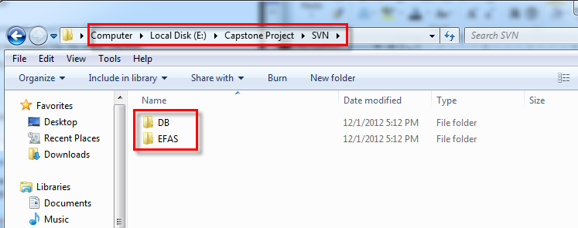

Figure F-72 Prepare Deployment Package

#### Deploy database

* Open Microsoft SQL Server Management Studio
* Create a database named **EFDB**

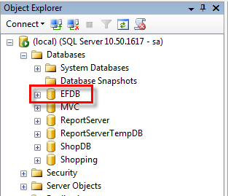

Figure F-73 Deploy Database (1)

* Right click on the EFAM database and choose **Tasks -> Restore -> Database…**

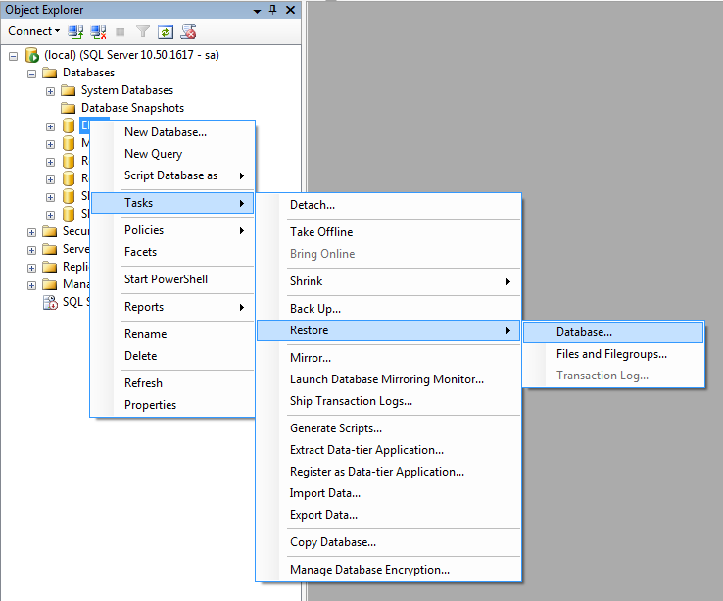

Figure F-74 Deploy Database (2)

* Choose From **device** and clicks … (**3** **dots**) button

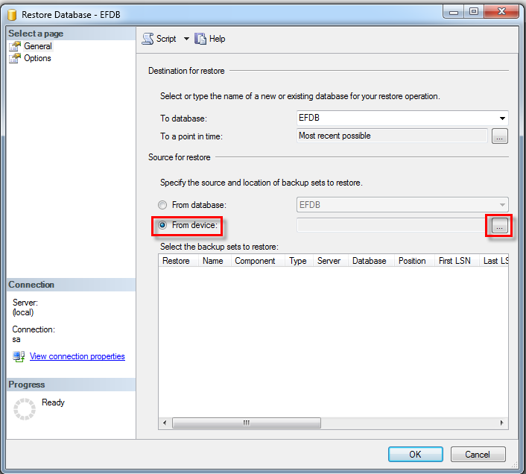

Figure F-75 Deploy Database (3)

* Click **Add** button

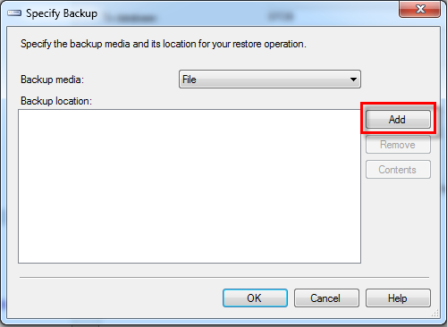

Figure F-76 Deploy Database (4)

* Browse to **EFDB.bak** file in **<deployment package>\DB** folder and click

**OK** button **two** times for backing to the Restore Database - EFDB dialog

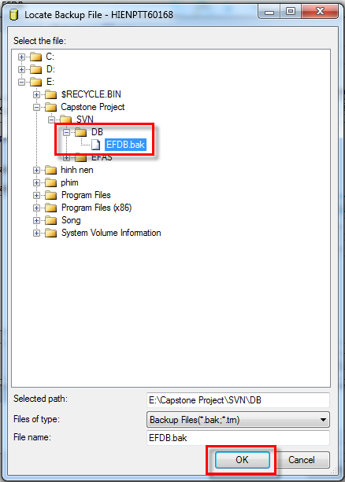

Figure F-77 Deploy Database (5)

* Check the checkbox in **Restore** column, and then click **Options**

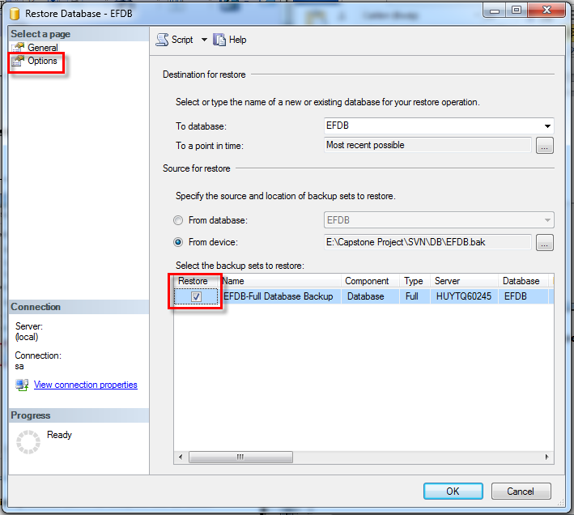

Figure F-78 Deploy Database (6)

* Check **Overwrite the existing database (WITH REPLACE)** and click **OK** button

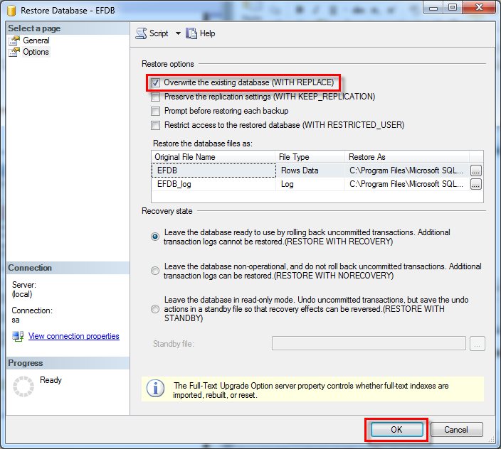

Figure F-79 Deploy Database (7)

\*IMPORTANT:

Run this script in DBMS to enable cross storeprocedure call

USE [EFDB]

GO

sp\_configure 'Show Advanced Options', 1

GO

RECONFIGURE

GO

sp\_configure 'Ad Hoc Distributed Queries', 1

GO

RECONFIGURE

#### Deploy web application

* Copy WAR file in distribute folder in CD

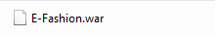

* Copy it to webapps folder of TomCat 7.0

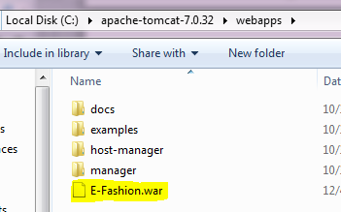

Figure F-80 Deploy Web Application (1)

* Edit server.xml in **conf** folder in Tomcat for support ENCODING UTF-8 URI

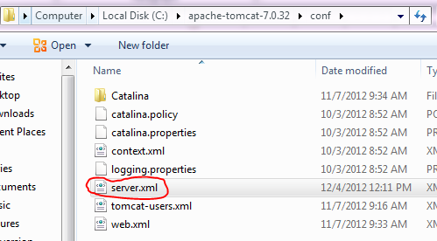



Figure F-81 Deloy Web Application (2)

* Run tomcat and it will auto deploy the E-Fashion application

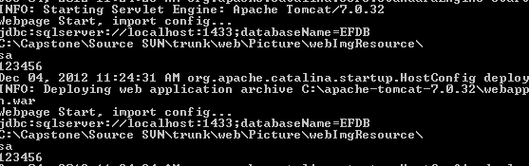

* After automatic deploy, stop Tomcat
* Change web configurations (**ref. steps below**)
* Start tomcat again for final start up

Figure F-82 Run Tomcat

#### Change web configurations

* After automatic deploy you will have new application folder name E-Fashion in webapps folder of TomCat

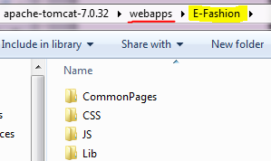

Figure F-83 Configure Web

* Open Lib folder in E-Fashion folder and double click on Config.ini to view config file

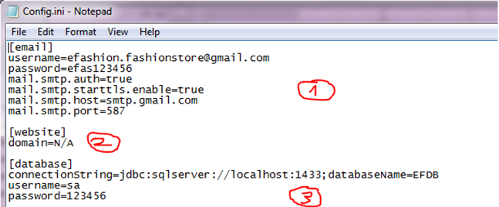

Figure F-84 Configure Ini

1: email gmail of system web use to send to customer

2: website domain if website

3: database Configs

* Edit and save

### Setting up the environment at client side

* N/A

## User’s Guide

### Boss’s Guide



#### View Report

* Click “Quản lý báo cáo” to view report at header website



* Choose day and click “Xem báo cáo”

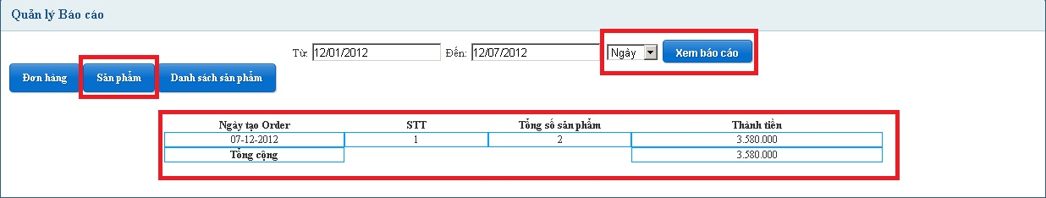

Figure F-85 View Report Guide (1)

* Result:

**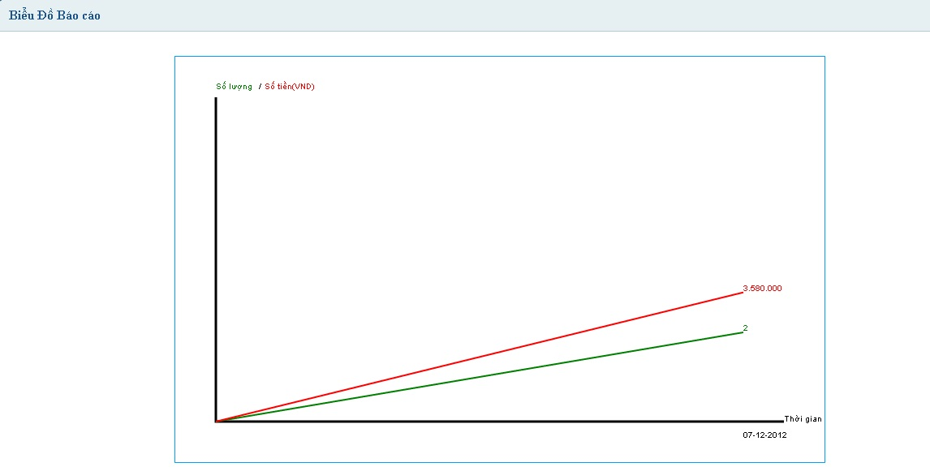**

Figure F-86 View Report Guide (2)

### Staff’s Guide

#### View Inbox Message

* Click on “Hộp thư nội bộ” on Staff Main Page.
* Click on mails on Message Box page.

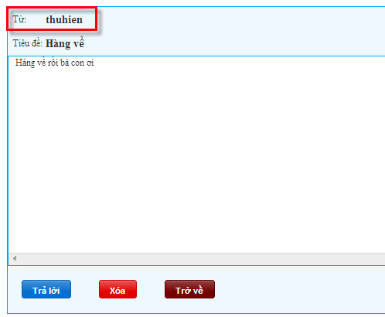

Figure F-87 View Inbox Message Guide

#### View Output Message

* Click on “Hộp thư đi” in menu “Hộp thư nội bộ” on staff Main page.
* Click on mails on Message Box page.

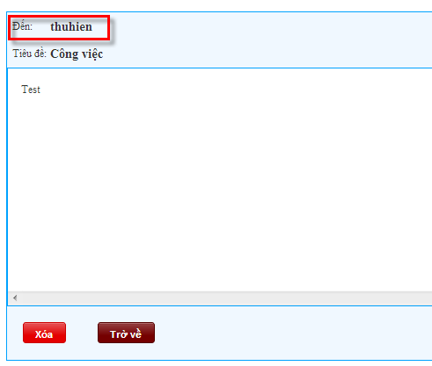

Figure F-88 View Outbox Message Guide

#### Reply Private Message

* Click title of message in “Hộp thư đến” 🡪 content message is displayed.
* Click “Trả lời”.

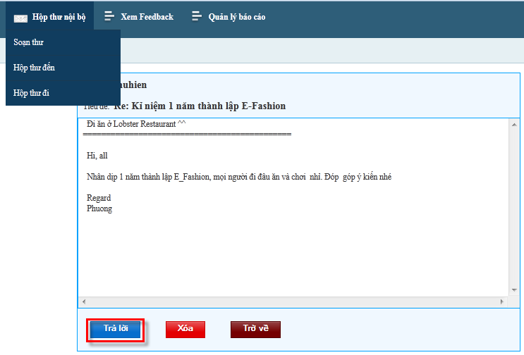

Figure F-89 Reply Message Guide

#### Delete Private Message

* Case 1:
  + At message inbox staff. Click “Hộp thư nội bộ”.
  + Check messages which staff to want delete.
  + Click “Xóa” button.

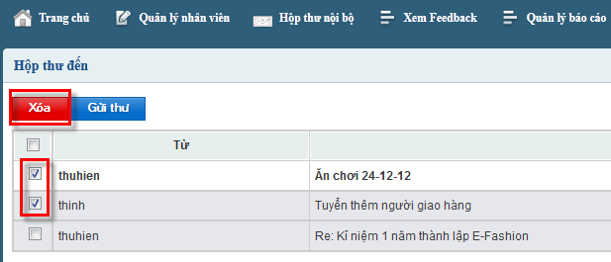

Figure F-90 Delete Message Guide (1)

* Case 2:
  + Delete all message inbox.
  + Check at first box.
  + Click “Xóa” button.

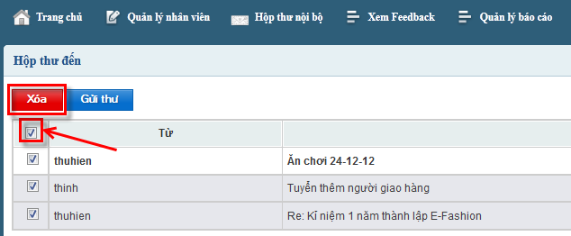

Figure F-91 Delete Message Guide (2)

* Case 3:
  + Click title of message to show content.
  + Click “Xóa” button.

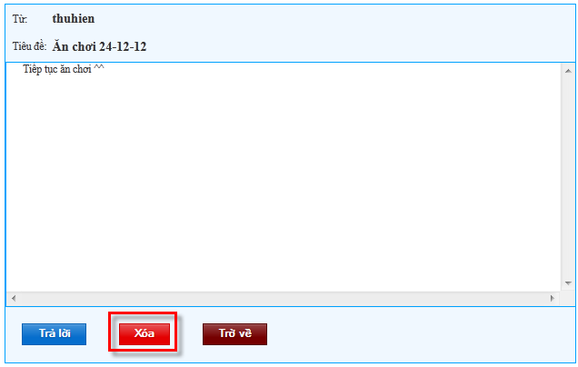

Figure F-92 Delete Message Guide (3)

### Admin’s Guide

* This function is used by Admin of system

#### Add Product

* Click “Thêm sản phẩm” in menu “Quản lí sản phẩm” at header website.

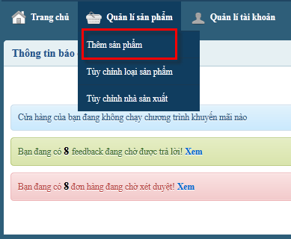

Figure F-93 Add Product Guide (1)



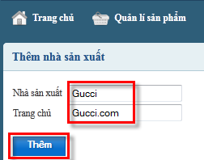



Figure F-94 Add Product Guide (2)

#### Asign Order

* Focus on “Phân công giao hàng” table.
* Choose [Tên] deliverer to set “Chọn người giao hàng”
* Write note or not.
* Click “Duyệt” button.

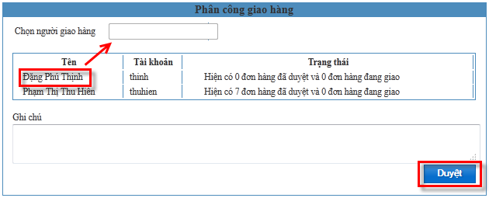

Figure F-95 Assign Order Guide



#### Export PDF Order Detail

* Select “Quản lí đơn hàng”.
* Click “chi tiết” of order title.
* Focus “Đơn hàng<ID>” table.
* Click “Tải về PDF”.

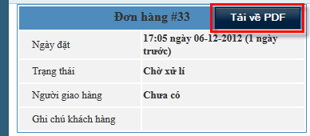

Figure F-96 Export PDF Guide

#### Reply FeedBack

* Click “Quản lí feedback” at header website.
* Click each title to view feedbak from customer.
* Write reply content.
* Click “Trả lời” button.

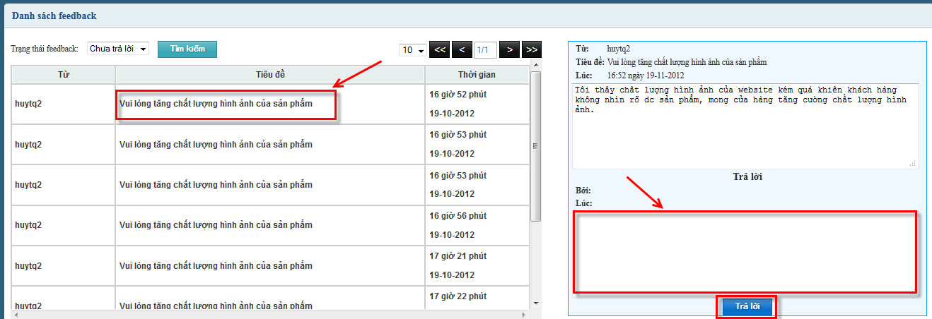

Figure F-97 Reply Feedback Guide



#### Add New Promotion

* Click “Tạo đợt khuyến mãi” in menu “Quản lí khuyến mãi” at header website.
* Fill name sale in [Tên đợt khuyến mãi], date in [Từ ngày] to [Đến ngày].
* Search product to add sale:
* Case 1:
  + Select main category from “Kiểu chính” dropdown list and select second category from “Kiểu phụ” (or Search with “Nhà sản xuất”).
  + Click “Tìm” button.
  + Click “Thêm” button while admin select product to add sale.
  + Click “Lưu” button

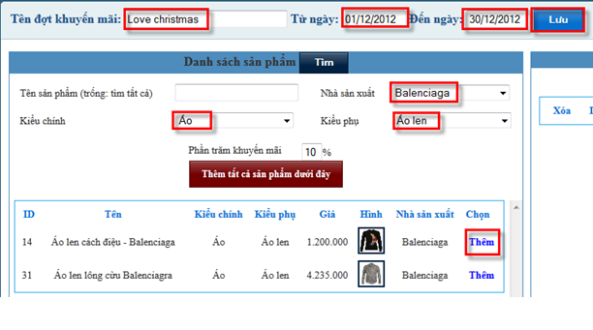

Figure F-98 Add Promotion Guide (1)

* Case 2:
  + Type product name to [Tên sản phẩm] textbox.
  + Click “Tìm” button.
  + Click “Thêm” button while admin select product to add sale.
  + Click “Lưu” button

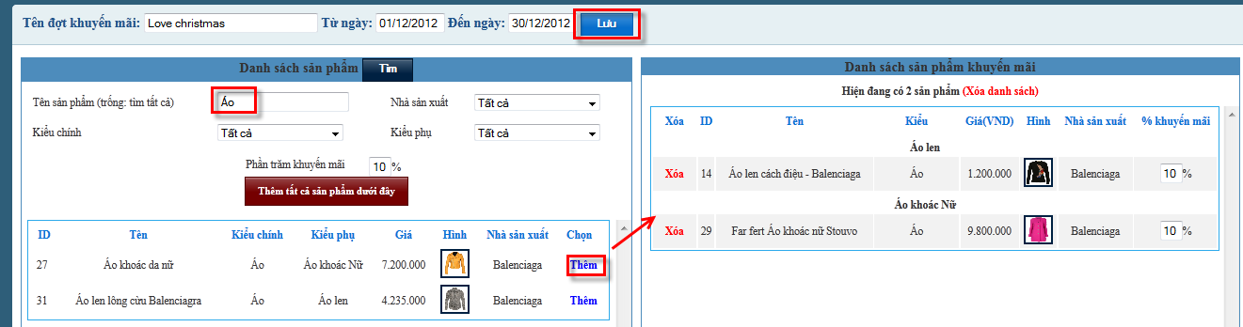

Figure F-99 Add Promotion Guide (2)

### Deliverer’s Guide

#### View Order Detail

* Login with role “Deliverer” to system.
* Click “Lịch giao hàng” at header website.

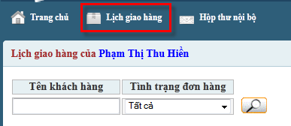

Figure F-100 View Order Detail Guide (1)

* Click “Chi tiết” link to view customer’s detail order

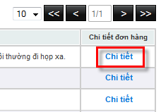

Figure F-101 View Order Detail Guide (2)

#### Search Order Delivery

* Fill customer name in [Tên khách hàng], order status in [Tình trạng đơn hàng] to search.
* Click icon search.

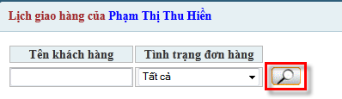

Figure F-102 Search Order Delivery Guide

#### View Order Detail PDF

* Click “Lịch giao hàng” at header website.
* Click “Chi tiết” link to view customer’s detail order.
* Focus “Chi tiết đơn hàng (VND)” table.
* Click “Tải về PDF”.

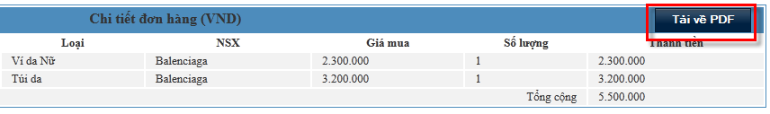

Figure F-103 View Order Detail PDF Guide

#### Change Order Delivery Status

* Case 1:
  + Change status in dropdown list, write note in check oreder page.
  + Click “Cập nhật” button to save status.

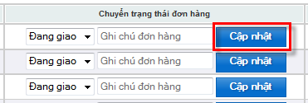

Figure F-104 Change Order Delivery Guide (1)

* Case 2:
  + Change status in dropdown list, write note in detail page.
  + Click “Thay đổi” button to save.

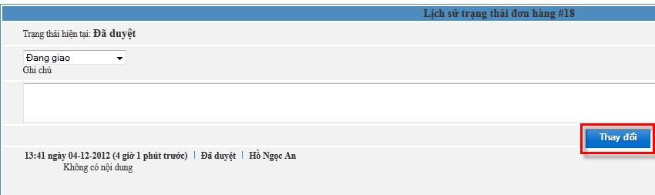

Figure F-105 Change Order Delivery Guide (2)

### Guest’s Guide

#### Register

* Go to E-Fashion website.
* Click “Đăng nhập” button on menu tab at the top right corner of website
* Click “Chưa có tài khoản?” to register

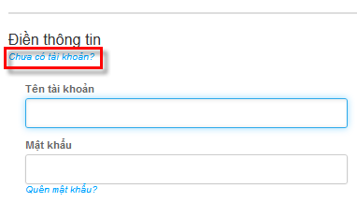

* Fill information which system request.
* Click “Tạo tài khoản” button.

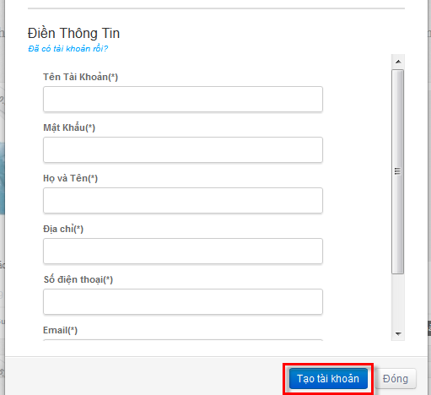

Figure F-106 Register Guide

#### View Product Detail

* Case 1: Click on image of product.

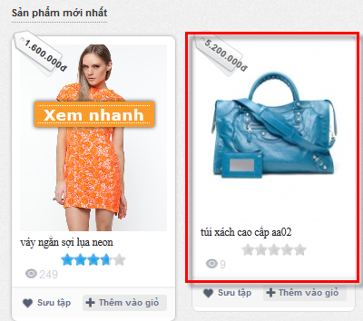

* Click “Thông tin sản phẩm” tab to view detail

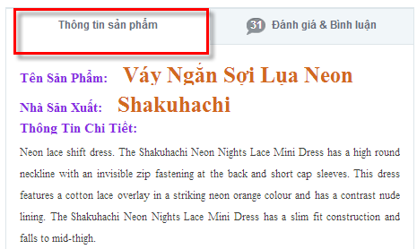

Figure F-107 View Product Detail Guide (1)

* Case 2: click on “Xem nhanh” of product to view detail

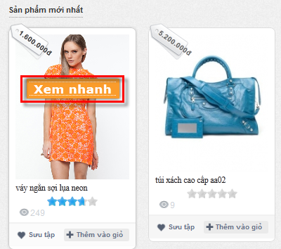

Figure F-108 View Product Detail Guide (2)

Show product detail for customer

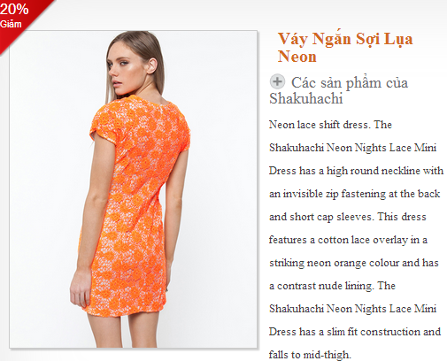

Figure F-109 View Product Detail Guide (3)

#### View Comments

* Go to E-Fashion website.
* Click on image of product to view detail.
* Click “Đánh giá & Bình luận”tab to view comment.

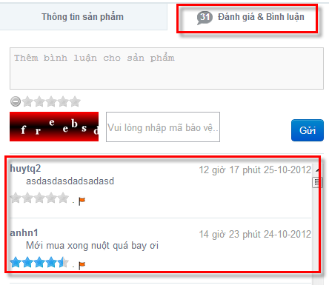

Figure F110 View Comment Guide



#### View Current Order

* User clicks “Giỏ Hàng<number>” on menu bar.

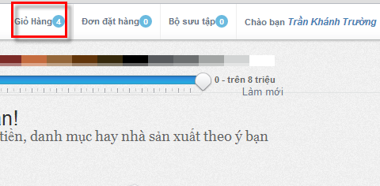

Figure F-111 View Current Order Guide (1)

* Show current order

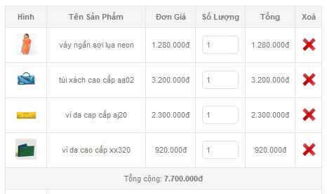

Figure F-112 View Current Order Guide (2)



#### View Feedback

* Click “Phản hồi” button on side bar.
* Click on title of desired feedback.

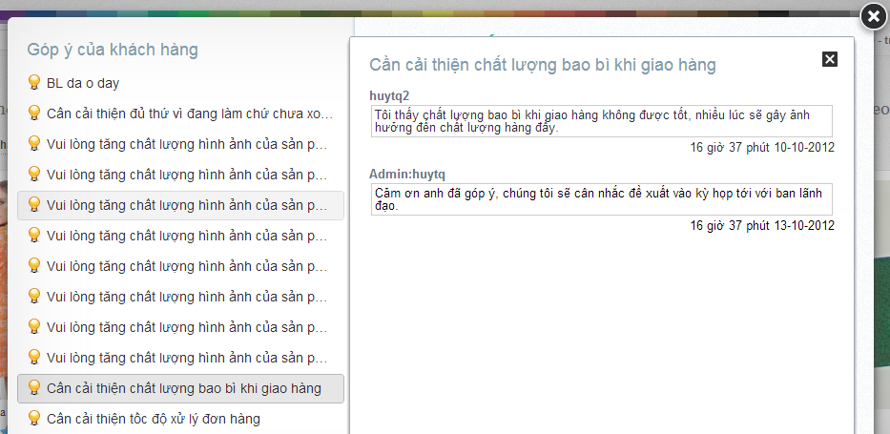

Figure F-113 View Feedback Guide



#### Search by Categories

* Select category in “Danh mục” drop down list
* Search result is displayed.

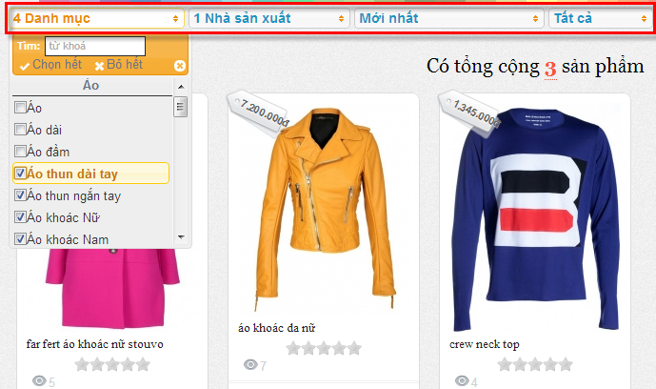

Figure F-114 Search by Category Guide

#### Search by Color

* Select color on color bar

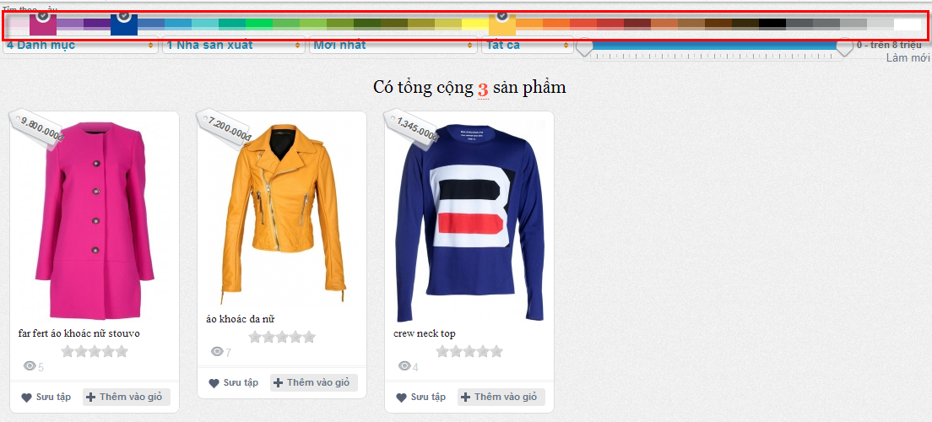

Figure F-115 Search by Color Guide

### Customer’s Guide

#### Comment Product

* Login E-Fashion website with role Customer.
* Click on image of product to view detail.
* Click “Đánh giá & Bình luận” to view comment.
* Write comment and security code.
* Click “Gửi” button to send comment.

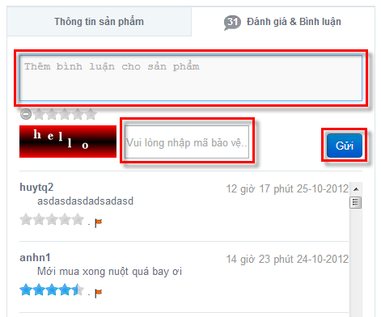

Figure F-116 Comment Product Guide

#### Rating Product

* Click on image of product to view detail.
* Click “Đánh giá & Bình luận” tab.
* Select start to rating product.

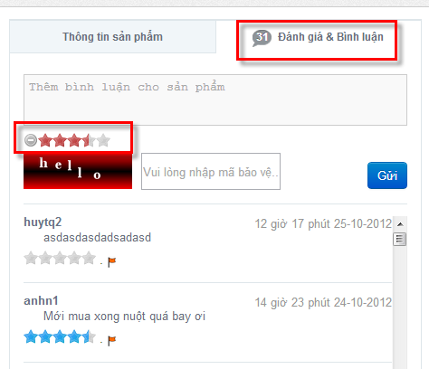

Figure F-117 Comment Product Guide



#### Submit Order

* Click “Giỏ Hàng<number>” on menu bar.
* Input security code.
* Click “Đặt hàng” button.

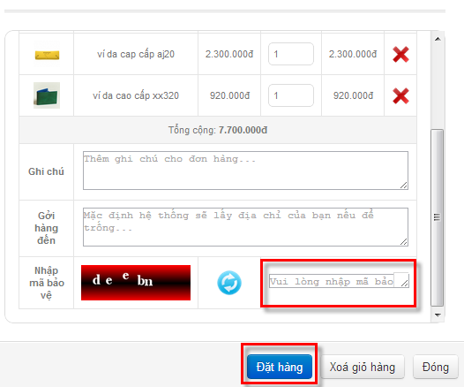

Figure F-118 Submit Order Guide

#### Update User Detail

* Click “Thông tin tài khoản” button on menu tab at the top right corner of website.
* Edit information and click “Thay đổi” button to update user detail.

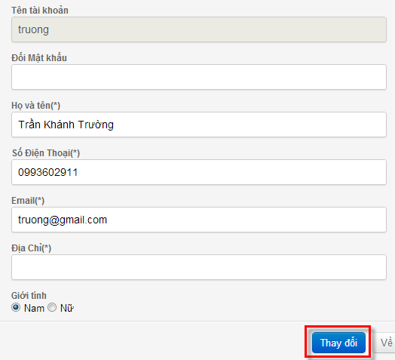

Figure F-119 Update User Detail Guide



#### View Collection

* Click “Bộ sưu tập<number>” on menu bar.

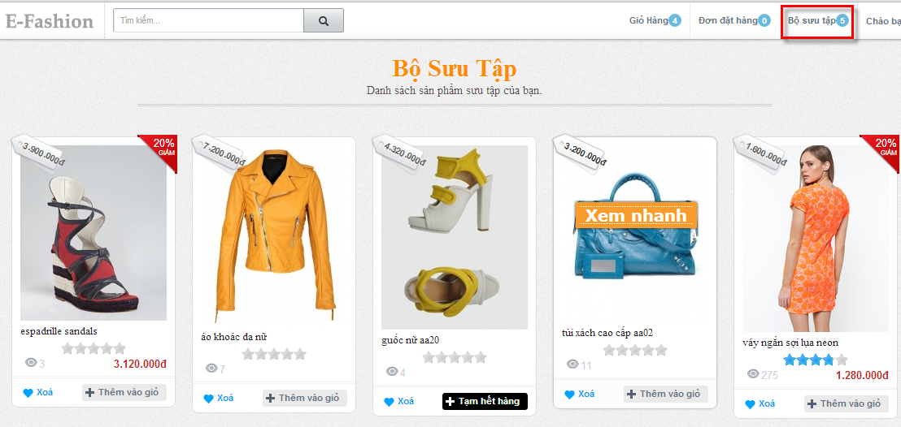

Figure F-120 View Collection Guide

#### Remove Item from Collection

* Click “Bộ sưu tập<number>” on menu bar.
* Click “Xóa” button on image product.

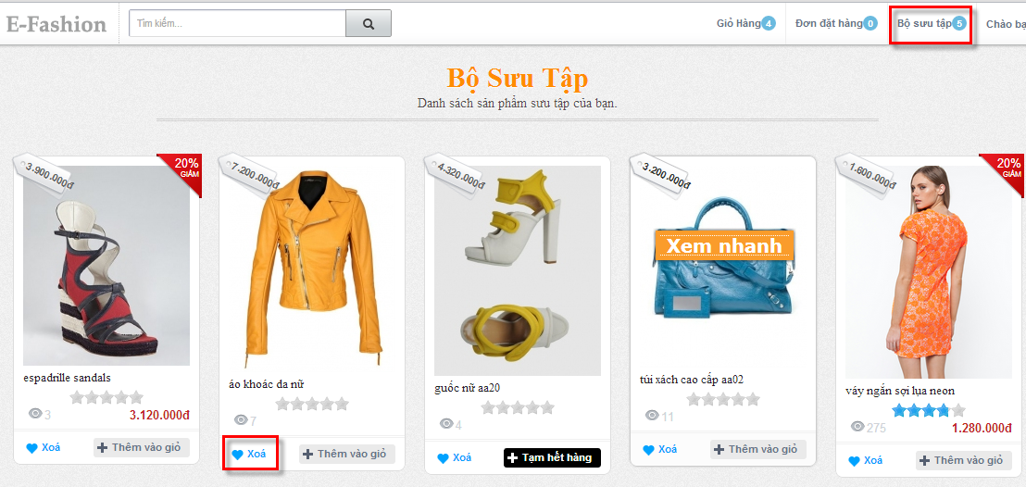

Figure F-121 Remove Item from Collection Guide



#### View Histories Order

* Click “Đơn đặt hàng<number>” on menu bar.
* View histories order.

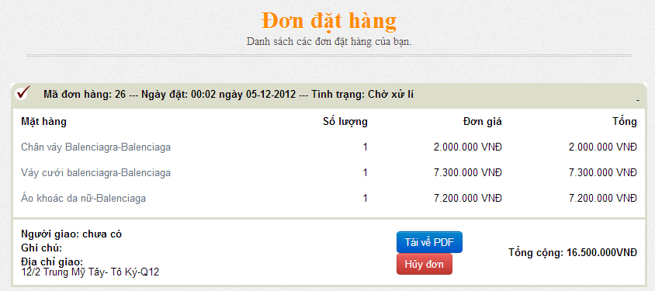

Figure F-122 View Histories Order Guide

* Click “Tải về PDF” to view Order Detail.
* Click “Hủy đơn” to delete order have status is “Chờ xử lí”.

#### View Detail Order PDF

* Click “Đơn đặt hàng<number>” on menu bar.
* View histories order.
* Click “Tải về PDF” to view Order Detail.

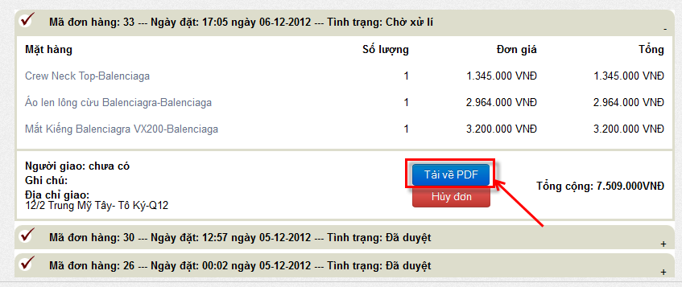

# Appendix

## Definitions, Acronyms and Abbreviations

|  |  |  |
| --- | --- | --- |
| No | Key word | Meaning |
| 01 | HTTP | Hyper text transfer protocol |
| 02 | EFashion | Electronic Online Fashion Store |

Table D-34 Definitions, Acronyms and Abbreviations

## References

Trang thương mại điện tử 123: <http://www.123.vn>

Trang thương mại điện tử 5giay: <http://www.5giay.vn>

W3school: <http://www.w3schools.com/jquery/default.asp>

Java coding convention**:** [www.oracle.com/java/codingconvention.html](http://www.oracle.com/java/codingconvention.html)

Agile model: <http://en.wikipedia.org/wiki/Agile_software_development>

Query Address: <http://www.asual.com/jquery/address/>

JQuery Masonry: <http://masonry.desandro.com/>

Stack over flow: <http://stackoverflow.com>